Steward Temple African Methodist Episcopal Church
85 Woodward Road, Quincy, Florida 32333
Reverend Lousia L. Thomas, Pastor

Video Audio Meeting ID: 775 259 7670 Dial-in Number: 646-558-8656 Passcode: 663369 Meeting ID: 775 259 7670
Passcode: 663369#
Website: www.stewardtempleamec.org Email: stewardtemple@tds.net

Save the date

Pastor’s Retirement Celebration August 2022
Venue To Be Determined

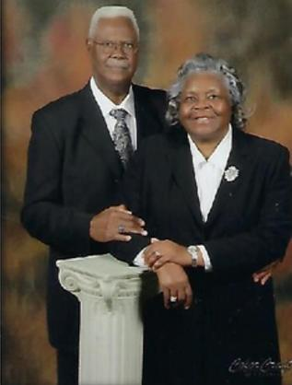
Reverend Louisa Thomas, Pastor

Twenty-Two Years of Effective Leadership, service and Church Growth

