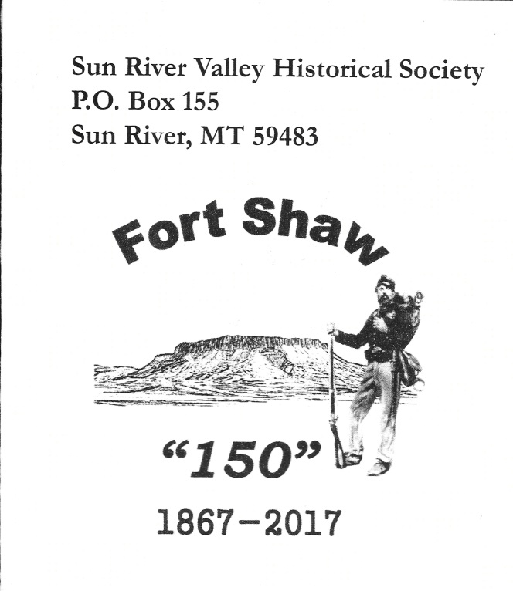
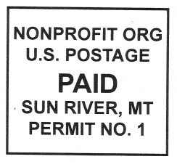

Spring 2021
THE SUN RIVER VALLEY HISTORICAL SOCIETY
P.O. Box 155, Sun River, MT 59483
Facebook: https://www.facebook.com/sunrivervalley/ and website--www.srvhs.info
Working for forty-four years to keep Valley history and memories alive!
The Sun River Valley Historical Society is a 501-c-3 non-profit. Please remember that charitable gift giving is tax deductible.
Thank you for your support!

SPRING 2021 NEWSLETTER

As the poet Robert Burns wrote “The best laid plans of mice and men often go awry”… well, that has definitely been our lives for the last year. Meetings have had to be cancelled and plans have had to be changed. However, with your support, much has still been accomplished.
Don Ensley and John Bennett, along with help from others, have continued to work on the fort buildings and the Military Cemetery. The third wall of the Memorial Tower has been completed and the upper part of the tower has been painted. (It all looks wonderful!) Drive out to historic Fort Shaw and see for yourself! 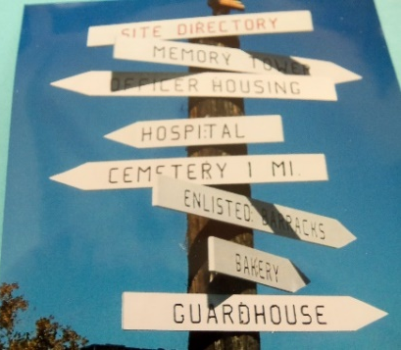 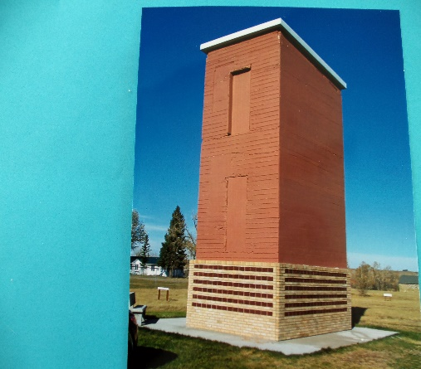
Have you seen the Memory Tower at
historic Fort Shaw? The third wall of names is now complete. There are 290 names on it. We have room for another 50 names on the 4th wall. If you want your family, class, or organization to be remembered with a Memory Brick, please contact the SRVHS at 965-3025. The Memory Bricks are $100.00 each.
A lot of places to visit!
Now, with the vaccine, it is possible that our lives will become more normal. The Society is hoping to have meetings again, to have tours this summer, and to have the yearly yard sale, starting in July. (Please think of us when you have stuff to donate.)
As activities increase, look for notices at the Valley post offices, in the local newspapers, and on our Facebook page.
MARK YOUR CALENDARS!
Summer tours are now scheduled to start on Friday, July 9, from 1:00 p.m. – 5:00 p.m. at historic Fort Shaw. They will continue each Friday until the end of August.
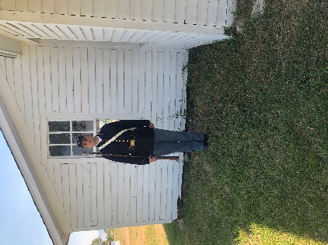
A special thanks to John Turner who
attended every tour last summer in his authentic uniforms. We all learned a lot
from him!
Loved ones who have passed
Eldon Peterson, Dale Sheldon, Fern Tronstad, Ernest Hamann, Arlene C. Murdock, Michael Maurantonio, Dorothy Gebhardt, James Jacobsen, Joel McHale, Larry Wright, Thelma Zeller, Charles Penwell, Glenn Gasvoda, Elerine LaRocque, Hal Davies,Floyd Lake, Deloris Tessman Patefield, Janet Gray , Nora Lukin, Glenn Peterson, Bob Champion

Memorials have been received for:
Ida Jane Sauke Johnson, Elerine LaRocque, Thelma Zeller, Ron Long, Dale Sheldon, Timer Daley. What a wonderful way to remember your loved one and honor their love of this special Valley.

CAN YOU HELP?
Your continued support is of vital importance in helping with projects at the fort. In particular, maintenance on the Indian monument, installing correct siding and paint for the buildings, and some rooms need sheetrock. Your memberships, donations, and purchases make this work possible. If you would like your donation to go to a specific purpose, just let us know.

EXCITING NEWS!!
Last year, a member wrote to inquire about a couple of booklets. Copies were found and have been reprinted at a reasonable cost. The 1964 Sun River Valley Centennial booklet is available at $10.00 and the story of The Indian School at Fort Shaw, written by John Greer in 1958, in available at $12.00. Shipping and handling are $2.00 for each copy. Also available:
Sun River Valley History 1 (a pictorial history of the Sun River Valley) at $30.00 plus $5.00 shipping and handling
Sun River Valley History II at $40.00 plus $5.00 shipping and handling.

SO MANY TO THANK!

As always, we are grateful for our members. Your continued support through memberships, donations, memorials, purchases of books, t-shirts, ornaments, medallions, and Memory Bricks has allowed the SRVHS to continue its work of preserving and protecting historic Fort Shaw and the Military Cemetery for future generations. Thank you!
From a box of parts to a finished desk! Good job, John Bennett!
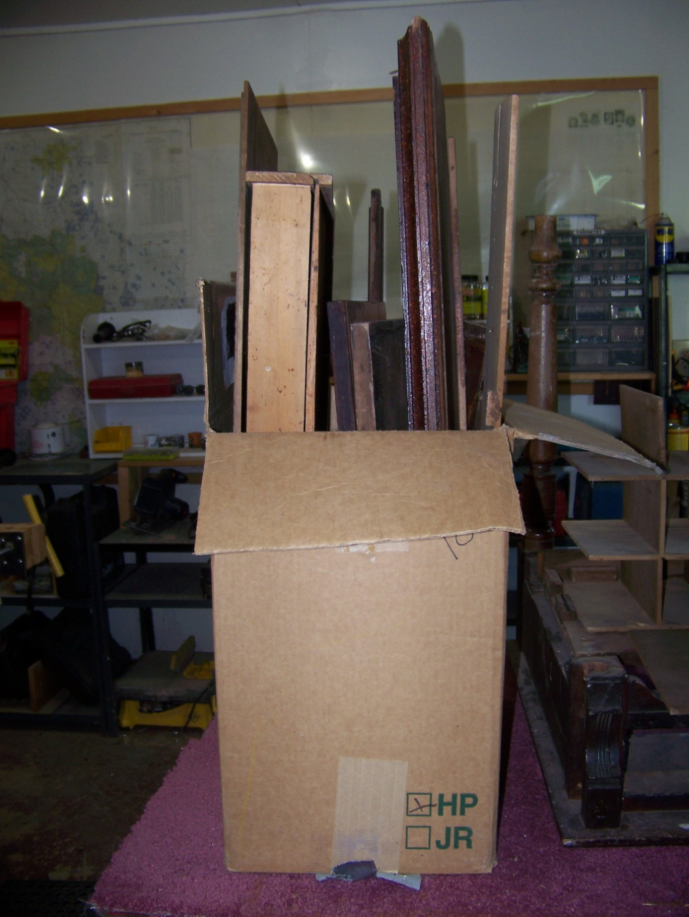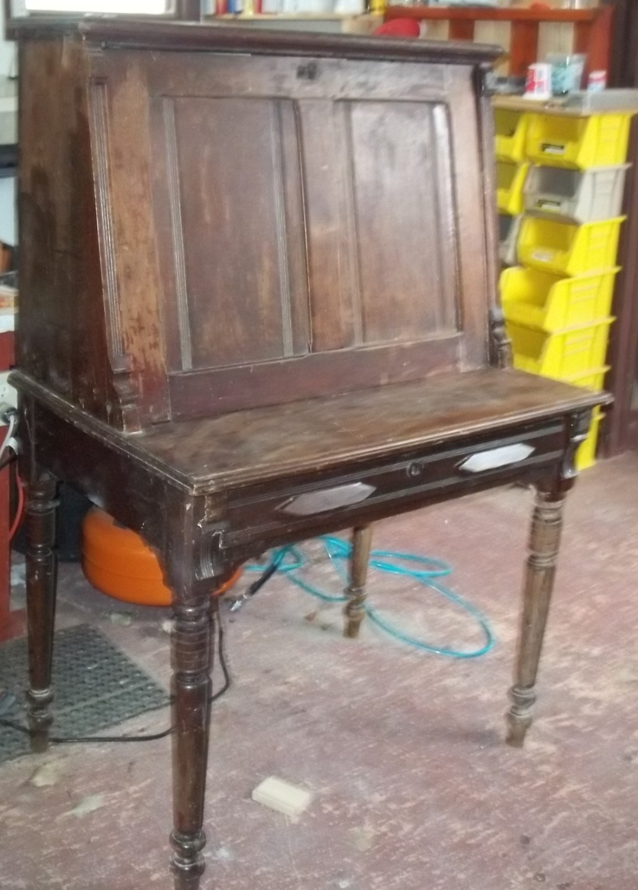
This desk belonged to Whiskey Brown—over a 150 years ago!!—when he lived at the edge of Shaw Butte, maintaining a stagecoach line and providing whiskey to travelers. While it took John over a year to figure out this puzzle, and repair and replace pieces, the end result is terrific!

There was a period of time when Fort Shaw was not in use. Buildings were recycled. Items were relocated to be used. This helped to preserve them. Now the fort is able to care for these items again and would love to have them returned as donations. If you know of any items that were originally at the fort—items from papers to furniture to tools—please consider donating them to be admired and treasured by generations to come. Thank you!

In other news: Dues for the J. C. Adams Stone Barn are due and can now be paid on the website https://jcadamsstonebarnco.org/. Call Bob Milford at 406-788-0876 for more info.
Thanks for your support. Please note: The SRVHS and the JCAdams Stone Barn are separate organizations.

OFFICERS AND BOARD OF DIRECTORS
President B. Batista 965-3025 Bob Milford 788-0876 Earl Sheldon 965-3487 Vice-President L. Rohrer 970-290-7452 John Bennett 264-5647 Don Ensley 761-4704
Treasurer S. Williams 465-5961 Chuck Sheldon 253-486-3540 Don Batista 965-3025 Secretary D. Sand 264-5942 Ina Mae Cooper 452-8926 Lynn Preston 509-760-1159

BECOME A MEMBER AND HELP PRESERVE VALLEY HISTORY
The membership year for the Sun River Valley Historical Society is from September 1st to August 31. Your continued support for projects and programs is most welcomed and needed. Donations are always welcome! For membership, please fill out this form and remit today. Please mail all memberships and donations to the SUN RIVER VALLEY HISTORICAL SOCIETY, P.O. BOX 155, Sun River, MT., 59483.
For membership year: September 1, 2020– August 31, 2021

Name: ________________________________________________

Address: _______________________________________________

________________________________________________

Phone/email______________________________________
______ Check enclosed for $_________________________

ANNUAL DUES:
Benefactor (Lifetime membership—one vote)……$200.00
Individual (one vote)………………………………… $ 25.00
Without your continued support, the SRVHS would cease to
exist and much of Valley history would be lost.
Thanks for helping to preserve the history of the Sun River
Valley!

