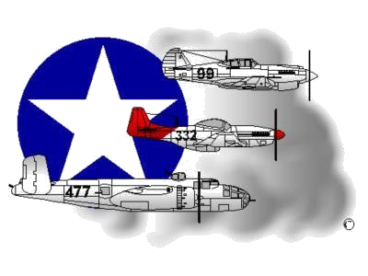
BIOGRAPHY
__________________________________________________________
A DOCUMENTED ORIGINAL TUSKEGEE AIRMAN

Tuskegee Airmen Inc. Public Relations, P.O. Box 830060
Tuskegee, AL 36083

Mr. Lawrence E. “Larry” Anderson

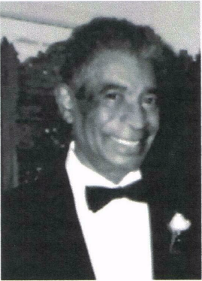
Born February 6, 1921 in Greensburg, Pa. to Lawrence E. Anderson, Sr., a chauffeur to a well known Pennsylvania family and Laura Walker Anderson, a housewife. He attended public schools in Greensburg and graduated from Greensburg High School in 1939.

Prior to and during the high school years, Larry attended and worked at the Greensburg School of Aviation, Greensburg, PA and the Latrobe School of Aviation, Latrobe, PA. Before his 19th birthday, he qualified for and received Civil Aeronautics Authority (CAA) Licenses in (a) Ground School Instructor Rating (including Aerodynamics, Theory and Principles of Flight, Aircraft Power Plants, Aircraft Frame and Structure, Navigation, Meteorology, Instruments, Parachutes and Aural Radio), (b) Aircraft Engine Mechanic, (c) Aircraft Mechanic, (d) Commercial Pilot License (single and multi-engine) and (e) Flight Instructor.
After rejection by the U.S. Army Air Corps, for supposedly having low blood pressure, he was called to Tuskegee, Alabama to serve as a Civilian Instructor in the training of Black Aviators and became Director of the Ground School at the Primary Level. His Primary Level Group, one of 23 in the Southeast training center, was rated number one several times and consistently ranked within the top five over a four year period.
Following the termination of the "Tuskegee Experiment," he joined Charles Foxx, also a former instructor at Tuskegee, in the Norfolk area where they instructed civilians (mostly veterans) in obtaining Pilots' licenses. For a short period, Mr. Anderson flew as a Crop Duster throughout Tidewater. Eventually, he went to work for the Naval Air Rework Facility at Naval Air Station (NAS), Norfolk and after 25 years with the Production Engineering Group, he retired as an Operations Analyst. Later, Mr. Anderson worked for the City of Norfolk as a Dispatcher and retired after 10 years.
When Mr. Anderson retired, he was involved with the Ingleside Civic League, the Norfolk Parks and Recreation Department and Cooperating Hampton Roads Organizations for Minorities in Engineering (CHROME). He was an original Tuskegee Airmen and a past president of the Tidewater Chapter – Tuskegee Airmen, Inc. and an active member before his death when he joined Tuskegee Airmen Incorporated’s Lonely Eagle Chapter on September 25, 1992. Lawrence 'Larry' Anderson is survived by his Widow and Heritage Members, Mrs. Margaret S. Anderson, his Daughters Leslie E. Anderson and Norma J. Anderson and his Grandson, Austin Morales and Granddaughter Blair A. Morales. His Daughter, Valerie J. Anderson, a past Tidewater Chapter – TAI Secretary, passed away in February 2020 after a long bout with cancer.

To learn more about Mr. Lawrence Anderson and/or the Tidewater Chapter’s Speakers Bureau and other activities that he participated in, please visit the Tidewater Chapter’s Website at the following location: www.TAI-TidewaterChapter.Com.

