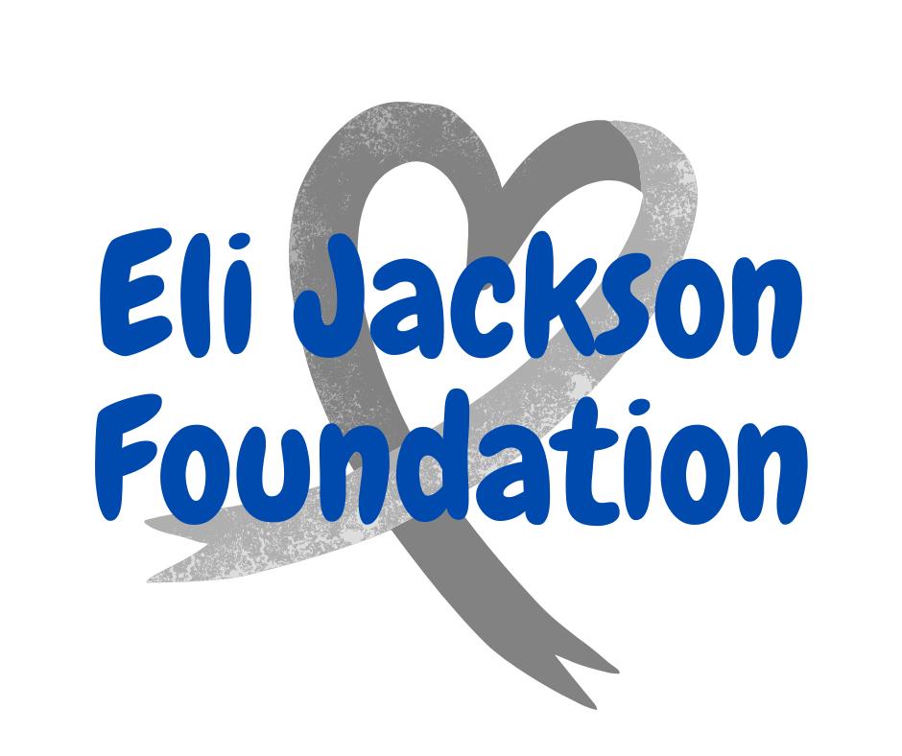

The Eli Jackson Foundation is offering Chilton County graduating seniors the opportunity to apply for a $1,000 scholarship. This scholarship is open to any Chilton County School System student who will be graduating in the Spring of 2023 AND pursuing a degree in the field of nursing or any medical field. All applications must be received on or before May 15, 2023. The finished application must include this form along with a completed essay that is no more than 1 page (single-spaced) in length.

Name: ______________________________________________________________________

High School: _________________________________________________________________

College you plan to attend in 2023-2024: ___________________________________________

College Major: ________________________________________________________________

G.P.A.: _____

Hobbies/Clubs/Community Service:
____________________________________________________________________________
____________________________________________________________________________
____________________________________________________________________________
____________________________________________________________________________
____________________________________________________________________________
____________________________________________________________________________
____________________________________________________________________________
____________________________________________________________________________

Please select ONE of these topics for your scholarship essay:

1. Why are you interested in a career in nursing or the medical field?
2. How will this scholarship make a difference for you?
3. Tell about a time you failed. What did you learn from the experience?
4. Who has been your biggest influence (or inspiration)?

Return this form along with completed essay ‘to info@elijacksonfoundation.com.

