***All details must be fully completed on the form for consideration***
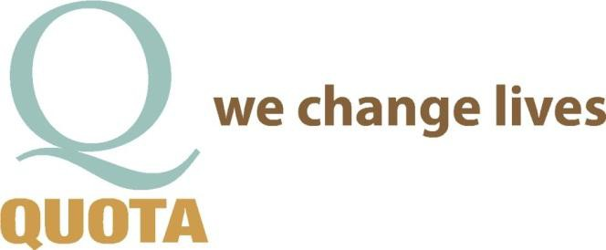
***Incomplete forms will delay or reject your application ***

Application for Requesting Funds from Quota
Pre-qualification Form

How did you hear about Quota?

APPLICANT CONTACT INFORMATION (PRIVATE INDIVIDUAL) DATE:

NAME:
AGE:

PARENT OR GUARDIAN (IF APPLICABLE):

OCCUPATION: GROSS ANNUAL INCOME:

ARE YOU WILLING TO PROVIDE FINANCIAL INFORMATION? YES or NO. If NO why?

MARITAL STATUS: SINGLE ______ MARRIED ______ SEPARATED______ DIVORCED ______
TOTAL NUMBER OF DEPENDENTS: _______ TOTAL NUMBER IN HOUSEHOLD: _______
ADDRESS CITY STATE ZIP

E-MAIL CELL PHONE# OTHER PHONE#

REFFERAL AGENCY AND/OR AGENCY REQUESTING FUNDS

BUSINESS NAME

BUSINESS CONTACT

ADDRESS CITY STATE
ZIP

EMAIL PHONE # FAX #_

ARE YOU A NON-PROFIT ORGANIZATION? YES or NO 501(c)3#

REQUEST FOR FUNDS: DESCRIBE IN DETAIL WHAT YOU ARE REQUESTING FUNDS FOR & NEEDS JUSTIFICATION

******TO HELP YOUR REQUEST PLEASE ATTACH ANY DOCUMENATION PERTAINING TO YOUR REQUEST OR ADDITIONAL INFORMATION ON A SEPARATE SHEET OF PAPER ******

HOW WILL THE FUNDS BENEFIT UNDERPRIVILEDGED FAMILIES/CHILDREN AND/OR THE DEAF AND HARD OF HEARING COMMUNITY IN CENTRAL OREGON?

FINANCIAL INFORMATION – AS APPLICABLE

COST OF THE REQUESTED PRODUCT OR SERVICE

PROVIDE A QUOTE/INVOICE OR ANY OTHER DOCUMENATION PERTAINING TO THE COST
YES I HAVE or NO I DON’T. IF NO WHY?

WHO DOES THE PAYMENT GO TO

WHERE DOES THE PAYMENT NEED TO BE SENT

WHAT IS THE DEADLINE FOR THE FUNDS TO OBTAIN THE PRODUCT/SERVICE?

DOES THIS ESTIMATE INCLUDE A PROFESSIONAL DISCOUNT? YES or NO IF YES HOW MUCH

DOES THE APPLICANT QUALIFY FOR BENEFITS THROUGH THE OREGON HEALTH PLAN OR VIM YES or NO
IF YES PLEASE DESCRIBE AND HOW MUCH?

CAN YOU OR ARE YOU PREPARED TO PAY A PORTION OF THE COST IF NEED? YES or NO.
IF YES HOW MUCH? IF NO WHY?

DOES YOUR HEALTH INSURANCE PROVIDE ANY COVERAGE? YES or NO. IF YES HOW MUCH?

ARE YOU ELIGIBLE FOR FINANCING THROUGH A BANK, CREDIT UNION, FINANCE COMPANY OR FINANCIAL ASSISTANCE THROUGH THE PROVIDER OF THE SERVICE/PRODUCT?
YES or NO IF NO WHY?

COMMUNITY SERVICE / QUOTA:
IS APPLICANT WILLING OR ABLE TO VOLUNTEER FOR A COMMUNITY SERVICE PROJECT THROUGH QUOTA
YES or NO. IF NO WHY?

IF THE APPLICANT IS AWARDED A BENEFIT, CAN HE/SHE ATTEND A QUOTA MEETING TO OFFER A BRIEF
TESTIMONIAL? YES or NO. IF NO WHY?

PROCESS FOR SUBMITTING REQUESTS: NOTE: THE PROCESS FOR OBTAINING FUNDING APPROVAL TAKES 30-60 DAYS.
SUBMIT COMPLETED REQUEST TO: QUOTA SERVICE COMMITTEE, PO BOX 1372, BEND OR 97709
Or EMAIL TO: quotaofcoservice@gmail.com
NOTE: APPROVED FUNDS ARE RELEASED ONLY TO THE PROVIDER COMPANY.

QUOTA USE ONLY: | APP RECEIVED: | SERVICE MEETING_ APPROVE / DECLINED OTHER_ | BOARD  MEETING: APPROVE / DECLINE | GENERAL  MEETING: APPROVE / DECLINE | CHECK REQ  CH#_

