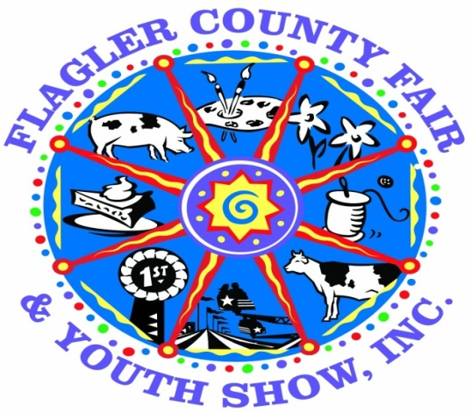
The Agriculture Committee is pleased to announce the continuation of our
“Country Critter Competition”
at the FLAGLER COUNTY FAIR AND YOUTH SHOW April 5th-9th, 2017

The purpose of this competition:
- Encourage participation from youth in our community who have little knowledge of agriculture
- Allow youth to have a competitive animal project without raising a live animal
Rules:
- Entries may be submitted by INDIVIDUALS only.
- Age Divisions (as of September 1, 2016)
Cloverbuds 5-7 Junior 8-10 Intermediate 11-13 Senior 13-18
- Entries will be judged and awarded Ribbons and Cash Prizes.
- Placing/Awards in each age division will be:
1st Place – Blue Ribbon & $15.00 Cash Reward
2nd Place – Red Ribbon & $10.00 Cash Reward
3rd Place – White Ribbon & $5.00 Cash Reward
- An overall “Best of Show” winner will be awarded a rosette and $25.00 cash award
- Critters have a maximum size of 3’ x 3’ x 2’ (LxWxH)
- Critters will be judged on creativity, attractiveness, originality & neatness.
- All critters will be on display at the fairgrounds during the upcoming Flagler County Fair & Youth Show
Important Dates & Deadlines:
- April 2nd 2017 (12pm-4pm) & April 3rd 2017 (9am-7pm)
Turn Country Critters into the Cattlemen’s Hall for display
- April 4th 2017 - Judging
- April 10th 2017 – Pick up Country Critters (between 1pm-6pm)
(If not picked up by this time the critter will become the property of the fair)
Contacts for this Competition:
Penny Buckles – Fair Manager (386) 931-6597
Michelle Jankowski – Home & Family Division Fair Superintendent (386) 931-0911
Tonya Snyder – (386) 523-5036
Email: flaglerctyfair@bellsouth.net Website: www.flaglercountyfair.com

