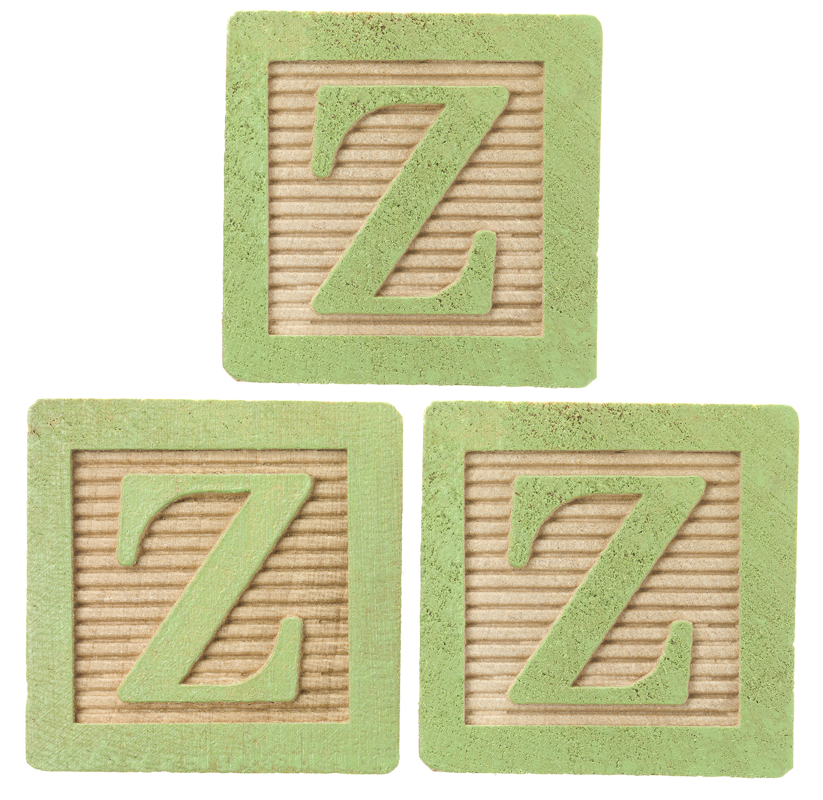

Just part of your comprehensive wellness program. Find out more at www.empowerlinc.com or call a health coach today at 888.882.LINC (5462).



Urest

a proven approach to better sleep hygiene

WILL U

FIND

ZS?