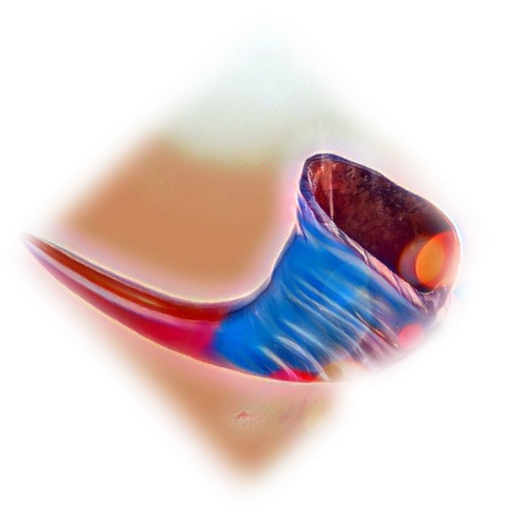
Philippine Nurses Association of Central Florida NEWS
PNACF TAMBULI
ORLANDO
Editor-in-Chief: Rose Apostol | Managing Editor: Alexis del Fonzo

IN THIS ISSUE:
- Recap: 2019 Christmas Gala
- How Well Do We Know the PNAA Foundation?
- Communication Insight during COVID-19
- Op-Ed: Stress of COVID-19 on Nurses
- PNAAF & PNACF Virtual 5K Walk
- Recap: PNAA’s 1st Virtual Convention
- Recruitment Strategies

UPCOMING EVENTS:
- Submit your articles/answers to PNAA for the upcoming September 2020 issue of inside PNAA. They are looking for millennial members to participate – see flyer attached for more information.
- Are you a PNACF member interested in running for office? Keep reading further for more details on how you can get involved with this amazing organization.
- Check out this 3-part webinar series from PNAA and PNASD (click the image):
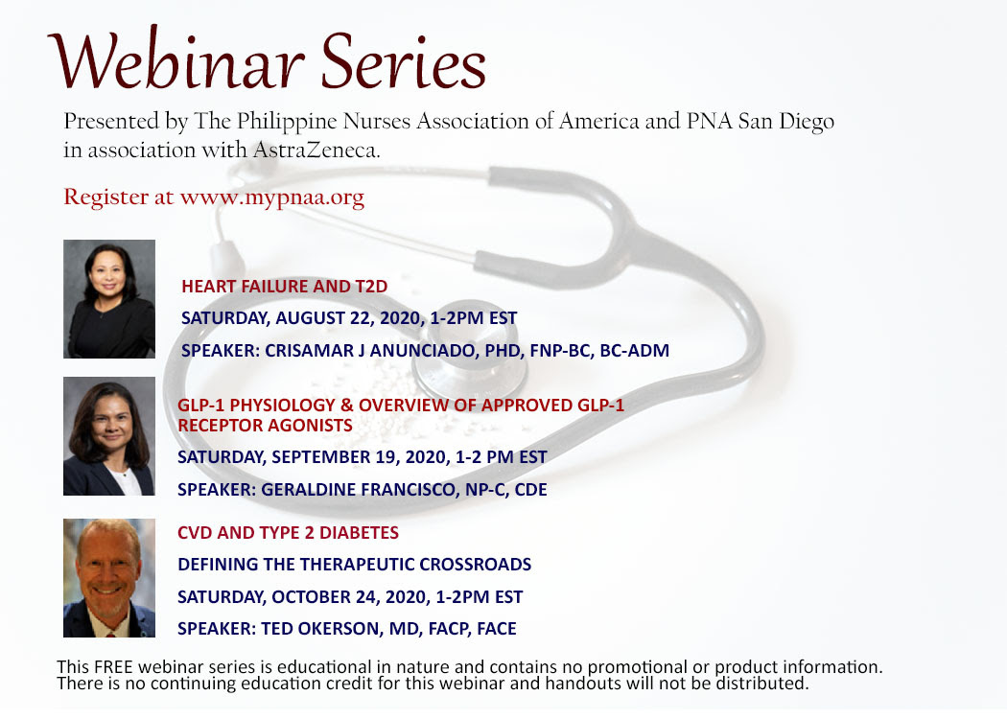

PNACF Annual Christmas Gala
Submitted by: Mary Jane Zamora BSN, RN-BC

Philippine Nurses Association of Central Florida (PNACF) celebrated its annual Christmas Gala at Hilton Buenavista Palace Hotel in Orlando, FL on December 7, 2019. The theme of the gala was red and gold. The Masters of Ceremony were Manny Ramos (PNACF President 2016-2018) and Alice Tullo (PNACF President-Elect) who began the night by welcoming everyone for attending the Christmas Gala and then recognizing the achievements and activities the chapter fulfilled that year. Manny and Alice entertained the audience during the delicious dinner with a very amusing Christmas trivia game that earned some guests holiday gifts. The gala continued with a beautiful program consisting of many talents, including Zenaida “Baby” Alcaraz-Bronson who sang several popular ballads, a special song number by Noel Arriola, and two performances by the PNACF Executive Board who danced to “Ang Himig Ng Pasko” and “Cumbia Semana Dance.” And the night would not have been complete without DJ Noel providing spirited dance music to celebrate the evening and get friends and family into the holiday spirit. The gala was a blast and a wonderful way to usher in the Christmas season. A heartfelt thank you to Hilton Buenavista Palace hotel for their kind hospitality and cheers to the chefs that prepared the amazing and delicious foods.
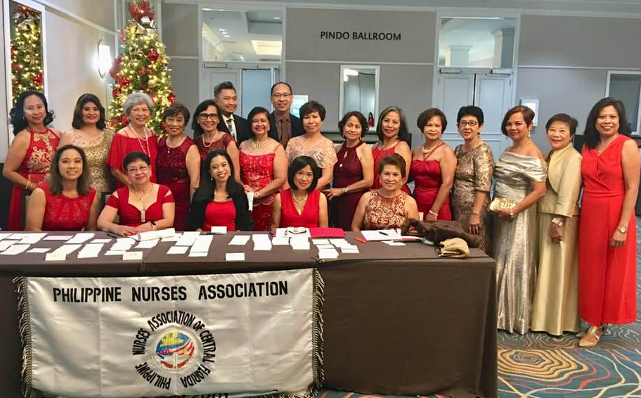

How Well Do We Know Our Foundation?
Submitted by: Alicia Tullo MSN, RN, CPC President Elect, 2018-2020

During the during the 40th National Convention in Atlanta, Georgia in 2019, Alicia Tullo, the current president-elect of PNA Central Florida was inducted as a Board of Trustee to the PNAA Foundation. This is a rare opportunity because aside from having a chapter member represented at the Foundation level, it also allows the chapter members a direct access to what is happening within the Foundation. Even though the Executive Board members of the PNAA are invited to their meetings, they do not have voting privileges at those meetings. Oftentimes, issues that are pertinent do not trickle down to the members at the chapter level, therefore having representation is an advantage.
What is the PNAA Foundation and what is its function? The PNAA Foundation was formed in 2001 and incorporated on October 2002 in Trenton, New Jersey. It is a non-profit organization that is tax exempt under section 501(C) 3 of the Internal Revenue Code. Although it is a stand-alone organization, working side-by-side with the PNA America, its main function is to serve as the financial and philanthropic arm of the PNAA. These organizations although operating separately are two sides to one coin.
The PNAAF focuses on development programs in support of the objectives of the PNAA and one of its goals is to provide the organization the structure and establish mechanisms to acquire, allocate, disburse, and manage developmental resources. You could say, the PNAAF handles the wallet and keeps the books for the organization.
MISSION:
The Philippine Nurses Association of America Foundation, Inc. promotes and provides opportunities for philanthropy in support of professional advancement of all Filipino American nurses and health for all through nursing care, education, scholarship, management and research.
PNAAF allocates its resources to educational and professional programs and activities, including continuing education, research, and scholarships. It provides educational grants to PNAA Leadership Training Institute at regional and national conferences.
Early part of 2007 the board of trustees launched the first major project, the Founding Members Initiative, which is an opportunity for all nurses, their families, friends and supporters, to be a Founding Member of the Foundation. The main purpose of the FMI is to raise funds to acquire a permanent address for PNAA/PNAAF. That goal was achieved when the Legacy Building was paid in full. The PNA of New Jersey took the responsibility of managing and maintaining the building. It was proposed that the offices of the PNAA, PNAAF and PNANJ will be housed in the building. To generate revenue, the facility will be rented out for various activities.
The PNAAF has several committees that serve different functions. For example, the Program Development Committee are charged with raising funds by various means. One fundraiser is the Legacy Tree that raised the funds to pay for the building. The Council of Trustees and the Founding Member Initiatives have both sunseted, but donations are still open at various levels are still encouraged.
The Education Committee is responsible for handling applications for CEU approval of programs. They also fund research studies and provide scholarships. The PNAAF has organized and conducted five International Collaborative Conferences in the Philippines. The 5th conference in 2019 with the Theme: Quantum Leap to the Future: Pathway of Quality into Education and Practice was held in Davao City with the Ateneo de Davao Colleges. The 4th International collaboration was with Bicol University in Legazpi City from January 2017. The 3rd International Collaborative Conference was in collaboration with Filamer Christian University College of Nursing (FCUCN) held on January, in Roxas City, Philippines.
There is a plan underway to hold the next international collaborative conference on January 2021, in Vigan, Ilocos Sur.
One of their community outreach endeavor is the Gawad Kalinga housing in Bulacan. After funding to build a few houses, PNAAF continues to support various projects for the residents in the village such as conducting medical missions, providing dental kits, establishing a village clinic, and the most recent was funding the request of women for sewing machines to help establish a form of cottage industry that can become a source of income. They also fund disaster reliefs for victims of earthquakes, volcanic eruptions and other disasters that has affected the Philippines.
During the 40th National Convention, the PNAAF launched the book titled “The Philippine Nurses Association of America: A Tapestry,” which is an anthology, written by many talented and dedicated volunteers whose main characters according to Nelson Tuazon, Editor are the past PNAA Presidents and their executive boards who wrote multiple stories creating a notable document that memorialized the essence of the story of the PNAA, capturing places and reverently venerated the people that shaped the history of the PNAA. I believe that each Filipino nurse must have a copy and read this book to appreciate the contributions we all made to the nursing profession and the healthcare industry in the USA and to read about the courage, passion and dedication of the nurses who pioneered the formation of the PNAA.
As a chapter member of the PNAA/PNAAF, we belong to a “two-parent household, “and we have a duty to stay informed of the activities of both organizations. To learn more about the Foundation, go to https://mypnaafoundation.wildapricot.org/
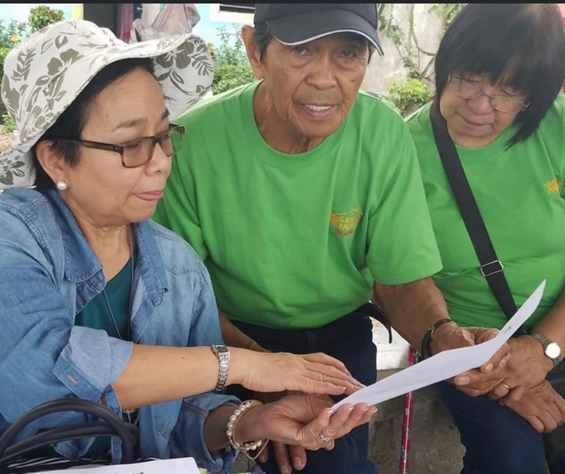
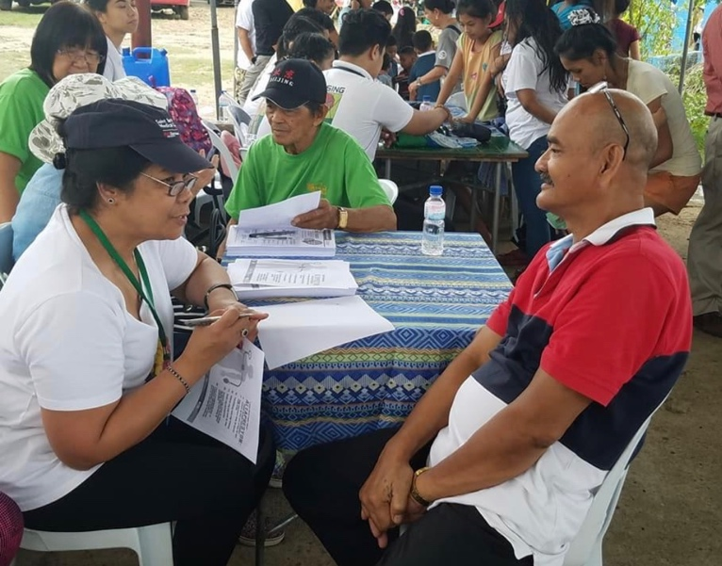

Insight into the Communication Process During the COVID-19 Pandemic
Submitted by: Submitted by: Alicia Tullo MSN, RN, CPC President Elect, 2018-2020

A pandemic is not a common occurrence, and it is important that we document our experiences lest we forget. I first learned about the COVID-19 Pandemic while communicating with one of my nephews back in January 2020 when he asked how we are doing with the flu season in Florida; he mentioned that some form of “very bad pneumonia” was identified by the WHO. That same month, WHO twitted that” there is a cluster of pneumonia cases – with no deaths – I Wuhan, Hubei province”. I checked Google map to find out where Wuhan was, and quickly dismissed the thought that it is a threat. However, being born with whimsical curiosity, I decide to do a research by going to the WHO website and found an article: Emergencies Preparedness, entitled “Pneumonia of unknown cause- China.” The article contained a risk assessment and advice about the patients who developed pneumonia and their public health response.
As a knowledge-seeker, I was on the WHO website almost daily to read more about it. On January 12, was an article titled “Novel Coronavirus – China, Disease outbreak news: Update”. The word “novel” tweaked my curiosity. On January 20, an article on the WHO website was about US delegation visiting China and although I started to become concerned, the last line somehow gave me a sigh of relief: “While challenges remain regarding transmission, epidemiology and our understanding of the behavior of the virus, WHO and it’s; partners will work together with China to respond to the outbreak.” After that, my daily source of information was the television for the daily briefings, my computer on the WHO, CDC, and Florida DOH websites. I also received weekly updates from first hand experiences shared by family, relatives, friends and colleagues who live and work in different countries around the world and across the USA and Canada. My being a nurse and my husband being a physician, we both received first-hand experiences of caring for Covid-19 patients in all settings and specialties.
In Florida where a hurricane is a threat every year from June to November, being in the path of a hurricane can have serious devastating consequences. Several years ago, I was part of a team at my hospital to create a Hurricane Communication Plan. I learned that hurricanes, also called tropical cyclones, tropical storms, and tropical depressions pose a variety of threats that can lead to crises. Long lasting damage can occur from the heavy rainfall, the wind, and storm surge which causes loss of life. Sometimes tornados form and rip currents can result from hurricanes. Therefore, the best time to prepare for it is before the hurricane season begins.
In creating our crises communication plan, we looked at several factors. Those factors were: speed, education, accuracy, compassion and how to handle travel restriction, and when staff need to stay in the hospital. This plan is appropriate in any disaster, and therefore is useful during a pandemic. So, I look back on how the plan for the COVID-19 was communicated using these factors.
Speed. So, when this Covid-19 Pandemic hit, my first question was, how quickly was the public informed of this pandemic? Many may disagree, but based on the timeline, President Trump was quick on declaring a public emergency.
On January 30, 2020, the WHO named the coronavirus a “Public Health Emergency of International Concern” and warned that “all countries should be prepared for containment, including active surveillance, early detection, isolation a case management, contact tracing and prevention of onward spread.”
The next day, January 31, through the U.S Department of Health and Human Services, the Trump Administration declared a public health emergency, and Imposed a mandatory 14-day quarantine for any U.S. Citizen who has been to Hubei Province in China within the preceding two weeks; denying entry of non-US nationals who had traveled to China within the preceding two weeks.
Simultaneously, our Florida Governor Ron DeSantis has been on the media updating us daily on the pandemic. Our first two confirmed cases in Florida was announced on March 1; one travelled to Italy, the other had contact with someone who tested positive. The next day, AARP urged the Florida nursing homes to start preparing since senior citizens are more likely to experience severe symptom sand make sure they had adequate personal protective equipment.
How were we educated? President Trump formed a Task Force who disseminated information about the pandemic, guidelines to stop the spread of the disease, number of cases, predictive models of spread and ways to flatten the curve, and possible medications for convid-19 patients, etc. He had daily briefings to inform the country.
Our Florida Governor also formed his own Task Force, the Florida Department of Health was doing much of the same thing; asking residents not to travel to certain areas overseas; and the universities asked students and employees to use caution when traveling abroad during spring break.
On March 3, The Florida Department of Health set up a coronavirus hotline so residents can call 1-866-779-6121 to get their questions answered. The hotline was originally only open on weekdays but has since been expanded to be available 24/7. Questions can also be emailed to COVID-19@flhealth.gov.
On Mach 16, in the state’s ongoing efforts to provide transparency and clarity regarding COVID-19, the Florida Department of Health announced the launch of a new COVID-19 Case Dashboard. To keep Florida residents and visitors safe, informed and aware about the status of the virus, this dashboard will be updated twice daily. Dr. Brix, a physician and diplomat who specializes in HIV/AIDS immunology, vaccine research, and global health who serves as the Coronavirus Response Coordinator for the Trump Administration's White House Coronavirus Task Force, recognized the Florida DOH’s dashboard.
Dr. Brix gave a shout out to DOH’s interactive model: “If you go to the Florida Public Health website on COVID, they’ve been able to show their communities’ cases and tests district by district, county by county, ZIP code by ZIP code,” she remarked. “That’s the kind of knowledge and power we need to put into the hands of American people so that they can see where the virus is, where the cases are, and make decisions.” (https://floridapolitics.com/archives/328990-dr-deborah-birx-highlights-florida-department-of-health-covid-19-website). This made me proud of my Governor and what our DOH was doing. I felt it could not get any better than that.
Was the information about the virus accurate? It’s as accurate as it can get because this is a “novel” virus and nobody is an expert at it. All the scientists, virologists, physicians and other providers around the world are learning as they go. Controversy abound as there has been no agreement on the treatment of this disease. Everybody is still learning as we go.
Did I see compassion? On March 17, President Trump announced financial relief plan for Americans in the wake of coronavirus to help offset the financial hardship faced by workers. President Trump also announced that the treasury and IRS will delay the tax season deadline by 90 days for federal returns to give Americans more time, pushing the due date to mid-July. Despite delays and controversies, personal protective equipment and ventilators to the states who needed them. Temporary hospitals were built, and the two Navy Ships were deployed to Los Angeles and New York to help.
The Coronavirus Aid, Relief, and Economic Security Act (CARES) contains a stimulus program called the Paycheck Protection Program (PPP) for businesses with fewer than 500 employees. The $349 billion funded under the Small Business Administration (SBA) is intended to provide zero-fee loans to businesses to guarantee eight weeks of payroll and other costs to help those businesses remain viable and allow their workers to pay their bills. Program available through June 30, 2020.
On March 9, our Florida Gov. DeSantis declared a state of emergency to create a pathway to obtain funding and resources to stop the spread of COVID-19.
The Florida Department of Education ordered all public schools closed as of March 16 until March 30, which was later extended to April 15. Governor Ron DeSantis has urged public universities to finish their courses online. DeSantis ordered residents to stay home beginning at midnight on April 1. The Governor previously resisted calls to close beaches in the state, urging caution for holiday-makers celebrating spring break. He ordered that anyone from New York, New Jersey and Connecticut to Florida self-isolates for 14 days.
He issued stay-at-home orders for only three counties in South Florida and two in Central Florida because he believed “that statewide lockdown would be too disruptive to residents and businesses.” However, Disney and Universal closed their parks. Seminole County issued social-distancing mandate which is not the same as the sty-at-home order. On April 17, Gov. DeSantis gave the green light to reopen some beaches and parks if they can be done safely. He also announced that schools will remain closed for the remainder of the academic year.
My employer reached out to us to inform, to remind and to provide support and these were accomplished using the internet. The PNA-CF stays informed, share stories, cancelled gatherings and events, conducted meetings online and continue to support one another.
As of May 4, the health department says that over 514,000 coronavirus tests have been administered across Florida, with 7.6% of those coming back positive. On May 6, the death rate is 4.25 % which is lower than the national average.
As the numbers of those are infected, hospitalized and died rose every day, the President’s Task Force had daily briefings about how to stop the spread, how to flatten the curve, how to mitigate the situation, etc. Each of the Governors had their own State mandates with regards to social distancing, mask-wearing and lockdowns which were not the same nationwide causing confusion, dissent and chaos. There remains to be no agreement with regards to treatment and there is doubt if there is going to be a vaccine.
At the time of his writing, Florida tested 3,002,641, with 350,047 positive cases and 4982 deaths. It appears that there is a great number who do not become significantly ill even when they become in contract with the virus. And while the number of new cases continue to grow, the number of deaths has been declining. There is no one in the world who has not been affected by this pandemic. While we cannot make light of the real threat to life, millions did not suffer from the effects of Covid-19 but to the response according to Dr. Kelly Victory, a board-certified trauma and emergency physician with a degree in public health and an expert in disaster preparedness and the medical management of mass casualties. It is unclear what will happen in the coming months, but the measures employed such as the lockdown caused millions of people lost their jobs, delayed necessary medical care, became isolated from loved ones, missed months of school, and have been prohibited from worshiping and suffered needlessly.
We have been told that the individuals who do not fare well are the older people who have underlying comorbidities; those that we most worry about are diabetes, hypertension, obesity and lung disease such as asthma or emphysema.
Five months into this pandemic, our sources of information remain the Florida Department of Health, CDC, and WHO if one needed to know about CoVID-19. After all the noise, it is pretty much agreed upon that staying away from sick individuals, keeping distances, wearing a mask, and overall hygiene. We must use and our common sense and trust our immune systems to do its job. According to Dr. Kelly, we know how to keep our immune system performing at peak efficiency: healthy diet, exercise, adequate sleep, exposure to the sun, managing stress, taking extra Vitamin C & D and Zinc; maintain social support, gathering with family and friends, and the ability to worship. While the restrictions are slowly being lifted, people remain afraid and lacking the confidence to return to normal activities.
The internet and social media can be an amazing tool and has played as a powerful means of communication specially because practically everyone tunes in to it whether on their computers, television or mobile gadgets. There appears to be consistency among agencies on what we should all be doing, but consensus has not been established as to how best to treat a COVID patient since those who become tragically ill also have multiple underlying conditions that complicate the management. All in all, the communication process by our government leaders was timely, informative, questionably accurate, sometimes confusing, etc.
So, if our leaders are gathering data, creating guidelines and state mandates, to prevent the spread, to slow down hospitalization, and to decrease the number of deaths, these are being communicated continuously to the point that people are becoming saturated with COVID-related information and people are starting to tune them out. I can only guess this will be going on for longer that we all expect. I will re-visit this after the fall when we were warned that there might be a resurgence. Lett us wait and see.
Resources:
- WHO: Emergencies preparedness response? Retrieved from https://www.who.int/csr/don/12-january-2020-novel-coronavirus-china/en/
- WHO: Situation Report. Retrieved from https://www.who.int/docs/default-source/coronaviruse/situation-reports/20200130-sitrep-10-ncov.pdf?sfvrsn=d0b2e480_2
- CDC Website: https://www.cdc.gov/
- Florida Department of Health Dashboard: www.floridahealth.gov/statistics-and-data/fl-dose/dashboard.html

Op-Ed: Stresses of COVID-19 On Nurses
Submitted by: Alexis del Fonzo BSN, RN

Let me implore you all to picture this: It’s a weekday at work and during this busier than normal afternoon, the break room is filled with nurses and other team members. The TV is on CNN and they’re sharing the latest and greatest statistics and casualties of COVID-19. Everyone here knows what’s happening: how the number of positive individuals is increasing rapidly; how we’re at capacity in the ICU and all over the hospital, stretching assignments to almost unsafe ratios; and that we’re expanding into a 3rd and possibly 4th COVID cohort unit.
It is quiet in the room, save for the TV playing in the background. The weariness is palpable without anyone saying a word. The fatigue is visible on every single person’s face and, with every ring of a Spectra link, a frustrated sigh escapes a few lips. This is our new normal. The thing is, nobody wants this to be normalized. None of what is happening to the community, our patients, or us, should be touted as normal.
As of July 25th, there were a total of 414,511 reported positive cases according to the Florida Department of Health. Of those total positives, 5,777 individuals died due to COVID-19 or COVID-19 related complications.
Nurses and other health care members across all specialties and services are tired. The constant worrying about PPE, potential exposure, and the unknown of COVID-19 takes a toll on the frontline workers. Researchers from the University of California San Diego Department of Nursing found that the rates of suicide and depression among male and female nurses were greater than the general population. I have worked at the bedside for 3 years, in both oncology and ICU, and am no stranger to nursing fatigue and burnout. I’ve had days when I left work feeling like I wasn’t enough; I’ve sat in my ANM’s office in the corner crying, frustrated about others and the whole day; and I’ve drunk or taken something to help sleep because I ruminate over everything.
A pandemic takes things to a whole new level and it’s imperative that healthcare workers recognize when they’re about to reach their limits. The constantly varying PPE protocols, the unknowns about the disease progression and prognosis, the short-staffed units...it is a lot for everyone, especially nurses, to carry on their shoulders. The question everyone wants to ask is though is, “what can we do to combat this?” This being the compassion fatigue, the burnout, the moral distress. One of the main things that can be done is to promote a work environment that encourages discussion on ethical or difficult topics affecting the healthcare team. That could be in the form of debriefings post-event or through transparent and reciprocal feedback from members of all levels including administration. Additionally, having the support of on-site team members like chaplains is crucial in working through the tough times. Numerous hospitals are offering resources to help work out the stress during these times, such as the EAP (Employee Assistance Program). Most offer several sessions with a therapist for free or 24/7 phone support.
During these incredibly tense and stressful times, remember that self-care is important and that you are not alone; there is support for you. Take care of yourself. We need you.

PNAAF & PNACF Virtual 5K Walk
Submitted by: Krystine Zamora BSN, RN

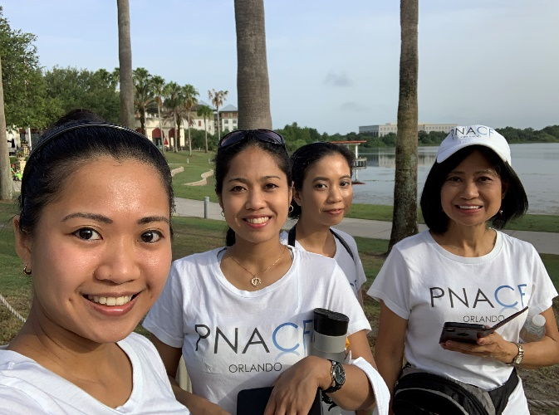
PNACF completed its PNAAF/PNAA Virtual 5K Walk/Run on July 27, 2020, 8:00 AM at Lake Baldwin Park, Florida. Our PNACF members excitedly gathered in the early morning down by the lake at Baldwin Park ready to walk or run for a great cause. This was the first time the organizations did a virtual walk, but everybody enthusiastically came together to help fundraise and sponsor the PNAAF’s missions in supporting education, research, scholarships, and community services.
Keeping in mind of COVID-19 precautions, PNACF members started the virtual walk by breaking up into smaller groups and maintaining our social distance with each other and other people round the park. We walked under the cloudy, somewhat sunny weather. Even with the Florida humidity, we managed to walked/run our way around Lake Baldwin in good spirits. In celebration of the end of the virtual walk, PNACF members took group photos and got refreshed with snacks and drinks, and lunch at Pho 88. Even though we were not at our normal 5K walk/run at the annual PNAA National Convention this year, as PNACF members, we had a great experience in this virtual walk. We were able to fundraise and sponsor PNAAF/PNAA’s programs to make a great impact in our communities and across the country.
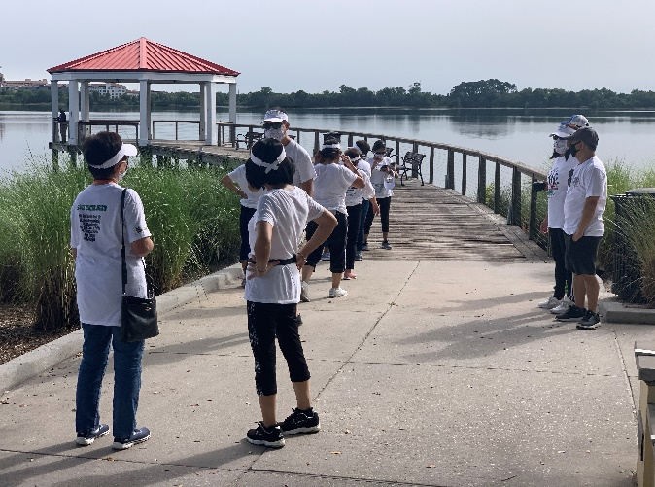
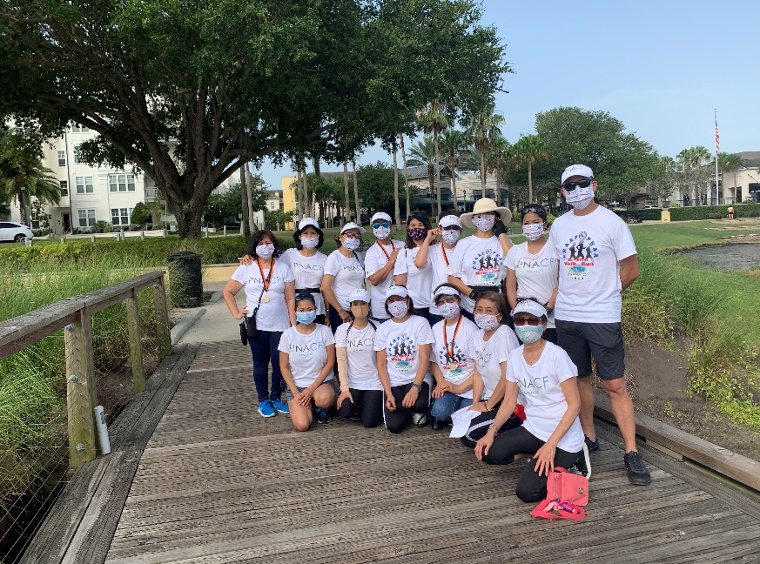

Recap: PNAA’s 1st Virtual Convention
Submitted by: Noemi Reyes BSN, RN, CNOR PNACF President 2018-2020

The 1st Virtual National Convention was a huge success even with only 8 weeks of preparation due to the cancellation of the National Convention in San Diego caused by the COVID pandemic.
The Networking Night kicked off the Convention with special guests from the GMA network Philippines. They graced the occasion with songs and messages supporting the fundraising effort of PNAA to “Heal the Nurses” campaign. This is a part of the COVID-19 Task Force Committee created by Dr. Mary Joy Dia to provide intermediate and long term programs to support the well-being of our nurses and the community. It was a successful campaign under Dino Doliente and they received $20,551 in total donations for one night.
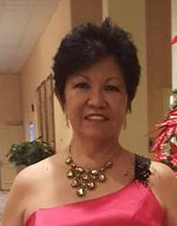
The 2nd day was the Leadership Institute and Clinical Nursing Practice. President Madelyn Yu discussed the PNAA advocacy and accomplishments of all the past Presidents followed by PNAA Foundation updates by Nancy Hoff, the PNAAF President. The incoming PNAA President Dr. Mary Joy Dia discussed design strategies for effective transition planning. She emphasized the need to identify and develop new people to assume leadership positions and the need for a comprehensive plan to be developed with an eye towards the future of the organization. Dr. Gemma Banaag talked about leadership tools for successful team management. She talked about leaders empowering people and taking ownership of the organization. She also spoke about the characteristics a leader should possess like empathy, transparency, vulnerability and intentionality.
The graduates of the iLDP class 2020 were introduced by the iLDP leads Manny Ramos and Mindy Ofiana. The graduates developed their own management plans and tools to help them become successful leaders. Our very own President-elect Alice Tullo was one of the successful graduates.
Dr. Rhigel Tan, Board Member of Nevada Board of Nursing spoke about genomics use in achieving individual treatments and optimizing drug therapy. He stated that genetics affect how medications work in our body and how it differs between individuals. Mr. Nick Macchione, Director and Deputy Administrative Officer San Diego County Health and Human Services spoke about post COVID -19 sequelae from a county perspective.
The winners of PNAA Research grants were presented by Dr. Sigrid Ladores, the Chair of PNAA Research Committee and President Madelyn Yu followed with awarding her Presidential awardees.
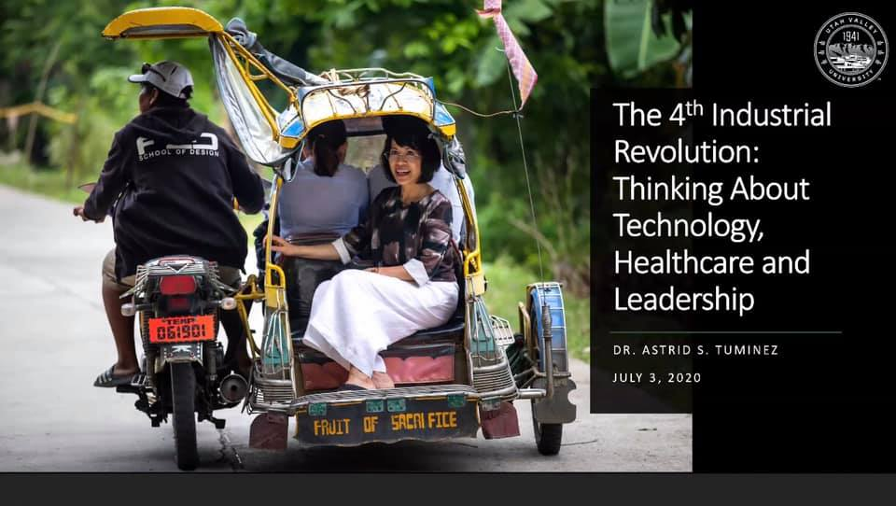
The Education Day had world class speakers. They were very engaging and informative. The President of American Nurses Association, Dr. Ernest Grant talked about PNAA becoming an affiliate member of the American Nurses Association. President, Madelyn Yu acknowledged and laid out the accomplishments of all the past presidents of PNAA. It is awe inspiring to hear what PNAA has accomplished through the years. The keynote speaker, Dr. Astrid Tuminez, the President of Utah Valley University and former Regional Director of Microsoft Southeast Asia, spoke about “The 4th Industrial Revolution: Healthcare, Technology and Leadership.” She has a very impressive and remarkable leadership style. Dr. Tuminez told us how she had caring mentors that helped and encouraged her from childhood until college. She graduated with full scholarship from the University of the Philippines. She never forgets where she came from and continuously works to help improve the lives of people in her community. She emphasized the importance of bringing resilience in our lives and having the ability to say “no” in certain circumstances.
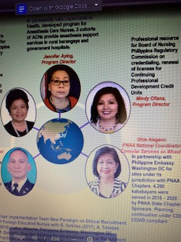
Dr. Richard Ricciardi, the President of Sigma Theta Tau International spoke about infusing joy during a global pandemic. He said the nurse’s joy can contribute to patient outcome therefore we need to instill and sustain joy in the workplace. Dr. Beverly Malone the Chief Executive Officer of the National League for Nursing talked about nurses as heroes. Dr. Danet Bluhm, Associate Professor of the School of Nursing in University of Texas Health Science Center of San Antonio talked about advocating for capacity building and engagement among Filipino Americans to improve outcomes. Dr. Marlon Saria Clinical Nurse Specialist Inpatient Oncology at Providence Saint John’s Health spoke about bridging the digital divide. It was interesting to know that we are categorized according to our technological proficiency as the digital natives (first to grow up in digital technology), digital immigrants (adopted aspects of new technology) and the digital foreigners who are new to concepts of digital technology.
President Madelyn Yu introduced the different Committee Chairs who then gave recognition to their outstanding members. Vickie Navarro, the Chairman of the Community Outreach Committee recognized our very own Virginia (Ghie) Alagano, for an outstanding job as the PNAA National Coordinator on Consular Services on Wheels. There were 4,200 total kababayans helped through the Consular Outreach sponsorship of different chapter from 2016 – 2020. The Philippine Consul General Gonzaga sent a letter to the PNAA leadership acknowledging the exceptional partnership with Ghie and the Philippine Embassy. Her guidance and counsel during the transition at the Consular Office were very much appreciated. In Addition, Ghie recently gave a virtual Infection Control and Prevention class to the Consular staff.
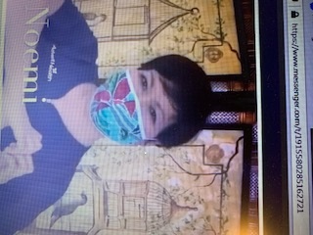
The General Assembly was the most attended day in the National Convention. Dr. Felix Jurado was the Master of Ceremonies. He talked about the two types of PNAA funds. One is the operational funds that includes awards and induction, the President’s operating expenses, website, IRS filing fee, etc. and the other is the restricted funds that includes Humanitarian services, locally and globally, grants, 5K Run, Leadership Institute, etc. Then President Madelyn Yu delivered her State of the PNAA address including all the achievements of her administration. PNAA is now an ANCC (American Nurses Credentialing Center. Each Regional Vice Presidents as well as the different committee chairs, the Treasurer, Membership chair and the Nom-elec chair took turns giving their 2- year report. The Regional COPRRs for 2020-2022 were also introduced. The highlight for me was the 2023 PNAA National Convention bidding video by PNACF. The video presentation was fun and exciting. Alice and I alternately spoke why we should be voted to host the 2023 National Convention followed by highlights from the 2017 National Convention that we successfully hosted. The video was created by the son of Manny Ramos under Manny’s direction. We won by a majority vote. So, it is official, PNACF is hosting the 2023 PNAA National Convention.
Singing tributes to our fallen comrades and to the front liners followed. President Madelyn Yu spoke and gave recognition to her Executive Board members. Scholarship Awards were given to deserving candidates. Then there was the Presidential gavel hand-off from President Madelyn Yu to Dr. Mary Joy Dia. The day ended with PNAA and CGFNS signing a resolution to encourage Filipino nurses to use ethical recruiters that have been certified by the Alliance of International Ethical Recruitment Practices and to encourage staffing and placement firms to seek certification from the Alliance. They are working to educate members and foreign nurses about immigration legislation, employment agreement and ethical recruitment practices.
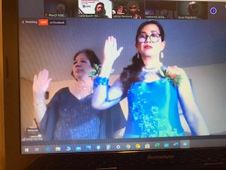
The different regions gave their best group performances virtually. The South Central Region passing of masks from the SCR COPRR Melissa Cunanan to the different Presidents ending with SCR Vice President Dr. Gloria Beriones symbolically represented the cohesiveness and the unity of the group.
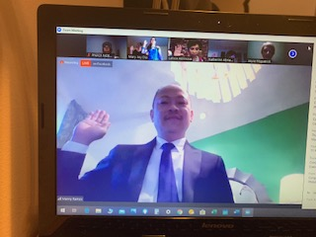
The Gala night embodied the elegance and sophistication of everyone as seen in their suits and gowns. Dr. Sigrid Ladores was the emcee and was stunning in her red gown. President Madelyn Yu gave her Presidential address and then handed out Advocacy Awards. The Nursing Excellence Awards were given by Manelita Dayon the PNAA awards chair. The keynote speaker was Wilhelmina Manzano, the Senior Vice President, Chief Nursing Executive and Chief Quality Officer of New York Presbyterian Hospital. We were serenaded by husband and wife team of Katrina Saporsantos (soprano) and Benjamin Dia (pianist). Watching and listening to them felt like we were at Lincoln Center in New York. The induction of the incoming officers was conducted by Dr. Joyce Fitzpatrick, Professor of Nursing and Inaugural director of Marian Shaughnessy Nurse Leadership Academy. Dr. Fitzpatrick was presented with an honorary membership to PNAA by President Madelyn Yu due to her years of service and collaboration with PNAA. Dr. Mary Joy Dia looked very elegant in her blue gown as she took her Presidential Oath of Office. Our SCR Vice President Dr. Gloria Beriones took oath as the President-elect and our very own Manny Ramos was inducted as a PNAA Board Member along with other officers. Manny also served as the screen master and DJ for the night.
There were toasts and dancing afterwards with the music of DJ Ramos. Attendees were having so much fun that nobody wanted to leave. It almost felt like a regular in person party as others were in their own backyard watching July 4th fireworks.
A Sunday mass culminated the most memorable National Convention. A virtual celebration of Mass was held at Our Lady of Mount Carmel in San Diego. It honored the cancer survivors, departed love ones and COVID -19 victims and survivors.
It was the most amazing 1st Virtual National Convention. All attendees were energized by the speakers especially by Dr. Tuminez who exemplified rags to riches story and never forgets to pay it forward. This National Convention embodied learning, awards and recognition, friendship, fun, excitement being in the company of intellectual and scholarly people. It was the most memorable PNAA National Convention in the history of PNAA and the very first virtual one.
See you all in the 2021 Virtual PNAA National Convention in New England!

What’s in It for Me? Helpful Hints in Successful Recruitment and Retention
Submitted by: Lorelie Sta Ana-Perez BSN, RN PCCN

‘What’s in it for me?’, is the question most people ask when they are being recruited to become a member of an organization. In other words, “When I pay my dues what do I get in exchange?”. For a new recruiter, the question can be intimidating and might take few seconds before the recruiter can think of something to say. The hesitancy can be perceived by the potential member as a lack of positive things in the organization and will decline the invitation.
Most experts will say that an organization goes through a growth phase after it is established but, without the commitment or lack of engagement from its members, it will fail within 5 years. PNACF, as an organization, was no exception to this statistic. In fact, after 5 years from its inception in 2000 it went dormant for 4 years. In 2009, it was resurrected with a different focus and to this day it continues to adjust with the times.
It appears PNACF is going strong and has passed the 5 year “itch” multiple times. Yet, despite its success, recruitment and retention of members continue to remain a challenging task. In Orlando and nearby cities, there are thousands of Filipino nurses working in different institutions, in various specialties and diverse positions. However, the members of PNACF represent only a fraction of this population. Thus, begs the question: Why is it so difficult to recruit or retain members in an organization?
According to research, lack of communication, family activity and lack of time are the top reasons in the decline in membership in several nursing organization (White and Olson 2004). However, with careful planning and practice we might still be able to win them over.
What did I learn as chairman of the PNACF Membership Committee?
- You need to know our organization well. Do you know the Mission and Goals by heart? Why do we exist? What is our purpose? We should be able to tell our recruits how our organization differentiates from the others. Helpful hint: Practice what you will say if someone asks you the question.
- Establish rapport. Once rapport is established, subtly start introducing the organization. Remember, these recruits are normal people. Would you rather join an organization of a new friend or an aggressive recruiter? Helpful hint: People will forget what you did but won’t forget how you made them feel (Maya Angelou).
- Be prepared to actively recruit. Every missed opportunity is a lost member. When I was the chair of membership committee, I carried several membership brochures at all times. At any chance, I would take the opportunity to introduce someone to our organization. If they showed any interest in membership, I would immediately process and register the recruit. Helpful Tip: Always try to recruit on the first encounter. Don’t let them go home to ponder and change their mind.
- Be persistent. Asking once or twice may not be enough to convince someone to join. Gloria, a member of our Executive Board, is one of our top recruiters. Through her diligence, she was able to accomplish her 3-year journey in recruiting an important candidate as a member of PNACF. Helpful hint: Incentivize members, e.g. free one-year renewal fees or free tickets to association events if they recruit certain number of members. It can bring out the competitive side of members.
- Expand on sought-after benefits with your recruit. When your recruit asks the question: “Why should I join?” Instead of immediately enumerating the benefits, ask the simple question: “What are you looking for in an organization?” A typical recruit may seek educational offerings, community service opportunities or may simply want to strengthen their resume and move up the clinical ladder, etc. Utilize their answer as a selling point to catch their attention. Then you can expound on what other benefits we are offering. Helpful hint: It is important to catch their attention first. Then, be sure to frequently remind them of these benefits.
- Follow-up and continue to build rapport. In any organization, a member is more inclined to participate the more comfortable they feel. It is important to make members feel included and not conned for their money. Use this opportunity to invite new members to social settings. Social settings will later translate to organizational settings i.e. assembly or executive board meetings. Helpful hint: Remember you are their point of contact and members will incline to respond to you than someone they do not know.
- Translation. How do we move from a social setting to an actively engaged member? Invite them to attend one of the EB meetings. Let them witness what we do, why we do it, how we do it and when do we need to have it done. Ask their input. It will stir their interest if they are part of the planning and know their ideas are considered in the process. Helpful hint: This will be a great opportunity to ask them to join in one of the standing committees.
- Work continuously to enhance any events. Plan way in advance to be able to invite credible speakers, interesting topics to draw in attendees. Be creative and introduce new activities and entertainment to make them come back year after year. Remember our leadership retreats? First, we camped when none of the other 50 PNAA chapters had done before. Then, we followed with a cruise and brought in our activities with what was available on the island. Didn’t we have so much fun and non-stop laughing? Then we camped more and did a scavenger hunt under the nature’s canopy. We closed the event competing in the pool which brought more laughter. We were exhausted but our hearts were full of joy. Helpful hint: Allow members to bring free guests to some of our activities to convince someone new to join the association. The key phrase is to prepare early, advertise early and communicate early.
- Communicate often through e mails, text, phone calls, traditional mail, social media and website. Helpful hint: It is important that our website is up to date on the latest news, events and other offerings.
- Feedback is a good way to tell us what we are doing right or what we are doing wrong. After they signed up it is important that 6 months later, we go back to them and say, “You mentioned when we first invited you to join us that being… is important to you as a member. “Are we meeting your expectation? It shows that we are listening to their needs and may even tell their friends about it and a means of recruitment.
Helpful hint: Don’t let their membership lapse before getting their feedback then it might be too late to retain them.
Equally important is to pay attention to the negative feedback. Recently, we conducted an anonymous survey of our members to give us perspective on what our members are feeling or thinking about our association. Expectedly, most of the responses are very favorable. One interesting comment though was “PNACF leaders and officers tend to congregate only with their fellow officers.” Do you remember when you were a kid and your parents bring you to an event where you didn’t know anyone? You might be looking at some kids playing and felt bored and you could not wait to go home. Until a kid approached you and ask you to join them, then you cried when it’s time to go home. Helpful Hint: Play musical chairs during social gatherings so each EB will have a conscious effort to have personal interaction to new faces, and seldom seen faces.
- But most of all don’t forget – “work hard, play harder!”
These helpful hints seem to be a lot but with practice and conscious efforts, recruitment should come naturally. Now are you ready to answer when someone asks you “What is in it for me?”

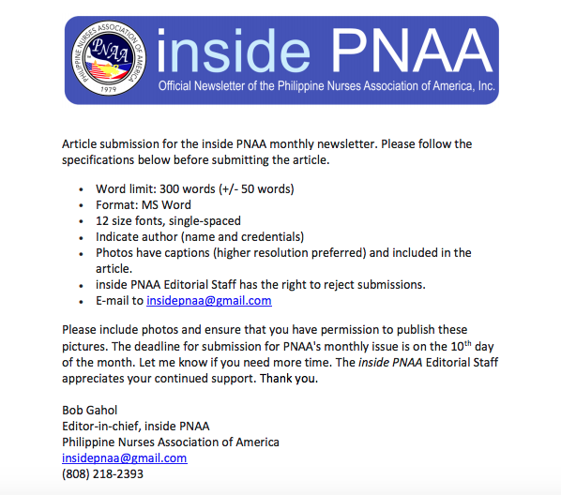
CALLING FOR SUBMISSIONS!

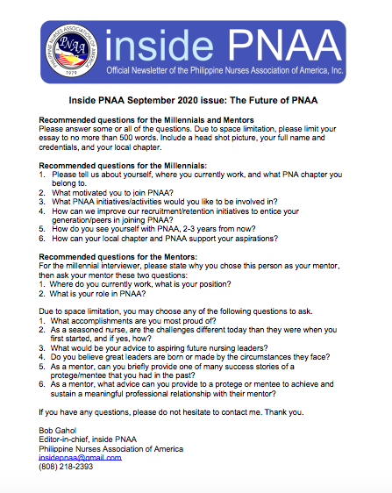
ARE YOU A MILLENIAL AND A MEMBER OF PNAA? HELP US OUT!

