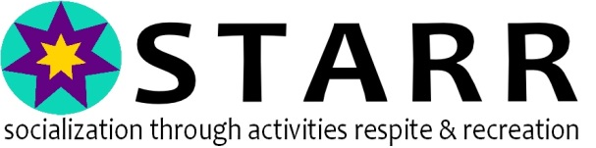

We are Growing Strong! We hope you are as excited as we are!

We are honored that you are considering serving with us on the STARR Leadership Team. We hope you will consider this a wonderful way to give back to your community. We love who we serve, what we do and hope you will too.

If you are able to serve on the STARR Leadership Team, would you please consider helping us develop or lead one of our new committees to join us in our efforts to fulfill our mission and meet our Short & Long Term Strategic Goals? If you are interested in being a volunteer, one of our team members will contact you shortly to talk about how to get started making a difference in the lives of the clients we serve.

Our Mission:
STARR is dedicated to providing intellectually or developmentally challenged adults with superior programs that promote social skills through activities and respite for individuals and their families.

Our Vision:
STARR will be recognized regionally as the foremost leader and model for Recreation and Respite Programs for intellectually and developmentally challenged adults by 2020, and STARR will own its own building in which to conduct all operations by 2027.

We expect to meet 10 times during 2018 for board meetings that run 2 hours at the most. We typically meet the 3rd Thursday of each month from 5-7 PM. We usually meet at the Placerville Raley’s Conference Room.

January 18 February 15 March 15 April 19 May 17
June 21 August 16 September 20 October 18 November 15
NOTE: July & December are Dark

We ask all board members to lead or be highly active in at least one of the following committees for at least 6 months before considering becoming a member of our Board of Directors. We look forward to hearing which team you feel you can be a positive influence on and participate in their activities:

Fundraising – Annual Fundraiser/Special Events/Ongoing Donor Support
Volunteer Coordination – Volunteer Recruitment for Ongoing and Special Events
Capital Campaign – This is a long range planning committee.
Marketing – Social Media/PSA’s, Print Ads, Newsletters and Flyers, etc.
Program Support Committee-This is a direct client services & family support team
Trip Committee – This committee plans and executes strategies for any special trips for STARR
Ambassador Team – This is a special team. Working directly with clients & the community.

One of our goals is to recruit many more volunteers to help define, design and implement strategies for each of these teams over the next six months. We currently have a strong band of warriors, but need more hands to help us grow to our goals. We will be working to grow stronger every year while we continue to provide unique, high quality programs and services to our community.

To get started, please email us at info@starrprogram.org. We invite you as a guest to join any of our board meetings. Alternatively, come to one of our fun events and check out details on our website: www.starrprogram.org. Come get to know us; we hope you will find your passion to serve with us!

Thank you so much for your consideration,
The STARR Board of Directors

