

**“An**

**Old Hollywood**

**Soiree”**

“

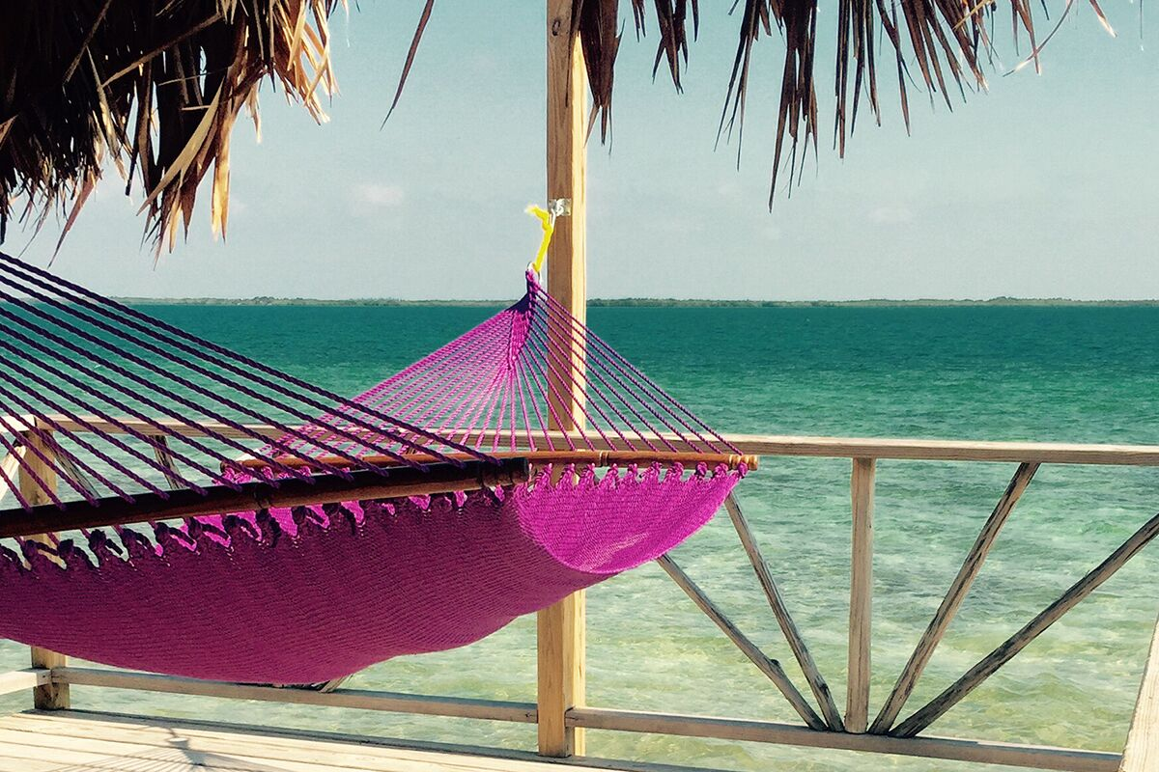

Auction Catalog

## https://www.cityofsouthlake.com/images/InfoAdvanced/206/FirePatchNoBackground.gif

**Our Mission:**

*"To provide a premier, not-for-profit*

*AMI Montessori program*

*that fosters the unique academic, social and*

*personal development*

*of each student*

*and motivates them for a lifetime of*

*learning and success."*

## 

## Welcome!

## Dear Southlake Montessori Families and Friends,

## Welcome to “An Old Hollywood Soiree” Southlake Montessori Auction Event! We are so very grateful to each of you for supporting Southlake Montessori’s vision…

## “To cultivate the development of children,

## Using AMI Montessori principles,

## To become adults who contribute as leaders to the world’s greater good

## With integrity, compassion and global consciousness.”

## As our third school year comes to a close, we reflect on this important end of our first “three-year cycle” as a school community. What an incredible ride this has become with growth from 12 students our first year to ending this third year serving 47 greater Southlake children! AND, we will begin next year with more than that!

## Our annual auction is not only, by far, our largest fundraiser of the year allowing us to continue to provide an authentic Montessori education for more and more children in the greater Southlake area, but it is also our greatest opportunity to build community through great food, exciting bidding and a shared dedication to our children.

## We thank you for your support this evening and hope that you have an incredible time!

## And…. don’t forget…. BID HIGH AND BID OFTEN!!!

## With our deepest gratitude and appreciation,

## Your Southlake Montessori Board and Staff

## Coming Attractions

## 6:00 | Welcome

## 6:00 | Hors d’oeuvres & Silent Auction

## 7:00 | Silent Auction Begins to Close

## 7:30 | Thank yous and Introductions

## 8:00 | LIVE Auction

## 9:00 | Proceed to Close-out… THANK YOU!!

## Credits

## We absolutely owe any success of this event to the following tireless, ultra-enthusiastic, ultracapable, invaluable volunteers:

## **Susan Bierrenbach Katrina Frank Cherie Morgan Emily Roberts Danielle Tucker**

## AND, of course, a HUGE thank you to our staff for all their work and contributions to tonight’s event!

## C:\Users\Debby\AppData\Local\Microsoft\Windows\INetCache\Content.Word\HollywoodCurtainFrame.jpg**WALK OF FAME SPONSOR:**

## cid:E9DCB893-35C0-47C1-ACA2-2306239098AA@fios-router.home**Dr. & Mrs. Dan Bartel**

*Thank you, Southlake Montessori,*

*for providing a wonderful education*

*for our grandson Grant!*

*~Dr. and Mrs. Dan Bartel*

## C:\Users\Debby\AppData\Local\Microsoft\Windows\INetCache\Content.Word\HollywoodCurtainFrame.jpg

## **Additional Credits**

## **Leading Actor Sponsor**

## Brad & Christy Putty

## **Supporting Actor Sponsors**

## Chris Trahan & Misty Barnett

## Susan & Chris Bierrenbach

## Cherie & John Morgan

## **Our Donors:**

## Fossil The Nagengast Family Malouf’s Southlake

## Grapevine Vintage Railroad Hilton Dean & DeLuca Invitational

## Sky Ranch Camps School of Rock Southlake/Keller iL Calabrese Ristorante & Bar

## Feedstore and More BBQ Southlake Brio Tuscan Grille Capital Grille

## Chick-fil-A The Classic at Roanoke Costco Warehouse

## Taziki’s Mediterranean Café Luna Grill, Southlake Nothing Bundt Bakes

## The Bierrenbach Family iFratelli, Southlake Menchies Frozen Yogurt

## Pei Wei, Southlake Taverna Rossa Central Market

## Dallas Symphony Orchestra Dinosaur World Hall Music Productions

## Emily Roberts/Susan Bierrenbach Texas Ballet Theatre Main Event

## Medieval Times Dinner & Tournament WaterTower Theatre NRH2O Family Water Park

## Ft. Worth Log Cabin Village Perot Museum of Nature and Sciences Lone Star Park at Grand Prairie

## Las Colinas Symphony Orchestra Dallas Zoo FC Dallas

## Trophy Club Country Club, Corey Clarkin Dallas Arboretum Texas Star Golf Course, Euless

## Fort Worth Zoo Lone Star Brahmas Painting with a Twist

## JumpStreet Dana’s Studio of Dance, Southlake K1 Speed

## Three Dog Bakery Sweet & Sassy, Southlake The Art House, Southlake

## The Toy Maven FlyKids Yoga Gymnastics Plus

## Vetro Glassblowing Kimbell Art Museum The Tucker Family

## Fireplug Inn Robin Jackson Photography Spicar’s Martial Arts

## Corinthian Wellness Spas The Boardroom Salon for Men Nicole Lockhart, Purely Pilates

## Live Auction

##### HHEADS OR TAILS IS BACK!!!

Before we start our serious bidding, join us for a game of Heads or Tails! $10 a round buys you a chance for a Fossil package worth over $500. Included in the package are TWO Fossil Smart Watches and a pair of Fossil Aviator sunglasses. $20 a round guarantees that you move on! The game will be explained more fully before we begin, but just be prepared to have some fun!

*Donated by: Fossil*

##### Head of School for a Day

Does your child ever wish they could be Head of School? Do they ever wonder… what exactly does Mrs. Riordan do? The winner will join Mrs. Riordan for the day learning what happens behind the scenes at Southlake Montessori school. Lunch with Mrs. Riordan, a collection of some valuable desk items, business cards and an honorary name tag included!

*Donated by: Southlake Montessori*

##### Picnic for Two with Mrs. Brohi

Win this item and a lucky child and a friend will get to spend some quality time with Mrs. Brohi enjoying a picnic lunch at a local park. The picnic lunch will be provided by Mrs. Brohi. Date and time to be coordinated with Mrs. Brohi. Yogi the Bear and Boo, Boo are not eligible for this prize.

*Donated by: Mrs. Brohi*

##### http://static.rukkus.com/seatmap/642fcc57a1b24036e04c9cc1387410e316641b86147423d21d223775/rangers-ballpark-in-arlington_Rangers%20Ballpark%20in%20Arlington_Seating_Chart.b3a0b01973ee.pngTexas Rangers vs. Houston Astros

After tonight, a lucky winner will be holding four (4) tickets AND a parking pass to the Texas Rangers vbs. Houston Astros game on June 3rd, 2017. Red star indicates your seats behind home plate: Section 30, Row 8.

*Donated by: The Bierrenbach Family*

**Texas Rangers vs. New York Yankees**

Miss out on the Astros Game, or a die-hard fan that wants to see the Yankees and the Texas Rangers play ball, too? Four (4) tickets on September 9th, 2017, make this wish a reality. Same FANTASTIC seats behind home plate with a parking pass. Section 30, Row 8.

*Donated by: The Bierrenbach Family*

Skelatonized Leaf Art

Using a bit of science and a lot of care, the Southlake Montessori Elementary has created this breathtaking work of art by skeletonizing leaves. A unique, one-of-a-kind piece that would look beautiful in any room of your home.

*Donated by: The Southlake Montessori Sequoia Elementary Students*

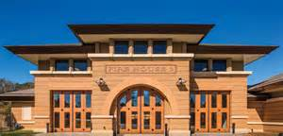Lunch with the

Southlake Firefighters

Need we say more? One VERY lucky child will get to choose to have lunch with the Southlake Firefighters at Southlake Montessori or at the Fire Station. T-shirt and goodies from the firefighters included.

*Donated by: City of Southlake, Fire epartment*



Lunch Courtesy of Ms. Chase

Ms. Chase will treat one lucky winner to lunches for a week! This sounds like a win-win for parents and students alike! Yum, yum!

*Donated by: Ms. Chase*

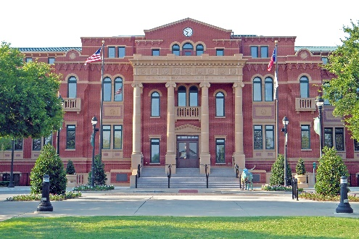Southlake Mayor for a Day

Future leaders of Southlake, this one is for you! The winner will have the opportunity to meet Mayor Laura Hill at Southlake Town Hall for a tour of the city departments, photos and refreshments!

*Donated by: City of Southlake, Mayor Laura Hill*



Five Nights in Belize…

Need We Say More???

Five-night stay for two (2) at Thatch Caye in beautiful Belize. Rest and Relaxation package also included: Three daily meals, local alcoholic and non-alcoholic beverages, boat transfer, marine reserve fee, use of kayaks, paddleboards, snorkel gear and fishing poles. Excludes Easter, Thanksgiving and New Year’s Week.

*Donated by: Kalypso’s, Bill Posten & George Young*

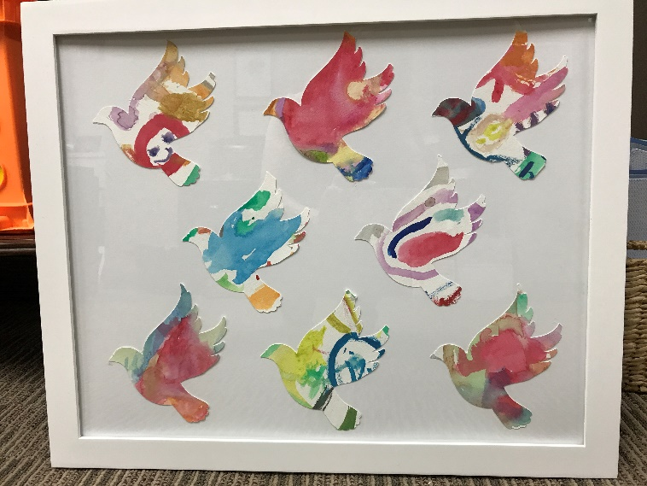

Peace and the Magnolia Classroom

Eight beautiful doves made from the work of Mrs. McLaughlin’s Magnolia classroom Primary students fly in peaceful unison in this remarkable piece. Dr. Montessori would be pleased.

*Donated by: Magnolia Primary Students*

Lunch with a Southlake Policeman

Miss out on Lunch with the Firefighters or just prefer to dine with one of Southlake’s finest, now is the time for you to bid high and bid often! One lucky child has the opportunity to have lunch with their favorite Southlake Policeman! T-shirt and some goodies included.

*Donated by: The City of Southlake, Police Department*

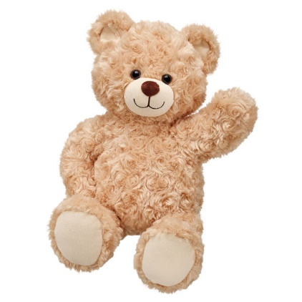 Build-A-Bear Trip with

Mrs. McLaughlin

One lucky child will join Mrs. McLaughlin on a trip to Build-a-Bear Workshop at Grapevine Mills mall and enjoy a sweet treat in the food court afterwards. Limit $50 on workshop, $5 treat. Parent MUST attend. To be scheduled on a mutually convenient date in June or July 2017.

*Donated by: Mrs. McLaughlin*



Our Roots Remain One

“Like branches on a tree, we may grow in different directions, but our roots will always remain as one.” Incredible representation of this quote with Mrs. Brohi’s Gardenia Classroom students’ handprints lovingly placed as leaves on a unifying tree. Priceless!

*Donated by: Gardenia Primary Students*

Our “School”

Each little (and not so little!) handprint fish in this colorful work represents a moment in time in the life of our Southlake Montessori students. All working together SWIMMINGLY!

*Donated by: The Students of Southlake Montessori*

Hollywood Hotspot

##### Byron Nelson

Tee up! Winner will enjoy four passes to the AT&T Byron Nelson, held from May 17 to May 21, 2017. The AT&T Byron Nelson brings together top touring players from around the world, all with their eyes on the same prize.

*Anonymous*

*Value: $200*

##### Hall of Fame

Framed Ivan “Pudge” Rodriguez signed jersey with Hall of Fame patch.

*The Nagengast Family Value: $450*

##### Custom Tailored Suit

Let Malouf’s refresh your wardrobe with an updated suit from Samuelsohn. Malouf’s will complete your look with a complimentary dress shirt and tie. Malouf’s has been helping men look their best since 1949.

*Malouf’s Southlake Value: $2150*

##### All Aboard!

Winner will enjoy a private, behind the scenes tour for your family at the Grapevine Railroad. The tour will last approximately 45-90 minutes, and will include tours of the train, grounds and roundhouse. Perfect for the train enthusiast in your life! Photos prohibited. Please call in advance to schedule. Tour cannot coincide with special events or holidays.

Expires 12/31/17.

*Grapevine Vintage Railroad*

*Value: Priceless*

##### Staycation at the Anatole

Get away for the night and enjoy a one night stay for two at the Hilton Anatole, which also includes breakfast for two at the Terrace. Spanning 45 lush acres, just north of downtown, Hilton Anatole is a Dallas icon in the vibrant Design District. Discover our indoor and outdoor facilities including V Spa, Verandah Health Club and the new JadeWaters resort pool. Not valid on Thursdays, Fridays or Saturdays between Memorial Day and Labor Day. Expires 5/5/18.

*Hilton*

*Value: $250*

##### Dean & DeLuca Invitational

Watch Chris Kirk, Jordan Spieth and Ryan Palmer tee off the competition with two weeklong ground passes at The Colonial Country Club in Ft.Worth, May 24 to May 28, 2017. Redeem at a specified entrance to the event, NOT the will call office.

*Dean & DeLuca Invitational*

*Value: $250*

##### Summer Campers

Enjoy one week of 2017 summer camp tuition at Sky Ranch Summer Camp in Van, TX. Sky Ranch holds weekly camps for grades K-9, and offers children a life-transforming adventure and a fun, safe, Christ-centered environment in which to learn, explore, and grow.

*Sky Ranch Camps Value: $1,089*

##### Let’s Rock!

Your little rock star will enjoy one Rock 101 summer camp at School of Rock Southlake/Keller location. The performance-based camps incorporate songs, performing, musical games/activities, and team building exercises as a way to teach music theory, and how to rock out as a real band! Valid through 4/1/18.

*School of Rock Southlake/Keller Value: $549*

# Food & Beverage

##### Party of Six!

Enjoy an expertly prepared dinner for six at il Calabrese in Southlake. You and five guests will enjoy excellent Italian cuisine while dining in a relaxing atmosphere. Choose from regular menu and preselected wine options. Gratuity not included.

Reservation must be made 14 days in advance. Expires 5/5/18.

*iL Calabrese Ristorante & Bar Value: $450*

##### Feedstore BBQ

Take the night off of cooking and enjoy dinner for four! This package includes four meat or sandwich plates, four non-alcoholic beverages, and four desserts.

*Feedstore and More BBQ, Southlake*

*Value: $150*

##### Brio Tuscan Grille

Enjoy a $50 gift certificate towards your dinner at Brio in Southlake Town Square. Alcohol and gratuity excluded. Expires 2-22-18.

*Brio Tuscan Grille Value: $50*

##### Capital Grille

Enjoy fine dining with this $150 to the Capital Grille Uptown

*The Bierrenbach Family*

*Value: $150*

##### Chick-fil-A

Enjoy a gift basket from everyone’s favorite restaurant! Basket includes: insulated lunchbox, plush cow, calendar, headphones, notepad, cup, sunglasses and gift cards.

*Chick-fil-A Value: $100*

##### The Classic at Roanoke

Enjoy this $50 gift certificate to The Classic at Roanoke. The Classic at Roanoke was recently awarded the Trip Advisor® *Certificate of Excellence 2015* and OpenTable® *Diner’s Choice 2015*.

*The Classic at Roanoke*

*Value: $50*

##### Costco

Enjoy $25 off your next Costco-run!

*Costco Warehouse*

*Value: $25*

##### Taziki’s Mediterranean Cafe

Enjoy this $30 gift card. The Mediterranean-inspired menu has a bit of a southern accent, and is made from scratch every day.

*Taziki’s Mediterranean Cafe*

*Value: $30*

##### Luna Grill

Enjoy a $250 gift certificate towards Luna Grill Catering. Perfect for office, birthday or upcoming holiday parties!

*Luna Grill, Southlake Value: $250*

##### Nothing Bundt Cakes

A beautifully decorated cake and coupon booklet for “Cake of the Month” for 12 months.

*Nothing Bundt Cakes, Southlake Value: $220*

##### Wine Basket

*The Bierrenbach Family Value: $180*

**Cheesecake Factory**

Enjoy this $50 gift card on something delicious from the Cheesecake Factory!

*Cheesecake Factory*

*Value: $50*

##### iFratelli

Friday night pizza night a little easier with these gift certificates for four free pizzas!

*iFratelli, Southlake Value: $60*

##### Menchies Frozen Yogurt

Enjoy one gift certificate for a free frozen yogurt cake. Perfect for your next birthday party!

*Menchies Frozen Yogurt, Park Village*

*Value: $25*

##### Pei Wei

Take your $40 in gift cards and enjoy a family night out at Pei Wei!

*Pei Wei, Southlake*

*Value: $40*

##### Taverna Rossa

Enjoy dinner for four including two stone-fire pizzas, four small salads, one Vinnie’s cheese bread and four non-alcoholic drinks.

*Taverna Rosa*

*Value: $73*

##### Central Market

Enjoy a $100 gift card to Central Market Southlake.

*Central Market Value: $100*

**Great Harvest**

Enjoy this Great Harvest gift basket which includes a beautiful tea towel lined basket filled with fresh loaves of our Honey Whole Wheat and Cinnamon Chip breads, a jar of Honeyville Whipped Honey, a 3-pack of our famous cookies and one of our “Bread for a Year” cards. This card is good for 1 loaf of fresh bread every month for an entire year. The only way to get one of these wonderful cards

is in our Donation basket!

*Great Harvest*

*Value: $160*

Entertainment & Recreation

##### Medieval Times

Travel through the mists of time to a forgotten age and a tale of devotion, courage and love at Medieval Times Dinner & Tournament with these two general admission tickets valid Sunday through Thursday. Enjoy a “hands-on” feast as the dynamic performance unfolds before you.

*Medieval Times Dinner & Tournament*

*Value: $120*

##### WaterTower Theatre

Enjoy two tickets to a performance of *Native Gardens.* Gardens and cultures clash, turning friendly neighbors into feuding enemies in this funny Regional Premiere, written by Karen Zacarias, one of the most prominent Latina playwrights working today. Show runs from June 2-25th. Not valid for Saturday evening performance.

*WaterTower Theatre*

*Value: $60*

##### NRH20 Family Water Park

Beat the summer heat with two, one-day admission passes (Monday through Thursday) to NRH2O for the 2017 season.

*NRH20 Family Water Park*

*Value: $56*

##### Ft. Worth Log Cabin Village

Explore 19th Century Texas with four admission passes to the Ft. Worth Log Cabin Village. The Village is a living history museum devoted to the preservation of Texas heritage and history.

*Ft. Worth Log Cabin Village*

*Value: $22*

##### Perot Museum

A family four-pack, with four ticket vouchers for admission to general exhibits at the Perot Museum of Nature and Science. Five floors house 11 permanent exhibit halls containing state-of- the-art video and 3D computer animation with thrilling, life-like simulations where visitors can exercise their brains through hands-on activities, interactive kiosks and educational games.

*Perot Museum of Nature and Science*

*Value: $76*

##### A Day at the Races

And they’re off! One lucky winner receives two Track-Packs complete with preferred parking, two general admission tickets and two coupons towards a daily program to Lone Star Park in Grand Prairie.

*Lone Star Park at Grand Prairie Value: $46*

##### Las Colinas Symphony

Two winners will enjoy the gift of flexibility with a Flex Ticket package that allows you to use eight tickets however you want and whenever you want based on availability!

*Las Colinas Symphony Orchestra*

*Value: $130 each*

##### Dallas Zoo

Enjoy two adult passes and two youth passes to the Dallas Zoo! Visit great exhibits like the Giants of the Savannah, Wilds of Africa and the new Nature Connects exhibit.

*Dallas Zoo Value: $54*

##### FC Dallas

Enjoy four tickets and a parking pass to be used for one FC Dallas home game during the 2017 regular MLS season.

*FC Dallas Value: $128*

##### Golf Lessons

Enjoy four (4) 30-minute golf lessons at Trophy Club Country Club with a club Pro. Corey Clarkin is a Class-A member of the PGA, has over 2,000 hours teaching experience, and is a member of the TaylorMade®/Adidas® Golf Professional Staff.

*Trophy Club Country Club, Corey Clarkin*

*Value: $360*

##### Dallas Arboretum

Enjoy four complimentary passes for admission to the Arboretum. Explore over 20 beautiful gardens and pavilions at this award-winning Dallas treasure.

*Dallas Arboretum*

*Value: $60*

##### Texas Star Golf

Fore! Enjoy a complimentary weekday round for two at Texas Star Golf Course. Certificate includes two green fees with cart. This challenging course has been highly ranked by *Golf Digest*, *Golfweek*, the *Dallas Morning News* and *T&L Golf*.

*Texas Star Golf Course, Euless Value: $125*

##### Fort Worth Zoo

Explore over 20 exhibits and see over 500 species, including the world- famous *World of Primates* and *Texas Wild!* at the Fort Worth Zoo. Enjoy two complimentary adult admission passes.

*Fort Worth Zoo Value: $28*

##### Lone Star Brahmas

Enjoy four ticket vouchers for two seats each to watch Lone Star Brahmas Hockey, the 2015 NAHL South Division Champions!

*Lone Star Brahmas Hockey Club Value: $104*

**Main Event**

A $25 gift card to spend at Main Event on one of the many, many activities available!

*Main Event*

*Value: $25.00*

##### Painting with a Twist

Looks like art, feels like FUN! You BYOB and snacks, Painting with a Twist provides everything else for you to explore your creativity. Enjoy two certificates valid towards registration for events at the Grapevine location.

*Painting with a Twist*

*Value: $70*

**Dallas Symphony Orchestra**

Certificate redeemable for 2 tickets of your choice to a TI Classical Series Dallas Symphony concert. Expires 5/31/18.

*Dallas Symphony Orchestra*

*Value: $160*

**Dinosaur World**

Two complimentary passes for park admission. Expires 12/31/17

*Dinosaur World*

*Value: $25.50*

**Hall Music**

Gift certificate good for 1 month of 30-minute private music lessons for piano, guitar, voice, drums, songwriting, brass, woodwinds or violin.

*Value: $135*

**Texas Ballet Theatre**

2 box seat tickets to Texas Ballet Theatre's performance of Alice in Wonderland" on 5/20/17.

*Texas Ballet Theatre*

*Value: $330*

**Great Gathering-Ladies Bunco Night!**

Join Emily Roberts and Susan Bierrenbach for a night of food, fun and prizes at ladies Bunco Night, Friday, May 19th at 7:00p.m. You’ve never played Bunco? No problem! It’s a quick and easy dice game and we will provide instructions and prizes for the winners. There are only 22 spots available so hurry and get yours fast!

*Emily Roberts and Susan Bierrenbach*

*Value: A Night to Remember!*

For the Kids

##### JumpStreet

Need to burn off some “kid energy?” Enjoy two tickets, each for one-hour basic jump at any JumpStreet location.

*JumpStreet Value: $30*

##### Dana’s Studio of Dance

Free registration for new students. Perfect for your tiny dancer!

*Dana’s Studio of Dance, Southlake*

*Value: $45*

##### K1 Speed

Do you feel the need for speed? Enjoy two gift cards each good for one, fourteen lap race and license. Junior drivers must be 4’ tall and adult drivers must be at least 4’10’’ tall.

*K1 Speed Value: $56*

**Pastry Chef Experience**

Your little chef will love this package! Winner will receive a one hour personal baking session to create all natural dog treats for the family pooch.

*Three Dog Bakery Value: $275*

##### Sweet & Sassy

Your glittery-girl will love the Glittery Glam Makeover! Package includes a party up-do, polish, shimmery make-up application, glitter hearts or stars and a gourmet lollipop.

*Sweet & Sassy, Southlake*

*Value: $30*

##### Art House

Enjoy 50% off a birthday painting party for eight. With an hour of painting and an hour of party, it’s the perfect combination for a great day! After step-by-step instructions, each guest will take home their own 8x10 canvas painting they painted themselves.

*The Art House, Southlake Value: $120*

##### Toy Maven

Enjoy two $25 gift certificates to The Toy Maven in Southlake.

*The Toy Maven*

*Value: $50*

##### FlyKids Yoga

One-hour custom yoga class for up to 12 participants with a theme of your choice. Offer also includes a small treat after class!

*FlyKids Yoga*

*Value: $200*

##### Gymnastics Plus

A child’s large leotard from Elite Sportswear, L.P. with matching hair accessory.

*Gymnastics Plus Value: $45.50*

**Little Gym**

Gift certificate good for 1 month of classes and an annual membership for children ages 4 months to 12 years. Expires 12/31/17.

*Little Gym*

*Value: $129*

For the Home

### Glass Bowl

*Vetro Glassblowing Cherie Morgan*

*Value: $250*

**Kimbell Art Basket**

Gift basket including five catalogs of beautiful works from the artists such as Picasso, Matisse, Botticelli, and Caillebotte., as well as 50 blank Musee d’Orsay postcards and two France Kimbell Fest t-shirts.

*Kimbell Art Museum Value: $242*

**Signed Football**

Pro Football Hall of Fame member and Buffalo Bills Quarterback Jim Kelly signed football.

*The Tucker Family*

*Value: $350*

**Signed Photo**

International Tennis Hall of Fame member Jimmy Connors framed and signed photo.

*The Tucker Family*

*Value: $150*

**Fireplug Inn**

Certificate good for 3 free nights for your small dog (under 25 lbs.). No expiration date.

*Fireplug Inn*

*Value: $114*

**Robin Jackson Photography**

11x14 Family Portrait package with one hour of retouching. To see a slide show of Robin's portraiture, go to http://rjackson1.photobiz.com/viewing. Robin makes the portrait session fun and easy! Pets are welcome. Our gift certificates do not expire. Session can be at your home or at one of Robin's beautiful outdoor locations in Dallas, Fort Worth, Waco, Austin, San Antonio, Corpus Christi, Houston, Albuquerque & surrounding areas. Our clients are never pressured to make additional purchases. Call Robin with any questions: 214-356-4969

*Robin Jackson Photography*

*Value: $114*

Health & Beauty

**Martial Arts**

One month for you and a friend, sibling or parent at Spicar’s Martial Arts. We have the ultimate way for your child to build confidence, self-

esteem, develop self-discipline, self-control, and athletic skills, while having lots of fun through martial arts!

*Spicar’s Martial Arts, Southlake*

*Value: $169*

**Martial Arts birthday party**

Enjoy one free basic birthday party for up to 15 guests. Every minute is filled with fun action, games, and more!

*Spicer’s Martial Arts*

*Value: $249*

**Dragonfly Delight Spa Package**

Begin your day of relaxation with an aromatherapy foot soak, followed by a 50-minute custom massage and an 80-minute Radiance Facial.

*Corinthian Wellness Spa*

*Value: $228*

**The Boardroom**

One gift certificate for The Benchmark Haircut which includes a personal consultation, tailored cut, rejuvenating paraffin hand dip, scalp massage, pressure-point facial massage, steamed towel and a stress relieving hand massage. Also included: a koozie and two samples of TurboWash cleanser

*The Boardroom Salon for Men*

*Value: $60*

**Giggles and Grins**

Enjoy a gift basket containing a certificate for a free dental cleaning and fluoride treatment as well as toothbrushes and floss!

*Giggles and Grins Pediatric Dentistry, Southlake*

*Value: $350*

**Divine Yoga**

Whether you practice Yoga or you are just beginning, this package is for you! Enjoy three walk-in classes of Yoga at Divine Center of Yoga.

*Divine Center of Yoga, Southlake*

*Value: $51*

**Camp Gladiator**

Two winners will receive one complimentary four-week camp! Choose from a variety of times and locations to suit your busy schedule.

*Camp Gladiator DFW Value: $189 each*

**SunstoneFIT**

Two winners will enjoy one certificate good for one month unlimited class pass at any studio

*Sunstone FIT*

*Value: $200 each*

**doTERRA**

Basket of doTERRA products including anti-aging moisturizer, cleaning concentrate, and four bottles of essential oils including: TerraShield natural bug spray, DigestZen, Oregano, and Lemon & Rosemary.

*Cherie Morgan Value: $115*

**LifeSpa**

Enjoy two gift certificates: one for a 60-minute massage with Jenna, and one for a 60-minute custom facial with Amy.

*LifeSpa, Colleyville Value: $163*

**The Microblading Studio**

One microblading session and a 6-week touch-up!

*The Microblading Studio*

*Value: $500*

**Suburb Style**

Gift certificate good towards an item valued at $50 or greater from Suburb Style.

*Suburb Style*

*Value: $50*

**Purely Pilates**

Enjoy 3 private Pilates sessions on the apparatus including

Reformer, Cadillac, EXO Chair and Springboard and a pair of toe socks.

Expires 8/31/17.Certificate redeemable for 2 tickets of your choice to

a TI Classical Series Dallas Symphony concert. Expires 5/31/18.

*Nicole Lockhart, Purely Pilates*

*Value: $199*