REGULAR MEETING
MAY 21, 2020
A Regular Meeting of the Town Board of the Town of Hampton, County of Washington and the State of New York was held at the Town Hall and via Zoom, 2629 State Route 22A, Hampton, New York on the 21st day of May 2020.

Due to the Corona Virus, the OPEN MEETINGS LAW has been suspended by New York State,
therefore our Regular Town Board Meeting was closed to the Public. Supervisor O’Brien did provide a link to join the Zoom meeting.

PRESENT: David K. O’Brien------------Supervisor
Tamme Taran----------------Councilwoman, via Zoom
Donald Sady-----------------Councilman
Andrea Sweeney------------Councilwoman – absent
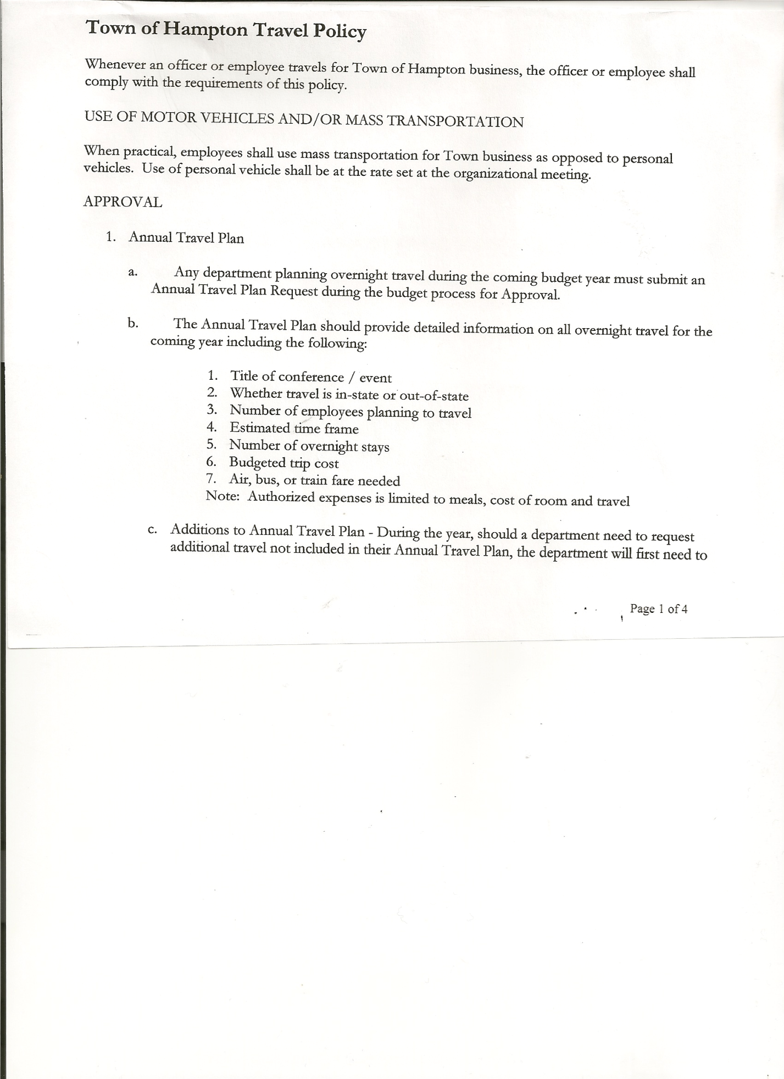
Michael Pietryka------------Councilman
Rebecca Jones---------------Town Clerk
Camilla Shaw----------------Tax Collector/Deputy Town Clerk – via Zoom
Herbert Sady, Jr.-------------Highway Superintendent – via Zoom

Planning Board Member(s): Bonnie Hawley, Chair; Ginny Kinsey, Matthew Pratt and Renee Rountree all via Zoom.

Also present: Stacie Panoushek via Zoom

The Regular Meeting was called to order by Supervisor O’Brien at 7:30pm, followed by the Pledge of Allegiance. Location of Fire Exits were given. Quorum of board members present.

Supervisor O’Brien asked for a moment of silence in memory of Vincent Chadwick, Ruth Jones and Edward Schaff.

RESOLUTION NO. 38-2020
APPROVAL OF THE MINUTES
On a motion of Councilman Sady, seconded by Councilman Pietryka, the following resolution was ADOPTED:
By Roll Call Vote: Supervisor O’Brien AYE
Councilman Sady AYE
Councilwoman Taran AYE
Councilman Pietryka AYE
Councilwoman Sweeney ABSENT
RESOLVED, that the Regular Town Board Minutes for April 16th, 2020 are approved.

Larry Carman, Dog Control Officer submitted his report, which was read by Supervisor O’Brien, copy of report is attached for 04/16/20-05/20/20.

Tax Collector’s Report – all funds paid out, no other activity

Bonnie Hawley, Chair gave Planning Board Report…
- List of questions asked at the April Meeting and Answers provided (copy attached)
- Question to Town Attorney Matt Fuller about process of hiring a consultant and his answer.(copy attached)

TOWN BOARD MEETING
MAY 21, 2020 PAGE 2

RESOLUTION NO. 39-2020
PLANNING BOARD - GRANT APPLICATION
On a motion of Councilman Sady, seconded by Councilman Pietryka, the following resolution was ADOPTED:
By Roll Call Vote: Supervisor O’Brien AYE
Councilman Sady AYE
Councilwoman Taran AYE
Councilman Pietryka AYE
Councilwoman Sweeney ABSENT
RESOLVED, to support the Planning Board in applying for a State Grant from NYS Department of Agriculture and Markets.

Herbert Sady, Jr., Highway Superintendent submitted his report, copy of which, is attached.
Discussed CHIPS Paving plans for Hickey Road. Blacktop vs FDR (Full Depth Reclamation).
Supervisor O’Brien suggested sending a letter to Hickey Road residents about what Highway Department is planning for Hickey Road.

Discussed the Doosan Loader at Capital Tractor, Inc. and the one Turunen has for sale.
The one at Turunen’s has more hours, has some leaks, no heat/wipers. (This is the one we rented last year) The one at Capital has less hours and is in great shape. Highway Superintendent and Deputy (Herb and Tyler) tried this one out and found it to be “real tight”, meaning no slop in the steering and bucket.
Discussion about how we would pay for it….Town Attorney does not recommend Municipal Financing. If the Equipment Reserve were used it would be almost depleted. Supervisor O’Brien will look into financing $10,000 for five years.

Communication received from New York State Department of Transportation….two (2) letters received:
- First one is in regards to Speed Limit reductions for eight (8) separate town highways.
(Copy of letter is attached)
- Second one is in regards to Passing Zone and Warning Signs, Route 22A near Hickey Road. (Copy of letter is attached)

SUPERVISOR’S REPORT/COUNTY UPDATES/COMMUNICATIONS

RESOLUTION NO. 40-2020
APPROVAL OF SUPERVISOR’S MONTHLY REPORT
On a motion of Councilwoman Taran, seconded by Councilman Sady, the following resolution was ADOPTED:
By Roll Call Vote: Supervisor O’Brien AYE
Councilman Sady AYE
Councilwoman Taran AYE
Councilman Pietryka AYE
Councilwoman Sweeney ABSENT

TOWN BOARD MEETING
MAY 21, 2020 PAGE 3

RESOLVED that, the Supervisor’s Monthly report be accepted as submitted for APRIL
03/31/20 04/30/20
ACCOUNT BALANCE RECEIPTS DISBURSEMENTS BALANCE
General Fund $ 67,357.63 $ 791.38 $ 7,154.97 $ 60,994.04
Highway Fund $ 169,689.21 $ 6975.53 $ 13,482.04 $ 163,182.70
Equipment Reserve $ 64,859.89 $ 2.66 $ 0.00 $ 64,862.55
Fire #1 $ 42,448.00 $ 0.00 $ 0.00 $ 42,448.00
Fire #2 $ 10,000.00 $ 0.00 $ 0.00 $ 10,000.00
Cemetery $ 1,729.29 $ 2.22 $ 0.00 $ 1,731.51
Totals $356,084.02 $ 7,771.79 $ 20,637.01 $343,218.80
All Board Members present signed Supervisor’s Report.

OLD BUSINESS
Franchise Agreement between Town of Hampton and Spectrum. Following a discussion regarding the above Agreement, the following resolution was introduced.
RESOLUTION NO. 41-2020
FRANCHISE AGREEMENT WITH SPECTRUM
On a motion of Councilman Sady, seconded by Councilman Pietryka, the following resolution was ADOPTED:
By Roll Call Vote: Supervisor O’Brien AYE
Councilman Sady AYE
Councilwoman Taran AYE
Councilman Pietryka AYE
Councilwoman Sweeney ABSENT
RESOLVED to introduce for consideration the attached Franchise Agreement between the Town of Hampton and Spectrum Northeast, LLC.
RESOLUTION NO. 42-2020
PUBLIC HEARING -FRANCHISE AGREEMENT WITH SPECTRUM
On a motion of Councilman Sady, seconded by Councilman Pietryka, the following resolution was ADOPTED:
By Roll Call Vote: Supervisor O’Brien AYE
Councilman Sady AYE
Councilwoman Taran AYE
Councilman Pietryka AYE
Councilwoman Sweeney ABSENT
RESOLVED, to set a Public Hearing for June 4th, 2020 at 7:00pm followed by a Special Town Board Meeting for consideration of adopting said Agreement.

Communication received from New York State Dept. of Taxation & Finance Office of Real Property Tax Services Final State Equalization Rate for the 2020 Assessment Roll is 92%.

Received two mortgage checks, one for $7162.21 and a supplemental check for $499.69.

Rebecca Jones, Town Clerk received her recertification as a Registered Municipal Clerk.

TOWN BOARD MEETING
MAY 21, 2020 PAGE 4

PUBLIC COMMENTS/COUNCIL COMMENTS
Renee Rountree asked about the sand shed being gone….Highway Department will designate an area at the sand pile for residents.

The Town Clerk’s report for April 2020 was submitted to the Board. The Town Clerk had Board Members review and sign bank reconciliation statements for the Town Clerk Account and Special Clerk Account dated April 30th, 2020.

RESOLUTION NO. 43-2020
AUDIT OF CLAIMS
On a motion of Councilwoman Taran, seconded by Councilman Pietryka, the following resolution was ADOPTED:
By Roll Call Vote: Supervisor O’Brien AYE
Councilman Sady AYE
Councilwoman Taran AYE
Councilman Pietryka AYE
Councilwoman Sweeney ABSENT
RESOLVED that the bills have been reviewed by the Town Board and are authorized for payment in the following amounts.
General Fund No. 42 through No. 48 $ 1,091.22
Highway Fund No. 50 through No. 60 $ 11,746.79
Total both funds $ 12,838.01

RESOLUTION NO. 44-2020
MEETING ADJOURNED
On a motion of Councilwoman Taran, seconded by Councilman Sady, the following resolution was ADOPTED:
By Roll Call Vote: Supervisor O’Brien AYE
Councilman Sady AYE
Councilwoman Taran AYE
Councilman Pietryka AYE
Councilwoman Sweeney ABSENT
RESOLVED that the meeting adjourned at 8:52pm.

Respectfully submitted,

Rebecca S. Jones, RMC
Town Clerk

