Follow the directions below to get to the appropriate destination and upload appropriate documentation for the 2022 Miss America State and Local Candidate Application and Agreement Contract

https://www.missillinois.org/local-contestant-forms/

- Click on the link above
- Complete the Local/State Contract
- Upload appropriate documents to prove eligibility
- Please note under the “Local/State Contestant Contract Submission Form” link there is a document that will need to be signed and attached to the jotform titled “State Scholarship Rules and Regulations”

First Name: ____________________________ Last Name: _____________________________

Email: _____________________________________________________________________

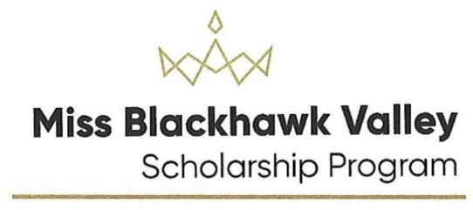
Please attach the contract and required documents to prove eligibility based on residence, student status, or employment.
- Contract
- Birth Certificate
- Driver's License or Government Issued ID
- Front of Medical Insurance Card
- Back of Medical Insurance Card
- Proof of Residence
- Official College Transcript (not a copy)
- Official Transcript of College Registration for Current Classes
- Copy of College Degree
- Official Graduate School Transcript
- Official Transcript of Graduate School Registration for Current Classes
- Copy of Graduate School Degree
- Employer W-2 Form
- Income Tax Filing

Revised 8/25/21

