Approved Minutes of Extra Brimpsfield Parish Council meeting
held on 14th April 2022 at 7.30pm
In the Village Hall
Welcome and introductions
Attendance recorded as Parish Councillors Tom Overbury, Roger Lock, Michael McWilliam, Jane Parsons, Heather Eaton, Claire Jardine & 1 member of the public
Apologies for absence received – Parish Councillor Archie Larthe & District Councillor Judd
County Councillor Joe Harris did not attend
Declaration of interests on matters on the agenda were invited -none
Public session – no comments at this stage as member of the public wished to speak on item 8
Minutes of the previous meeting approved and minor amendments were approved by Council
An opportunity was given for District and County Councillors to speak to the meeting regarding the proposed Boundary Review and its possible implications – not in attendance
Council considered and approved its response to Boundary review consultation – details distributed via email and as attached - Discussion points
Following 2 roadshows /information sharing by CDC, Council considered the boundary relating to Brimpsfield Parish area

There are some dwellings which are close geographically to Birdlip
It was noted that Birdlip & Cowley Parish Council is intended to split

Public consultation and the lack of communication by CDC and the member of public noted that he was not informed on the matter until he received the agenda of this meeting. He asked for his disappointment in the lack of consultation and publicity for this review

The member of public felt that the original map lines were not correctly drawn on CDC documents

Member (Chair) of the Parish Council had contacted the “affected” homeowners on the evening of the roadshow to make sure that they were aware. Other members contacted the public subsequently
CDC officer discussion point was raised by Parish Councillor as one of the quoted feed -back was disputed
Deadline date for feedback was discussed as the CDC meeting in May 2022 is due to make a decision.

Effect on electoral roll and individual contributions to annual precept was noted
Effect on postcode /house valuations was discussed

The Council specifically looked at Blue dotted line and accepted that this dwelling to move to Birdlip

Other properties discussed as listed on post-it note
Gowanlea/Blacklaines Farm House – had expressed a wish to be in Birdlip Parish
Haregrove /Leveretes
Church View Bungalow, Blacklaines House, Cranmore
Blacklaines Cottages 1, 2- had expressed an interest in Brimpsfield
Blacklaines Farm

Boundary within NDP’s (future) was noted

Council agreed this map as preferred boundary (as per SD email 13/4/22) 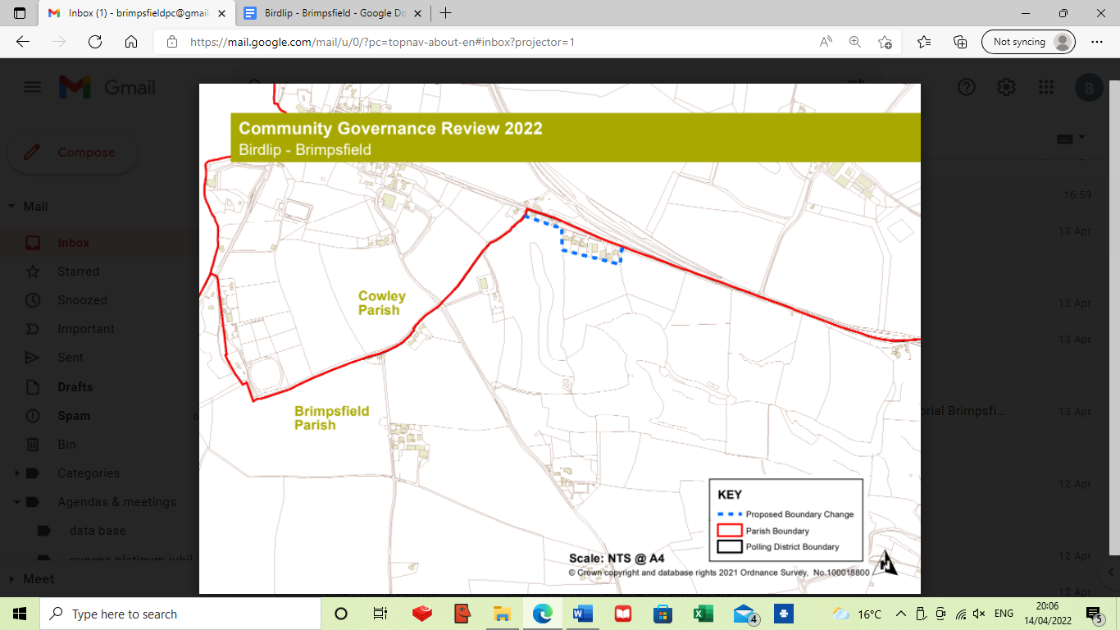

Council approved letter to property owners/contractors at Woodfield, Caudle Green to repair tracks across Brimpsfield PC owned common land -Cllr Claire Jardin
Any other business for the purpose of information sharing as no decisions can be made at this point
21/03856/FUL The Mill House additional information available -noted
Date of next meeting noted as 17th May 2022 at 7.00pm- AGM and 8pm for Parish Assembly
Village website to be asked to publicise. Agenda for Parish Assembly to be distributed 14 days before hand. Village Hall Committee Chair to be invited to present a report,
Close of meeting 20.17

