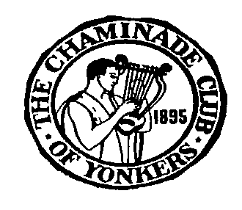

CHAMINADE SCHOLARSHIP REQUIREMENTS

- SPECIFIC QUALIFICATIONS
A high school junior or senior who is a resident of Westchester County OR sponsored by a member of the Chaminade Club.

- AMOUNT OF AWARDS
- $1,000 donated by Clarinetist Michael Webster (a former Chaminade Scholarship winner)
- Additional Awards to other outstanding applicants to be announced

3. BASIS OF AWARD
An audition is required, in which the applicants will be expected to present a program of three compositions of their choice from memory . Singers must select two (2) classical compositions from an opera or an art song and a third composition of their own choice. The audition will be performed before a panel of judges who are professional musicians. All performers except pianists must have their own accompaniment. (see application for details).

- SPONSOR
Chaminade Music Club of Yonkers

- APPLICATION PROCEDURES
- Complete the application form (copy enclosed)
- Enclose one letter of recommendation from the applicants guidance counselor, teacher or private music teacher (if available) or other music instructor.
Please mail the above to: Chaminade Club
c/o Marcia Klein
15 Round A Bend Road
Tarrytown NY 10691
APPLICATION DEADLINE : April 30, 2021
AUDITION DATE: To be Decided Spring /Summer2021
AUDITION LOCATION: Grinton I Will Library, Auditorium. (OR on zoom)
1500 Central Park Avenue (near Tuckahoe Road)
Yonkers, NY 10710
OR we will request a DVD if Covid-19 prevents in person auditions
Requirements and application may be duplicated or found on the web:
chaminademusic.org (select Scholarship)
For more information contact Joyce Henery at joycehenery@aol.com
or Marcia Klein at chaminade9@optonline.net
Applicants will be contacted with specific time to audition

