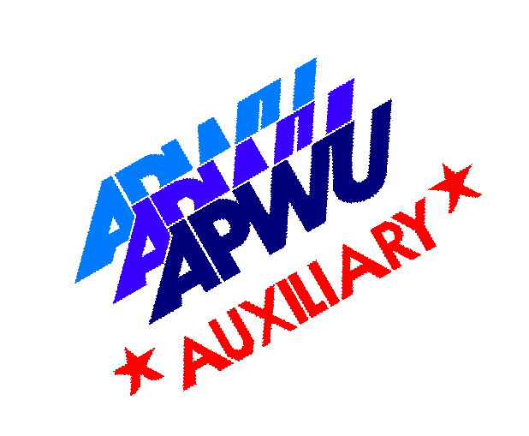 Nilan Scholarship 2024 Application
The National Auxiliary to the APWU is pleased to offer the 2024 Nilan Adult Continuing Educational Scholarship because we believe the following: Education is the key, instrumental in opening the door of opportunity, enabling one to advance, enrich lifestyles, and develop skills necessary to improve oneself in today’s world. This scholarship was first awarded at the National Convention in Las Vegas, Nevada, in August 1990.
Suppose you desire to update your skills or wish to make a career change requiring training to make your dreams possible. In that case, the APWU Auxiliary Adult Continuing Education Scholarship could help you reach these new heights.
NO 2023-2024 HIGH SCHOOL GRADUATES WILL BE CONSIDERED FOR THIS SCHOLARSHIP.
Applicants Name: _________________________________________________________________________
Mailing Address: __________________________________________________________________________
City __________________________________________State _____________________Zip _____________
Telephone #______________________________________SS #____________________________________
Last school attended __________________________________________Date(s)_______________________
College or vocational school you plan to attend and course of study or degree(s) completed ________________________________________________________________________________________
School name: ____________________________________________________________________________
Address: ________________________________________________________________________________ City_________________________________________ State _____________________ Zip______________
Sponsoring APWU Member’s name _______________________________Tel.# _______________________
Name of Local & State _____________________________________________________________________
Signature of Applicant _____________________________________________________________________
Essay Topic
The pros and cons of joining a Union in today’s society?

INSTRUCTIONS FOR THE 2024 ESSAY

All essays must be:
• Typed
• Double spaced
• On white paper

Between 175 and 250 words
The essay be accompanied
by the official application form.

Completed applications and essay
must be sent via Certified Mail,
Return Receipt Requested To:
Lisa Beer, Chairperson
3006 N 5th Ave
Whitehall, PA 18052
E-mail:
lbeer@apwuauxiliary.org

**Must be postmarked on or before July 1, 2024

RULES & GUIDELINES - FOR THE 2024 SCHOLARSHIP

1. NO 2023– 2024 high school graduates will be considered for the 2024 scholarship. Applicant MUST have had a break from High School of one year or more.
2. Applicant must be a member in good standing with APWU National Auxiliary. The applicant must have been an Auxiliary member in good standing for at least one (1) year prior to the application deadline.
3. Application must be on the official application form from the APWU National Auxiliary Continuing Education Scholarship Program.
4. Applicant must write an essay on the designated subject of no less than 175 and no greater than 250 words.
5. Completed application form with the essay must be mailed to Chairperson Lisa Beer (the address included with instructions) postmarked by July 1, 2024, by certified mail with the return receipt requested.
6. Applicant must be registered, enrolled, or attending an accredited college (college, university, vocational or technical school, etc.) at the time the scholarship is given.
7. The APWU National Auxiliary will award one (1) yearly scholarship of $1000.00
8. After verification that the recipient has enrolled with the school of their choice. The award will be sent to the business office of the school. The funds can be applied to the cost of books, food vouchers, or tuition. Scholarship must be used within 18 months of the award date.
9. The scholarship recipient is eligible to receive one (1) yearly scholarship for a maximum of two (2) years upon reapplication & selection process in accordance with the rules and guidelines of the scholarship.
10. If the recipient drops out before the completion of the course(s) (and within the refundable time frame), any unused funds that have already been sent to the recipient school for continuing education shall be refunded back to the National Auxiliary to the APWU.
11. No APWU Auxiliary National Executive Board member or family will be eligible for this scholarship.
12. No exceptions will be made to these rules.

)
PERSONAL INFORMATION (Will be used for press release information if your entry is the selected winner.)
Spouses Name (if applicable) _____________________________________________________________
Children’s Names & Ages ________________________________________________________________
DOB ________________ Sex: M ____F____ Current Occupation ________________________________
Hobbies, special interests: _______________________________________________________________
Community Involvement: ________________________________________________________________
Additional Comments and Future Goals: ____________________________________________________ _____________________________________________________________________________________ _____________________________________________________________________________________
I grant permission for the above information to be used in a press release.
Date: _________________________ Signature: ______________________________________________

