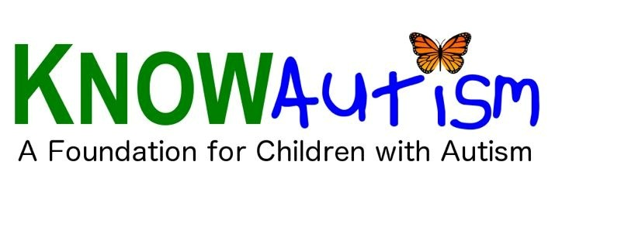
KNOWAutism Foundation
Tuition Assistance Program

The KNOWAutism Tuition Assistance Program is offering scholarships to financially disadvantaged children with autism between the age of eighteen months and older who is attending a special-needs school or special needs program.
(2) Award of $3,000
(4) Award of $2,000 and
(6) Award of $1,000 will be granted each year.
Awards are one-time only.

Eligible Applicants:
Individuals medically diagnosed with ASD and their family needs financial assistance and the child is attending one of the followings:
-A special-needs school / in a special education program
-Receiving speech therapy and/or occupational therapy
-Receiving Applied Behavior Analysis

Individual is a child between the ages of eighteen months and older. Program Committee
The Program Committee reviews quarterly applications and selected a limited number of applicants to receive a financial support scholarship. The committee is made up of representatives from the autism community, professionals from different fields and our director. All applications are confidential during the review process.

Tuition Assistance Program

Applicant Information

Full Name: Date:
Last First M.I.

Address:

Street Address |  | Apartment/Unit #
City | State | ZIP Code

Phone: Email

School /
Attending School / Program / Clinic
Clinic: Address:

School year that you seek to tuition assistance:

Grade:

Program: Date :

Student
Full Name:

Date of
Birth:

Social Security Number:

Briefly describe the student and please include any information that you believe would be helpful to our consideration.

Tuition Assistance Program

Financial Hardship

Describe your particular situation. Be sure to include how this situation has caused you to incur costs (and what the costs were) or loss of income that you have experienced (and what that lost was).

Signature

I certify that my answers are true and complete to the best of my knowledge.

Signature: Date:

Please return to: KNOWAutism Foundation
6430 Richmond Avenue – Suite 410
Houston, TX 77057
Attn: Tuition Assistance Program

A signed application can be emailed to: Judy Blake
E-mail: judyblake@know-autism.org

