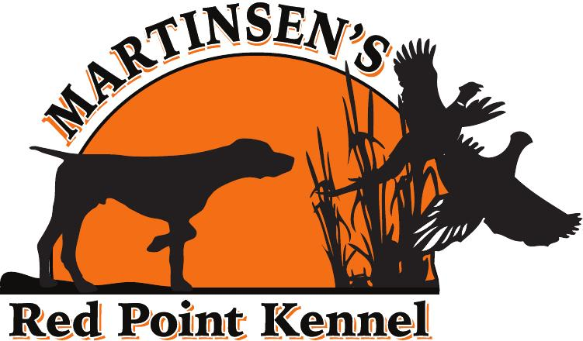
Name:
Address:
Phone#:
Email:
Puppy Questionnaire

- How did you hear about us?

- How often do you hunt?

- Do you hunt waterfowl?

- What is your favorite type of hunting?

- Have you heard of Navhda? If so what is your role in the club?

- What are the three most important attributes in your next vizsla?

- Do you have children? If so how many and what are their ages?

- Where will you keep your puppy for kenneling purposes? Will your dog be a house dog?

- Do you have any intentions of breeding your dog?

- Do you plan on training your dog yourself or sending it to a
trainer?

- What made you decide to own a Vizsla?

- What sex do you prefer? Are you open to both if preferred sex isn’t available?

- Do you have any intentions on testing your dog in advance hunt test or Navhda Test?

- What type of personality are you looking for in a vizsla?

- Do you own any other dogs? If so what breed?

Tate and I want to thank you for taking the time to fill out this form! It really helps us get to know you and what you are looking for in a dog. We want to do our best to place the puppy with you that is going to excel in your home and day to day life! You may also include any other details that you wish to help us with this new and excited adventure you all are about to embark on!

