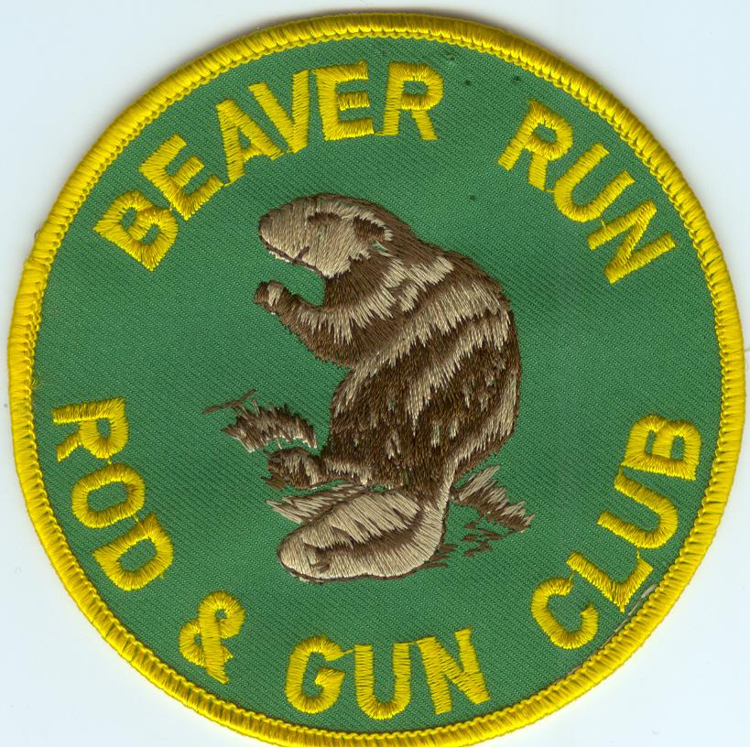

BEAVER RUN ROD & GUN CLUB
676 Stewart Creek Road
PO Box 84
Lehighton, PA 18235
Beaverrunrodandgunclub.com
570-386-4471
MEMBERSHIP APPLICATION
Application Fee: $30

I hereby apply for membership and if accepted I agree to comply with all rules and regulations. The fee submitted with this application will be returned if my application is denied after background check is performed. MUST BE 21 TO JOIN

(Please print clearly) Date____________________________

Name:_________________________________________________________________________

Address:_______________________________________________________________________

City:_______________________________ State:________ Zip Code:_________________

Age:_____ DOB:_______________ Telephone:_______________________________

Email address:___________________________________________________________________

Driver’s Lic#:___________________________________________________________________

Are you an NRA member? Yes:_______ No:_____ Member ID #:________________________

Have you ever been a member of Beaver Run? Yes:______ No:_______

List of other clubs where you are a member:___________________________________________
______________________________________________________________________________

Why are you interested in joining Beaver Run (choose all that apply)

□ For the Rifle Range □ For the Social Club □ For the hunting/fishing

Signature:_______________________________________________________

Sponsor:________________________________________________________

