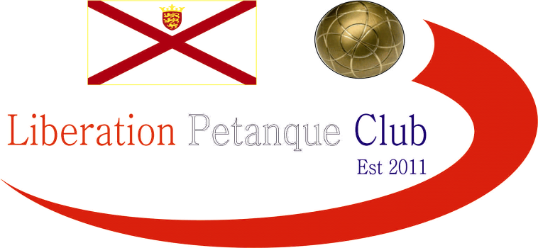

Summer 2015
End of Season
Report
What a record breaking season its been, not only did every single league title go down to the last match of the season but several players achieved their first title successes.
Premier League Double Champions
Ross Payne and Antony Di Santo
The main record breaker though was Ross Payne & Antony Di Santo, who became the first doubles team to ever win a Hatrick of titles, as despite losing their first match in three seasons to Colin & Steve came back to beat title rivals Callum & Andrew to seal their third successive Premier League Double title on points difference over Callum & Andrew. Matt Ryan & David Ibitson taking 3rd place.
Commiseration to those relegated from the Premier League, Alice & Brigitte, Paul & Céline and Eamonn & Karen.
Division 1 Double Champions
Brendan Jones and Stefan Riccio
Division 1 Doubles was won by Stefan & Brendan with Keith & Sue failing to get the double 13-0 win in their final match to force a play off, Pat Cooper & Gary Coburn finished took the final promotion spot to play in the Premier League next Summer.
Commiseration to those relegated Anna & Lauren Shipley and Valerie & Rosie.

Singles Division 2 Champion
Andrew Limbrick
Andrew sealed back to back Division 2 Singles titles after winning Winter 14-15 sealed the summer title with a draw over Amy. This mean’t Nathan had to settle for 2nd place and Gary Coburn took the last promotion spot after Lorna Limbrick could only draw with Amy to miss out on promotion although remained undefeated all season.
Commiseration to those relegated Rob Gregory, Henri and Christophe.

Singles Division 1 Champion
Geoffroy Buffetrille
Geoffroy won in impressive style, undefeated all season which mean’t Matt Buesnel had to settle for 2nd place for the third successive Summer season, but three straight promotions in the Summer Leagues is impressive. David Siouville regained his Premier League status bouncing straight back up after relegation last Summer. This mean’t James Gennoe just missed out on promotion.
Commiseration to those relegated John McGraw, Eamonn and Karen Bougeard.

Premier League Singles Champion
Andrew Bellamy
It went down to the last match and with Andrew drawing with Keith Pinel then Matt Ryan and Matt Pinel needed to win to pip Andrew to the title, but playing against each other in their final match mean’t it was always going to be a tough task, and so it was as they drew, which meant all three tied at the top on 22 points it came down to points difference and with an impressive +99 Andrew was way out in front to seal his first ever Premier League title.
Commiseration to those relegated Brian Harris, Paul Le Moine and Callum Stewart.
Well Done also to Ross Payne for winning the Club Singles Cup, Toby Northern & Matt Pinel for winning the Liberation Doubles Cup and Geoffroy Buffetrille for winning the Mêlée.

Don’t forget the end of Season Presentation & Meal Saturday 24th October 2015

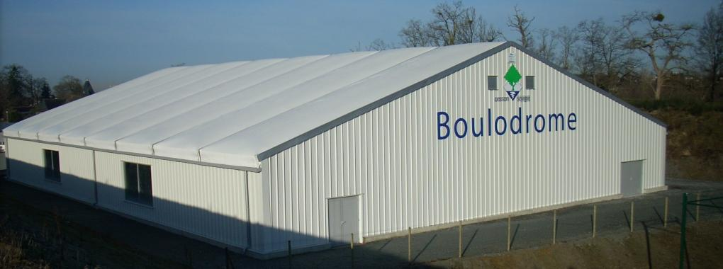
The Future of the Swimming pool at the fort? A nice thought!

I hope you all enjoyed the season and are looking forward to another great winter of petanque.

All end of summer season tables, winter fixtures and calendar on the website.

Club email address - liberationpc@gmail.com

Club Website - www.liberationpetanque.co.uk

Kind Regards

Toby Northern

Chairman

Liberation Petanque Club

SPONSORED BY

