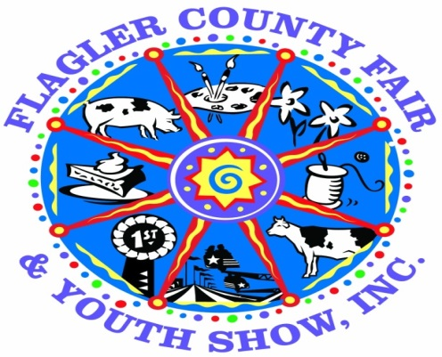
The Flagler County Fair & Youth Show is proud to announce the Annual
“Dorothy Wright Bullard Award”

The purpose of this award is to:
- Encourage more youth participation and increase entries in the Flagler County Fair and Youth Show’s educational programs.
- Encourage currently participating youth to explore other divisions
ALL livestock exhibitors are REQUIRED to participate.
Requirements:
- Must be a resident of Flagler County or attend a Flagler County School AND be a member of an appropriate Flagler County 4H Club or FFA Chapter. Exhibitor must meet minimum membership requirements of the respective club/chapter as accepted by the Flagler County Fair and Youth Show.
Age Requirements AS OF SEPTEMBER 1, 2016
Junior 8 to 10 years Intermediate 11 to 13 years Senior 14 to 18 years
- Any youth (excluding cloverbuds) participating in any livestock exhibition (including rabbits and chickens) must participate in at least 3 or more of the following programs:
  - Horticulture
  - Home and Family Division (a list will be provided of each division within this division - you can enter this division numerous times)
  - Shoe Box Float
  - Country Critter
  - Skillathon
- All entries must be turned in by the end of the day on Monday April 3rd 2017 in the cattleman’s hall.
(Please see the rules for each division you are entering in.)
If you have not met this requirement, you WILL NOT be permitted to show or sell your animal.
- Points awarded based on placing in each division
1st place – 20 Points
2nd Place – 15 Points
3rd place – 10 points
Best of Show 50 points
- Cash Awards for each age division
1st Place - $50.00
2nd Place - $25.00
3rd Place - $10.00

