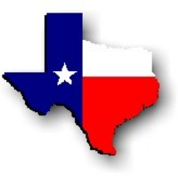Texas History with Mr. Brown Name ____________________ Period _____
Using a Map
Directions: Read the following information about using a map. Then use the maps in your text book on p.667-669 to answer the questions below
A good map will have a legend or key which will show the user what different symbols mean. Without a north arrow, it is difficult to determine the orientation of a map. With a north arrow a user can determine direction. The directional arrows on a map are called the compass rose. A map's title provides important clues about the cartographer's intentions and goals. A map represents a portion of the earth's surface. Since an accurate map represents the land, each map has a "scale" which indicates the relationship between a certain distance on the map and the distance on the ground. Color appears so often on maps that we often take it for granted that mountains are brown and rivers are blue. Just as there are many types of color maps, there are also many different color schemes used by cartographers. The map user should look to the legend for an explanation of colors on a map.
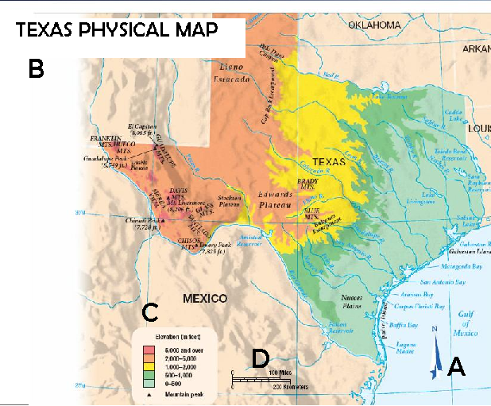
For questions 1-4 use this map (also on p.668) and determine what part of the map each lettered item indicates.
1) A -
2) B -
3) C -
4) D –
5) What city is the capital of Texas?

6) Which city is closest to the Canadian River? | 13) Name 3 mountain ranges in Texas:
7) What city is the closest to Odessa? | 14) What is the elevation range at the falcon reservoir?
8) What city is in the far North East corner of Texas? | 15) Name 3 national parks in Texas:
9) What is the closest city to Austin? | 16) Where is the George Bush Presidential Library?
10) What city is the farthest South? | 17) Name the two museums listed for Dallas:
11) The Rio Grande River forms the border between Texas and _________________. | 18) What is the State Park south of Fort Worth?
12) What is the tallest mountain in Texas? | 19) What city is the farthest West in Texas?

