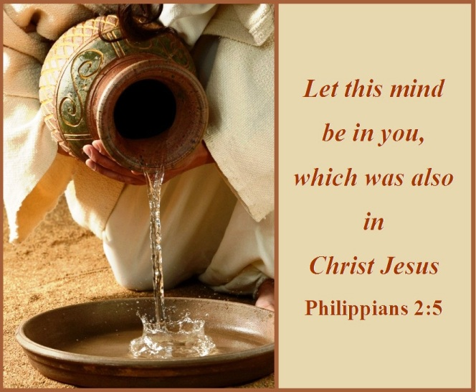

September 04, 2022

Twelfth Sunday after Pentecost

Carson City United Methodist Church

10:30 am

Greeting/Announcements

Call to Worship

L: Christ Jesus, though he was in the form of God, did not count equality with God a thing to be grasped.
P: But emptied himself, taking on the form of a servant, being born in our likeness.
L: And being found in human form he humbled himself and became obedient unto death, even death on a cross.
P: Therefore, God has highly exalted him and bestowed upon him the name which is above all names.
L: So that at the name of Jesus.
P: Every knee shall bow, in Heaven and on earth and under the earth.

*Hymn: Be Thou my Vision UMH 451

Opening Prayer:
Heavenly Father, graciously you accept us as living members of the body of Jesus Christ, you nourish us with spiritual food today in the Sacrament of Christs Body and Blood. As we continue our journey in a world filled with so much anger, pain, and selfishness, through your Holy Spirit remind us again Lord that, you are always with us, remind us again of your unending mercy and love for all your people. Remind us again that you have called us to be a light shining in this darkness and voices of peace and reconciliation to you through Christ our Lord. AMEN.

Contemporary Song: Let the Worshipers Arise
(Casting Crowns)

Offering

Doxology UMH 95

Offertory Prayer

Sharing of our Joys and Concerns

Call to Prayer: Breath on Me of Life UMH 420 V1

Pastoral Prayer

Gospel Reading: JOHN 13:1-5

Old Testament: 2 SAMUEL 22:28

Epistle Lesson: PHILLIPIANS 2:5-11

Contemporary Song: Revelation (Third Day)

Communion

MESSAGE

*Hymn: Grace Greater than our Sin UMH 365

Benediction

CCUMC – Announcements & Upcoming Events:

As a courtesy to others please silence or shut off cellphones

==================================================
Office will be closed Mon Sep 5th in observance of Labor Day.
==================================================
Ad Board/Finance mtg: Rescheduled for Sep 7th @ 6:30 pm. Everyone is welcome.
==================================================
UWF Thank Offering: Join other United Women in Faith (UMW) in the Fellowship Hall on Monday, Sep 12th at 11:00 am for the World Thank Offering program. Bring a sack lunch to enjoy as we fellowship together. Drinks will be provided. If you wish to pick up a donation box, please pick one up from the table as you enter the
Sanctuary.
==================================================
UWF Soup Luncheon: Sep 16th from 11:00 am to 1:00 pm.
==================================================Michigan Conference Mission U: Is held at Gaylord UMC October 17-18. Walthagaye is attending both so if you need a ride, please get in touch with her. The flyer is on the What’s Happening bulletin board with registrations on the shelf under it.
==================================================
Craft & Vendor Show: CCUMC will be hosting a Craft Show on Sat, Nov 5th, 9:00 am thru 2:00 pm. If you are a Vendor interested in reserving a spot, please contact Dawn Wager @ 989-285-2518.
==================================================
SPRC/Single Board Governance Meetings & Charge Conference Information

SPRC
Saturday, September 10th 3:00 pm, to be held at the Alma UMC.

CHURCH CONFERENCE 2022
Sunday, October 30th 2:00 pm, to be held at the Alma UMC.
Everyone is welcome to attend.

Look what’s returning

Come join the fun on Sun, Sep 11th
at 9:15 am for lots of activities to
welcome back our Sunday “Cool” Hour. Kids, teens, and/or Adults are invited.

Resumes on Sun, Sep. 11th
from 6:30-8:00 pm

Resumes on Sun, Sep. 14th
from 6:30-8:00 pm

Classes resume on
Sun, Sep. 18th at 9:15 am

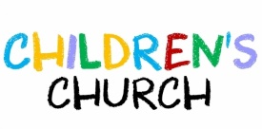
Resumes on Sun, Sep. 18th during
Worship Services @ 10:30 am

Serving & Supporting Sunday Worship
Audio/Video: Pat Monroe

Joys, Concerns & Prayer Request
For those battling cancers:
Jim Dunlap, Carolyn Nykerk, Dillan Abell,
Amorena Newman-Wojciakowski

For those who need support, guidance or have health concerns: Mindy Dennis, Jim Dunlap, Heather Kile

Weekly Giving
8/7 $2452.45 8/14 $2406.92
8/21 $4322.99 8/28 $3303.72

Nursery Schedule
9/15 Molly Fitzpatrick

Lighting of Candles

Passing of Collections Plate

Our Church in Ministry This Week

Tue: COA Meal 10 am – 2 pm
NO COA on Sep 1st & 8th

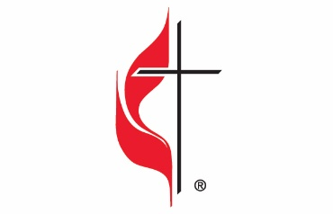

Carson City United Methodist Church
Location: 119 East Elm St., Carson City, MI
Mail: PO Box 298, Carson City, MI 48811
Phone: 989-584-3797 Email: carsoncityumc@gmail.com
Website: carsoncityumc.com
Sunday Worship Service: 10:30 am
Office Hours: Monday-Thursday, 9:00 am-12:00 pm
After hours by appointment
Pastor: Ian McDonald 906-322-5318
Secretary: Bonnie Seaman 989-763-1674

Weekly Sunday Bulletin now available on our website
@ www.carsoncityumc.com

“God Almighty, thank You for giving me opportunities to flex my faith muscles by trusting You to be my strength”

