Wedgewood Waves

Swim Team

Members aged 4-18 are encouraged to join the Wedgewood Waves Swim Team! Participation provides a fun, welcoming, and competitive learning environment. Swim team members improve throughout the season through teamwork and sportsmanship, and generally thrive with consistent participation. The Waves compete in eight meets on Wednesday nights and Saturday mornings during the season, as well as optional meets through the Suburban Swim League (sslswim.org). The season ends with a championship meet and celebration at the pool.

Team Representatives

Sandie Prather - sandie.prather@gmail.com

Shakyra Freeman- SHAKYRAF@msn.com

Coach: Mike Morton – michaemorton0322@gmail.com(302) 388-5178 “Wedgewood Waves” as the subject line

****MINIMUM Requirement- Your child must be able to swim one length of the pool unassisted and be a member of the Swim Club.*****

2019 Dates & Hours
Pool is open 12 pm to 8 pm unless otherwise indicated. Hours subject to change without notice.

May 25th- 27th
June 1,2,8-30
July 1-31
Aug 1-26, 30 and 31
September 1-2

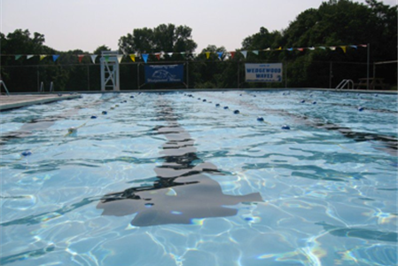
Membership Rules

- Family memberships are granted to those persons who permanently live in the same residence.
- A parent or guardian must register with a full-time student and/or with children under 16.
- Proof of residence is/may be required for all memberships or applications with three or more last names. The pool board and guards, as needed, may also request proof for other members at their discretion. Proof of residence includes driver’s license, report cards, etc. Falsification of proof is grounds for termination without refund.
- Any non-member (swimming or not) entering the pool grounds must sign in and be paid for as a guest. All pool guests must be accompanied by a member. Guest fees- 6$ weekdays, 8$ Weekends and holidays.
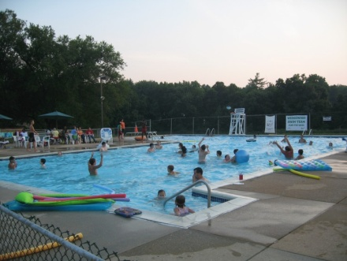

Wedgewood
Swim Club

2A Wedgefield Drive
New Castle, DE 19720

A great family pool for all ages!
www.WedgewoodPool.com
WedgewoodPool@hotmail.com

Registration
All fields are required.
Address: ______________________
_____________________________
Phone: (___) ___-____
Email: ________________________

Member Information
List full names. Include additional members on another sheet of paper.

Name: ________________________
Age: ______ Gender: M/F
Relation: (Self) Fee: $____

Name: ________________________
Age: ______ Gender: M/F
Relation: __________ Fee: $____

Name: ________________________
Age: ______ Gender: M/F
Relation: __________ Fee: $____

Name: ________________________
Age: ______ Gender: M/F
Relation: __________ Fee: $___

Maintenance fees
(# of members age 16+ $10 each): $______

Total Due: $_____

Emergency Contact Name & Phone:

_______________________________
I attest that the information given is true and adheres to the membership rules included in this brochure.

_____________________________Signature Date

Membership Fees

First Adult: $200
18 years old on or before May 31, 2016

Each Additional Adult: $175
(not enrolled in college)

Full-Time Student: $70
Enrolled at a college or university. Must register with paid adult.

Child (Age 2-16): $50
Must join with parent or guardian and live in same residence. Babies under 2 are FREE.

Maximum Fee Per Family: $475
Does not include maintenance fees or late fee.

Maintenance Fee: $10 per person or 1 hour volunteer time for members 16 and older. (Dates and times to be posted on Facebook page and sent via email).

Late fee of $ 25 applies if membership not paid by June 3 2019

Mail registration and payment (cash or check, payable to Wedgewood Swim Club) to:
Wedgewood Swim Club
c/o Krista Kendall Estraca
52 Duquesne Ct
New Castle, DE 19720

Contact Krista at 302-438-1874 or WedgewoodPool@hotmail.com with any questions or concerns.

Join the Fun!

Beautiful 6-Lane, 25-Yard Pool
Baby Pool Area
10-Foot Deep End with Diving Board
Red Cross Certified Lifeguards
Wedgewood Waves Swim Team
Snack Shack & Charcoal Grill available
Bath House
Pool Party Rental*
Family Swim Nights
2019 Movie Nights
(To be determined)

*Registration required. Additional fees apply.
****If paid membership received prior to April 15th you will receive 4 Guest passes to use in the 2019 season.****

