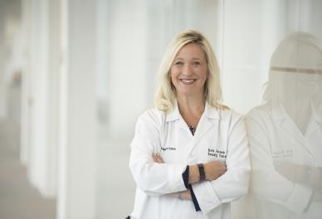BETH FAIMAN PHD, RN, MSN, APN-BC, BMTCN, AOCN, FAAN, FAPO

Nurse Practitioner, Department of Hematology and Medical Oncology Cleveland Clinic Taussig Cancer Institute, Cleveland, Ohio

Dr Faiman has become an exemplary leader in bringing critical knowledge of cancer nursing to clinical providers locally, nationally, and internationally. She demonstrates enthusiasm for continuous learning by conducting innovative research and has demonstrated the importance of using and integrating new medical knowledge within nursing practices. Dr Faiman received her Bachelor of Science in Nursing degree from Ursuline Academy (1996), a Master of Science in Nursing at Kent State University (2002), and a PhD in clinical research from Case Western Reserve University (2014). Dr Faiman is an adult nurse practitioner in the Department of Hematology/Oncology at the Cleveland Clinic in Ohio, and a clinical member of the Case Comprehensive Cancer Center under the Cancer Prevention, Control and Population Research Program. She has edited several books and authored many chapters and papers, including Editor of the 3rd Edition of the *Multiple Myeloma Textbook for Nurses* (2021), and both Editions of the *Blood* *and Marrow Certification Manual for Nurses* (2017, 2023), by ONS publishing. She previously held appointments on the American Board of Internal Medicine Maintenance of Hematology Certification Committee and American Society of Hematology.

In 2023, Dr Faiman was given the *NP/PA Educator of Distinction Award in Multiple Myeloma* and in 2022, was named the *Top NP in Hematology/Oncology* and inducted as an inaugural Fellow of Advanced Practice in Oncology (FAPO) awarded by the Advanced Practitioner Society for Hematology and Oncology (APSHO). Dr Faiman is a Distinguished Fellow in the American Academy of Nursing (FAAN) and current Editor-in-Chief of *Journal of the Advanced Practitioner in Oncology.* She remains an active author, presenter, mentor and educator on the topics of hematology, oncology and supportive cancer care.