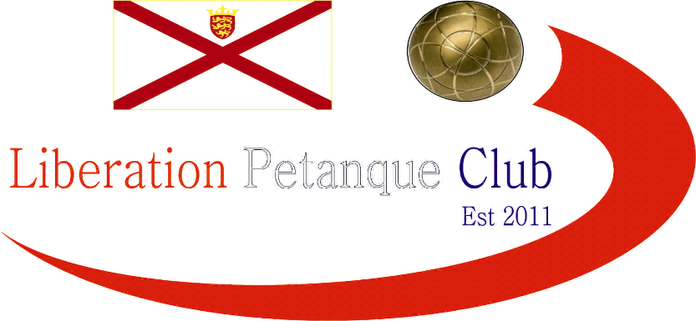

# Summer 2017 Season

# Week 7

# 10th May 2017

# Doubles League

# This Weekend – Colin Welsh Memorial Trophy (Sunday 14th May) – See club website for details.

# Just three matches played in the Premier league and Neil Selby & Ross Payne suffered a fanny against Matt Pinel & Richard Nevitt and lost the match. Matt Ryan & David Ibitson inflicted a heavy defeat on Callum Stewart & Andrew Bellamy.

# Ian Black & Luke Nightingale finally got a point against Joey Le Clech & Jonny Hill.

# Alan Oliveira & Craig Kelly almost achieved the unthinkable allowing Harrison & Richard just one point in two games winning 13-0, 13-1.

# Christophe & Iwona finally got a league win, beating Colin & Karen. Well done both. Ian & Jane Rondel continued their fine form with another win this time over Alan & Mike.

# Keith & Sue suffered a loss to David & Susan who have started the season really well. Alex & Jean got back to winning ways against Paul & Lauren.

# 

***NEXT WEEK***

**Singles League – Start Time 6pm**

**WEBSITE** [**www.liberationpetanque.co.uk**](http://www.liberationpetanque.co.uk)

**EMAIL** [**liberationpc@gmail.com**](mailto:liberationpc@gmail.com)

**Kind Regards**

**Report Editor**

**Toby Northern**

**Liberation Petanque Club**

# SPONSORED BY

# http://nebula.wsimg.com/135a1bd6338e1b589a50cdec98bd84d1?AccessKeyId=C6E923731F1A482DD910&disposition=0&alloworigin=1