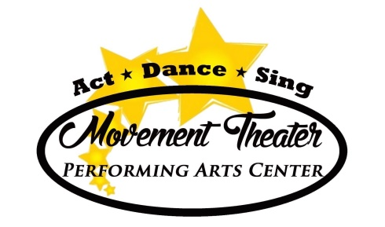NEW STUDENT PACKET
Welcome to Movement Theater! We are a Performing Arts School that offers classes, 1-day workshops, performances, and camps year round! We pride ourselves on experienced teachers, friendly atmosphere, and detail to proper training and emphasis on good technique. Please create a parent portal to view all offerings and on-line registration options.
WHAT WE OFFER…
Classes – we offer 3 semesters of classes in Dance, Theater, Vocals, and Acro
Fall semester (10 weeks), Winter semester (10 weeks), Summer session (6 weeks)
***Our 6 week Spring Semester is only for students performing in the Spring Showcase in May.
Camps – we offer various 1 week summer camps in Theater, Dance, and sometimes other areas like Art or Fashion for all ages.
1-Day Workshops – during February we offer 2 winter 1-day workshops for younger children in theater & dance. In the summer, we offer 1 day dance & theater workshops. These workshops are great if you cannot commit to a full session, but would like some exposure & experience to dance and/or theater!
Performing – we offer 3 performance opportunities to more serious students.
- Annual Spring Showcase (aka Recital for students) in May (1 day/1show) at Foy Concert Hall (Moravian College). Students must be enrolled in our winter semester to perform and also attend our 6 week rehearsal semester in the spring. The deadline to sign-up for the Spring Showcase happens in November along with a $70 costume fee. We need to collect costume money early to ensure enough time to get the costumes in before the show!
- Annual Christmas Musical in late November or early December. This is for 3rd grade through Adults parts. By audition only held in August. Two shows are performed at Foy Concert Hall (Moravian College). Rehearsal run Sept-Dec.
- Artist In Motion (AIM) is our community outreach group that rehearses once a week. Participants must be 4th gr & up and enrolled in a technique class.
Private Lessons – we offer private lessons for students focusing on a certain technique, performance or just preference for one on one training in Dance, Acting, or Voice.
Birthday Parties – we even offer Birthday parties at the studio.
Our studio is an open-concept studio with a small waiting area for parents. Our focus is on class time and technique. Please view our website for schedules, fees, and class descriptions. All offerings are separated by age or grade.
We hope your child finds a new home and passion at Movement Theater!

