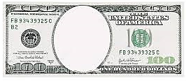
Glass
Steagal
Act
Sherman
Silver
Purchase
Act
Cross
Of
Gold
Speech
Hawley
Smoot
Tariff
Bland
Allison
Act
Omaha
Platform

