

Summer 2019 Season

Pre – Season Report

Welcome to the Summer 2019 Season and also welcome to new club members Tim Jackson, Brandon De La Haye, Natasha Romeril, James Childe Wendy Ritzema and Gary Cowburn and welcome back Brendan Jones, James Gennoe, Andrew and Lorna Limbrick.

With an increase of 9 singles league players this season we have moved to 3 leagues. The Premier League will see Richard Williams and Laurent Pellaton join the ranks, how will they get on? Who will finish higher?

https://www.surveymonkey.com/r/CK7JP79

Division 1 see’s Callum Stewart, Paul Le Moine and David Ibitson dropping in after relegation last season and are joined by Matt Ryan, Jake Romeril and James Rondel.

When looking at the rest of the field you have Joey Le Clech a former Premier League player, Paul Bell and Brigitte Ibitson who will be playing in the Premier League next winter and Cassie Stewart, Jersey’s representative in the World Singles Championships in Spain in May this is undoubtedly the strongest ever Division 1 league we have seen at the club.

Division 2 is where, Jean Stewart, Mo De Gruchy and Stephen Stoneman have fallen to with everyone else either playing the Summer League for the first time or re-joining. In fact we have a previous Division 2 winner in Andrew Limbrick back in 2015, before he realised the grass isn’t greener at Carrefour and returns to the best club in the Island☺. Surely then the pre-season favourite?

Matt Pinel will be looking to retain his Premier League Summer Singles title but will have work to do with newly crowned Winter Premier League Champion Geoffroy Buffetrille looking to add the Summer title to his Winter one and with Matt recovering from a broken arm (albeit his left one) may not be at his best. Only two players have managed to hold both Summer & Winter titles at the same time, Toby Northern and Andrew Bellamy-Burt, no easy task.

Will Neil Selby be able to improve even further after finishing third in the Winter Premier League, could Matt Buesnel probably the best pointer in the Island join the mix after his Winter 2017/18 Premier League title or could the Islands Men’s world Singles representative Andrew Bellamy-Burt win his third Summer title after winning in 2015 and 2016 (not forgetting his 2015/16 Winter title).

Doubles Leagues

Premier League Doubles, can Jake Romeril & Mark Nicol make it three in a row! Actually no as they are not playing together this season. Instead Jake is playing with James Gennoe who re-joins the club and Mark is playing with Dawn Buckley who is the current Mixed doubles champion (with Geoffroy in 2017 and 2018) which one of these will finish higher?

We also see two very experience teams in Gary Cowburn & Wendy Ritzema and Andrew & Lorna Limbrick join the Premier League ranks, this is in addition to newly promoted Alice & Brigitte, (Winter Premier League team) Paul Bell & David Le Gresley and Eamonn & Karen Bougeard will be testing their skills against some really big teams.

So who are the favourites, well the Island Doubles champions should be and that is Geoffroy Buffterille & Matt Buesnel but they will face competition from amongst others Matt Ryan & David Ibitson, Matt Pinel & Toby Northern, Ross Payne & Neil Selby and Callum Stewart & Andrew Bellamy-Burt, the latter though only avoided relegation in the Winter by 2 league points.

Division 1 looks like it could be anyone’s with some strong teams in Alan Mitchell & Mike Robinson, John McGaw & Nick Pallot, Laurent Pellaton & Matt Hutchings and Joey Le Clech & Brendan Jones to name a few!

The question will be how the new teams get on with Tim Jackson & Brandon De La Haye and Helene Retrosi & Natasha Romeril taking part, will they spring a surprise and beat the established teams? They have every chance.

First Open of the year is the Singles Open on Saturday 13th April (Fully booked – you can add your name to the reserve list).

Remember if you cannot play on the scheduled fixture date; please try to play in advance and if you are going on holiday please let your opponent know as soon as you do.


The Super 6 is back and bigger than ever. Well not quite, it is still six matches and a Tiebreaker but it is free, it is fun and the winner gets a Limited Edition Liberation prize at the end of the season!

Click on the link to play Week 1. https://www.surveymonkey.com/r/87LKVFP

WEBSITE www.liberationpetanque.co.uk
EMAIL liberationpc@gmail.com

Kind Regards
Toby Northern
Chairman
Liberation Petanque Club

SPONSORED BY



Summer 2019
Week 1 – 3rd April 2019
Singles League
The new season got underway with our largest membership for several years. We had a hail shower in the morning dampening the terrains for the first fixtures on the season.
Winter 2018/19 newly crowned Premier League champion Geoffroy started off his quest for back to back season titles against Alice Ibitson and yet again he won but with the second game going to 13 – 12 as Alice just missed out on a point.
Newly promoted pair Laurent Pellaton & Richard Williams played each other for a valuable three points in their first ever season in the Premier League. See below Super 6, which shows members thought Laurent would win this one.
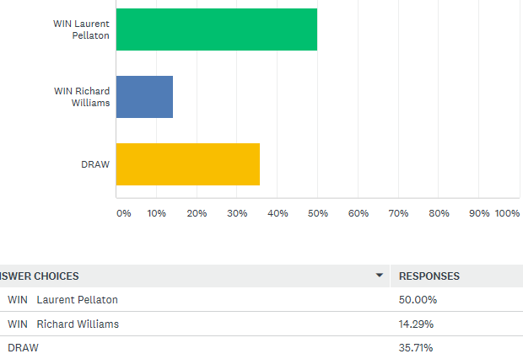

The actual result was a win for Laurent 13 – 8, 13-8 and he is tied at the top of the table with Geoffroy as a result. Laurent plays Toby next.
Brian Harris had his best season last summer finishing 5th before being relegated for a record 5th time in the winter. Brian had a tough first opponent (aren’t they all in the Premier League) in Matt Buesnel and Matt was 12 – 2 up in the first game before Brian came back for a more respectable 8 points. Brian though turned the tables on Matt in the second game winning 13 – 3 for a draw.
Two players hoping to relive former glory were Ross Payne and Toby Northern, anyone’s guess as the result of this, well Super 6 responders thought this:
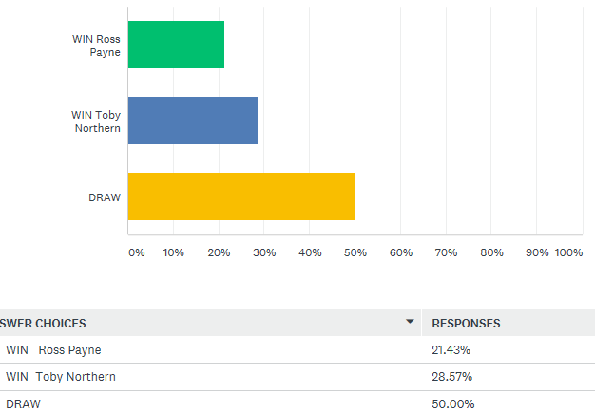

The actual result was a narrow win for Ross as he won the first game 13 – 12, but was 8 – 1 up and 12 – 5 up in that game, for some impressive firing in the second gave him the win.
Keith Pinel and Andrew Bellamy-Burt was un-played due to an injury to Keith, we wish you a speedy recovery Keith. So with Matt Pinel having a bye he played Andrew instead from week 7. Matt scored a record 33 points last summer as he blew everyone away, but only just avoided relegation in the winter, so which Matt will we see this season. The first game went Andrew’s way 13 – 8, before Matt turned the screw in the second game to win 13 – 1.
In division 1, nobody thought Harrison Marie would beat Callum Stewart one of the favourites for promotion. Harrison however had other ideas taking the first game 13 – 12 and was just 2 points away from a win losing 13 – 11 for a good result for Harrison, not so much for Callum though.
Davis Ibitson also dropping down a division played Cassie Stewart who had a fantastic end to the Winter Season. Could Cassie continue that run? Not quite, but a good draw.
Both Paul Le Moine and Joey Le Clech are former Premier League players so was going to be a tough match, Super 6 responders though Joey would edge it.
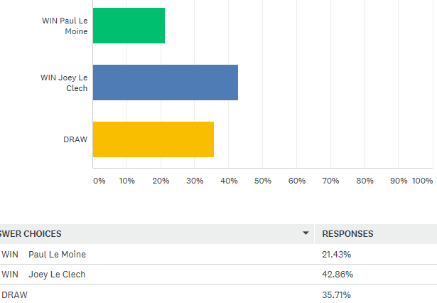

The result, well another draw in division 1.
James Rondel was playing his first Singles season and took on his Doubles partner in the Liberation Doubles Open from last year, a competition in which they finished Runners Up.

There wasn’t much separating them in the Super 6 results with James edging it despite the fact that Paul will be playing in the Premier League in the Winter 2019/20 season.
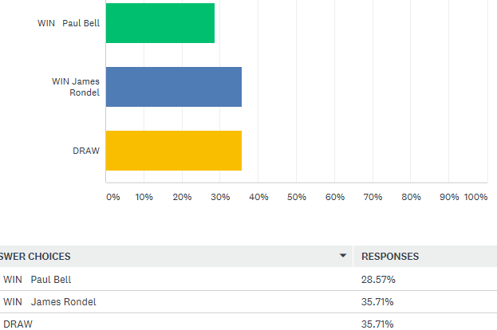

This had another game going to 13-12 but a draw was all they could manage.
Matt Ryan is the pre-season favourite, in fact he finished second in the Winter Premier League, but having missed the previous summer season dropped down a division for this summer. He played Matt Hutchings who had a fantastic game gaining a valuable point as 5 of the six matches ended in draws in this division.
Another player joining the singles league again is Jake Romeril, another player expected to challenge for the title. He played Brigitte Ibitson in his first match and he became the only player to win a match in Division 1’s week 1 fixtures to top the table.
In Division 2, favourite and JPA chairman, Andrew Limbrick played newcomer Tim Jackson, could Tim be a dark horse in the league? Not yet as Andrew cruised to victory in the first game before a little scare in the second having to come from behind to win.
James Villalard ruined many peoples Super 6 by beating Mo De Gruchy and I think James could be in with a shout of promotion this season.
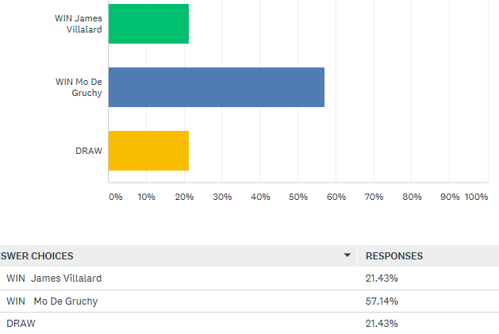

Natasha Romeril, one of the top female players in the Island joined the club, taking on Jean Stewart in her first match. A good match between the pair with Jean picking up a rare league win, could this be the start of something?
Lorna Limbrick another one of the top female players in the Island played club newcomer Branden De La Haye, with the match being played in advance and both players getting a draw.
Daniel Villalard would be hoping for better things in his second season and he took on Luke Canavan. It was a good start for both as they got off the mark with a valuable point.

Finally Brendan Jones returned to the club after a couple of year’s absence, how would he fair against Stephen Stoneman?
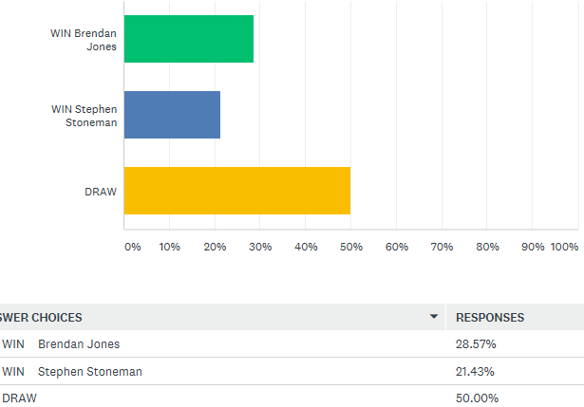

Brendan just edged the Super 6, but 50% thought a draw was most likely and they were right this was the 10th draw this week.
NEXT WEEK – 10TH April 2019 - SINGLES LEAGUE WEEK 2

Club email address - liberationpc@gmail.com

Club Website - www.liberationpetanque.co.uk

Kind Regards

Toby Northern

Chairman

Liberation Petanque Club



Summer 2019
Week 2 – 10th April 2019
Singles League
Week 2 saw Neil Selby play his first match and hoping for a much improved summer. He played Alice Ibitson who finished one place below him in the league last summer but Alice won this match for an important three points after losing to Geoffroy in week 1. How wrong were the Super 6 players!
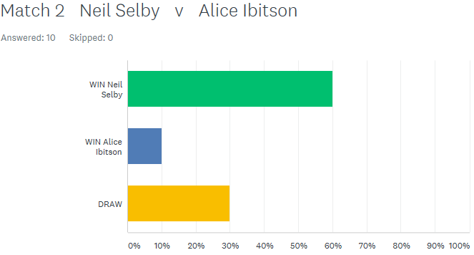

No one predicted Matt Pinel would beat Geoffroy in the Super 6, but how wrong they were as last summers Premier League champion Matt turned on the form to beat player of the moment and winter Premier League champion Geoffroy Buffetrille.

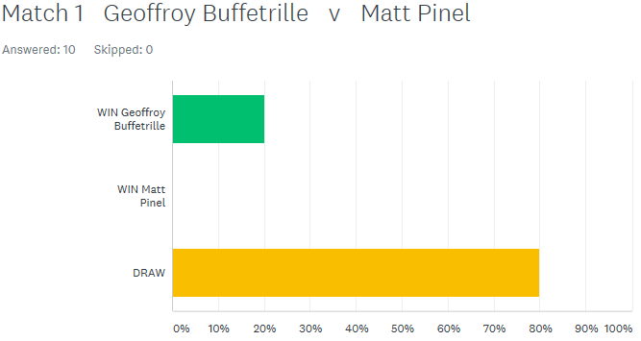

Andrew Bellamy-Burt survived a scare against Premier League newcomer Richard Williams, losing the first game 13 – 12 after giving Richard some coaching tips! Before recovering to get a draw but two valuable points dropped for Andrew.
Another newcomer Laurent played exceptionally well in the first game against Toby before moving terrain for the second game which turned out to be a mistake as Toby adapted better to the wet terrain to take the draw.
Matt Buesnel moved joint top on four points as he won a close match against Alex Stewart. Ross Payne also moved to four points with a draw against Brian Harris.
Division 1 saw Callum take on sister, Cassie and survive a score in game two coming from behind to win 13 – 11. Most Super 6 players got this one right
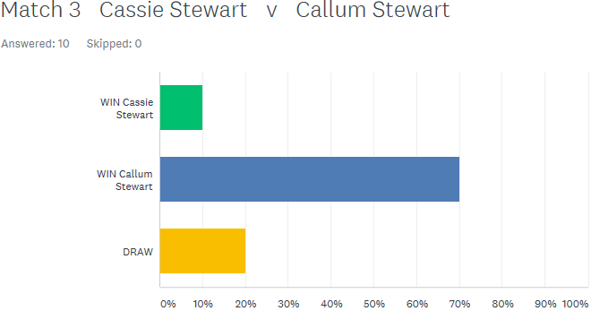

Division 1 pre-season favourite Matt Ryan was hoping to recover from dropping points in his first match against Matt Hutchings but played a tough opponent, his doubles partner David Ibitson. Matt made light work of game one winning 13 – 1 before David recovered in game two but not enough to get a draw.
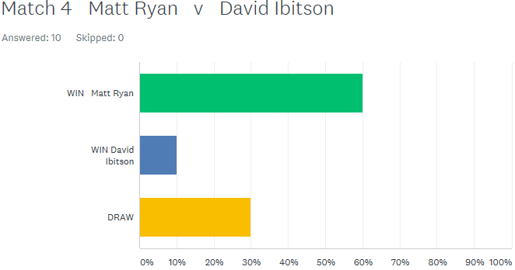

Joey Le Clech failed to win again this time against Harrison Marie but is on a long unbeaten run. Jake Romeril also drew two matches first against Paul Le Moine and then a match played in advance against David Ibitson.
Matt Hutchings has had a good start to the season winning against James Rondel and Brigitte Ibitson beat Paul Bell.
In division 2, Jean Stewart has had a fantastic start to the season winning both matches so far, this time against Mo De Gruchy and not only that but won 13 – 0 in one game.
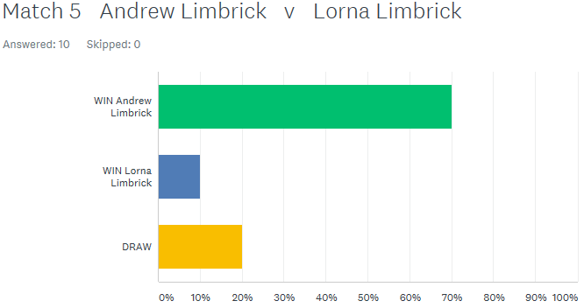
Andrew beat wife Lorna to maintain his perfect start to the season as predicted by most Super 6 players.

Andrew is not the only player on 2 wins from two though as James Villalard beat Luke Canavan to join Andrew and Jean on 6 points.

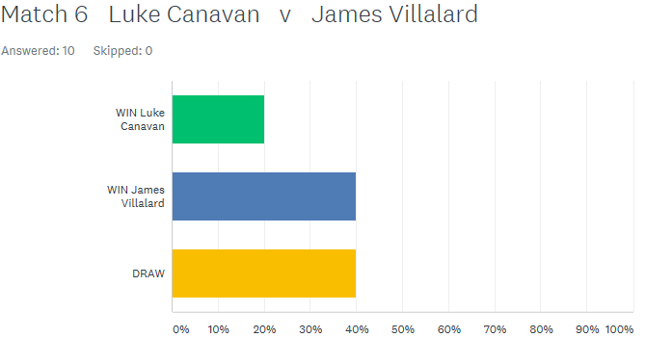

Daniel Villalard managed to get off the mark this season with a draw after winning the second game against Brendan Jones 13 – 12.
Natasha Romeril won her first ever singles match at the club beating Tim Jackson, well done Natasha.
Stephen Stoneman also got a win against newcomer Branden De La Haye for a good start to the season.
NEXT WEEK – 17TH April 2019 - DOUBLES LEAGUE WEEK 3

Club email address - liberationpc@gmail.com

Club Website - www.liberationpetanque.co.uk

Kind Regards

Toby Northern

Chairman

Liberation Petanque Club

Summer 2019
Week 3 – 17th April 2019
Doubles League
The first scheduled doubles league week saw many games cancelled despite the good weather.
In the Premier League, Ross Payne & Neil Selby got off the a flying start only conceding 6 points against Alex & Cassie Stewart as they bid for their first title as a team.
Two new teams joining the fold were both good sides with Wendy Ritzema & Gary Cowburn playing Andrew & Lorna Limbrick. This looked on paper to be a close game as was agreed by the Super 6 players. However the former opened their Liberation account with a comprehensive win 13 – 6, 13 – 1.
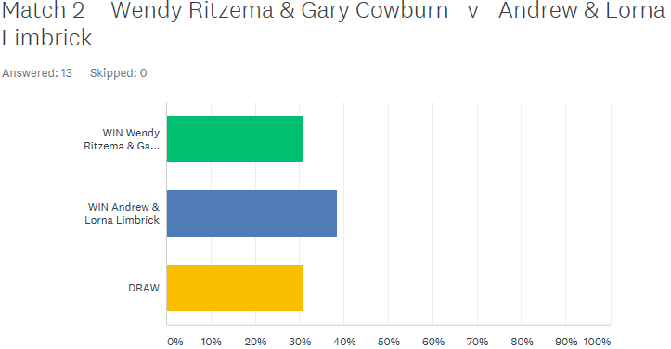

One of the favourites for the title Matt Pinel & Toby Northern played promoted Eamonn & Karen Bougeard. Eamonn was firing exceptionally well as both he and Karen took the first game before Matt & Toby stepped up a gear to gain a draw.
In Division 1 there was a very close match between Helene Retrosi & Natasha Romeril and Mo De Gruchy & Stephen Stoneman ending in a draw with just a couple of points separating the teams.
No one gave Jean Stewart & Chris Le Gallais a chance in their match against Alan Oliveira & Craig Kelly who dropped down from the Premier League and they were right. They should be the ones to beat in Division 1 this season.

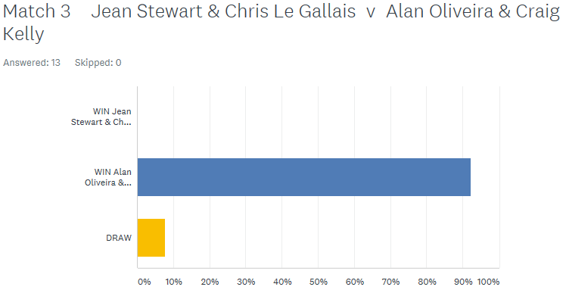

Colin Myers & Steve Simpkin v Harrison Marie & Richard Williams looked a close match with most people predicting a draw. It could have ended up a draw with one match going to 13 – 12 before Colin & Steve sealed the win.
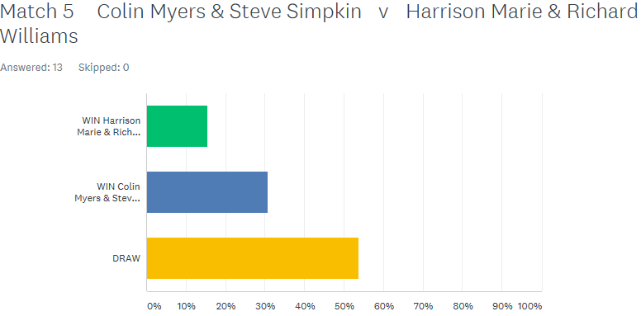

Tim Jackson & Brandon De La Haye hoping to get off the mark against Colin & Karen Hidrio, seasoned summer players but it wasn’t to be but still early days.

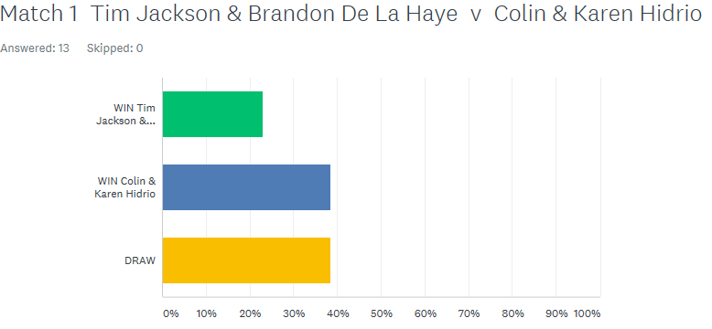

Last but not least the ever improving James Villalard & Daniel Villalard played tough opponents in Alan Mitchel & Mike Robinson and despite both James & Daniel improving all the time Alan & Mike proved too good as they look for back to back promotions.
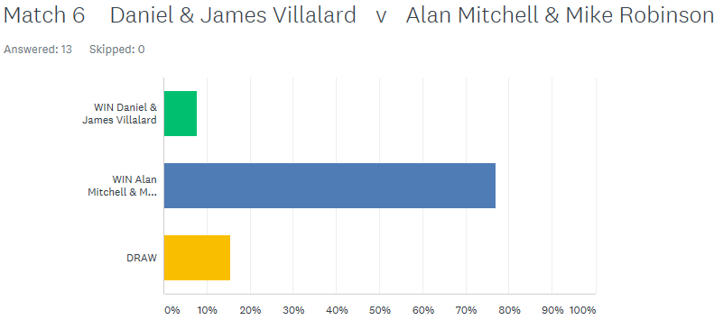

NEXT WEEK – 24TH April 2019 - SINGLES LEAGUE WEEK 3

Club email address - liberationpc@gmail.com

Club Website - www.liberationpetanque.co.uk

Kind Regards

Toby Northern

Chairman

Liberation Petanque Club

Summer 2019
Week 4 – 24th April 2019
Singles League
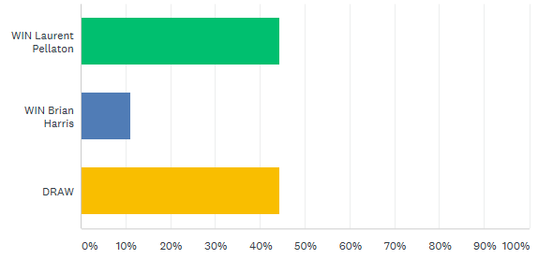
Week 3 in the Singles League saw Brian Harris top the table, but this is due to playing two matches in advance. However he only leads by 1 point having played two matches more than Matt Pinel and Matt Buesnel following his first loss to Toby Northern 13 – 5, 13- 4. Brian earlier beat both new boys in Laurent and Richard.

Matt Pinel kept the defence of his title on track by handing out a heavy defeat to Neil Selby who only scored 6 points in 2 games! Neil beat Matt in our Singles Open only a week earlier.

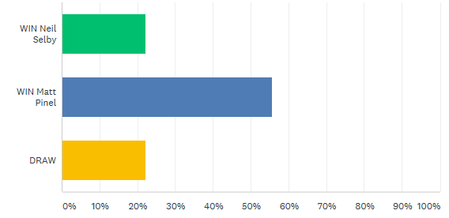

Richard Williams won his first Premier League match, against Keith Pinel although the first game went to 12. Well Done Richard.
Alex Stewart got his first league point of the season winning his first game against Ross Payne 13 – 1, before Ross fought back to take the second game 13 – 8 for a draw.
Division 1
Well what a close league Division 1 is, so far out of 17 matches played 12 have been draws and although the league leader Jake is undefeated he is only on 6 points having won 1 and drawn 3 matches. This followed another draw with Harrison Marie with only 3 points separating them with Jake winning 13 – 11 before Harrison took the next game 13 – 12.
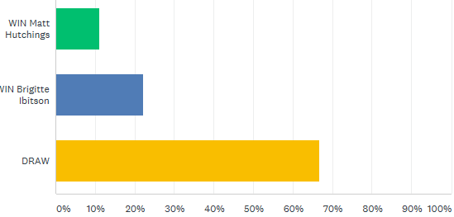
Matt Hutchings sits in 2nd position after another draw, this time to Brigitte Ibitson, Matt also unbeaten so far.

A very up and down match between David Ibitson and James Rondel. David won the first game 13 – 3 and then choose to stay on the same terrain but then lost 13 – 3 to James, posing the question should David have moved terrains?
Call v Joey, Cassie v Matt and Paul Le Moine v Paull Bell all un-played so a chance to move up the table with a win.
Division 2
Brendan Jones handed out James Villalard’s first defeat of the season ruining his 100% record and with Jean Stewart drawing against Luke Canavan this mean’t Andrew Limbrick moved clear at the top having won his third straight match handing out the latest loss to Stephen Stoneman.
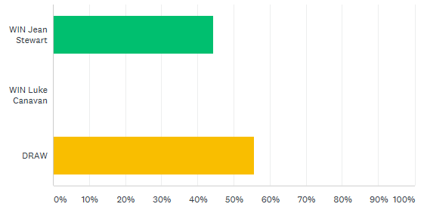

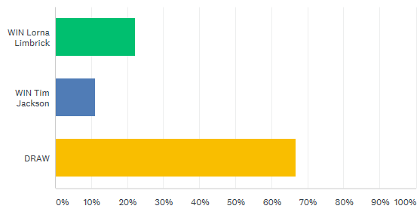
Congratulations to Tim Jackson who score his first league point of his Liberation Career with a good draw with Lorna Limbrick.

Outstanding Matches
Singles Premier League
Andrew Bellamy-Burt v Keith Pinel No Date
Andrew Bellamy-Burt v Toby Northern No Date
Singles Division 1
Callum Stewart v Joey Le Clech No Date
Paul Le Moine v Paul Bell Arranged 6th May
Cassie Stewart v Matt Ryan Arranged 25th April
Singles Division 2
Natasha Romeril v Mo De Gruchy No Date
Doubles Premier League
Paul Bell & David Le Gresley v David Ibitson & Matt Ryan No Date
Alice & Brigitte Ibitson v Mark Nicol & Dawn Buckley No Date
Matt Buesnel & Geoffroy Buffetrille v Callum Stewart & Andrew Bellamy-Burt No Date
Brian Harris & Paul Le Moine v James Gennoe & Jake Romeril No Date
Doubles Division 1
John McGaw & nick Pallot v Laurent Pellaton & Matt Hutchings
Joey Le Clech & Brendan Jones v Keith Pinel & Joao Rodrigues
NEXT WEEK – 1st May 2019 - DOUBLES LEAGUE WEEK 2

Club email address - liberationpc@gmail.com

Club Website - www.liberationpetanque.co.uk
Summer 2019
Week 5 – 2nd May 2019
Doubles League
Week 2 in the Doubles League saw Neil & Ross Draw to Brian & Paul in a shock result especially to those who did the Super 6. This means the pair are on 4 points along with many other teams but very early days in the doubles league.
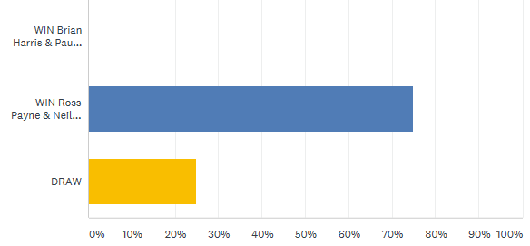

Dawn Buckley & Mark Nicol won back to back matches on the night beating Karen & Eamonn with two close games before handing out a heavy defeat to Alice & Brigitte 13 – 2, 13 – 2 to top the table early on.
New members Gary & Wendy had a big win in their first league match together but played experienced Liberation pair Alice & Brigitte, how would they fair this week.
Most people predicted a draw, the actual result was a draw but a big swing with Gary & Wendy taking the first game 13 – 5 only to lose 13 – 2 in the second game.
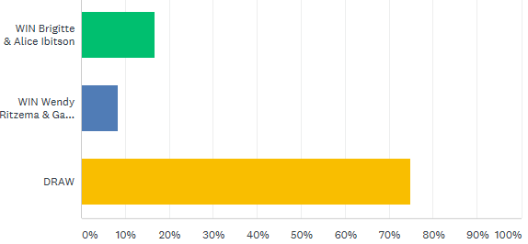

James & Jake faced tough opponents in Matt Pinel & Toby but with Jake fresh from his Island Triples title would have been full of confidence. Most people predicted a win for Matt & Toby and they were right with Toby placing well on a difficult terrain and Matt’s firing back up to some of his best for a 13 - 7, 13 – 6 win denting Jake & James title hopes but still chance to make it up.
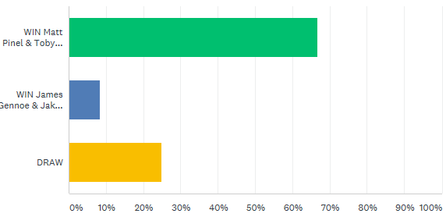

In Division 1 Alan & Craig, pre-season favourites played tough opponents John & Nick with the predictions going the way of a draw. Alan & Craig though look good at the moment to keep their 100% record this season, how long can they keep it going?
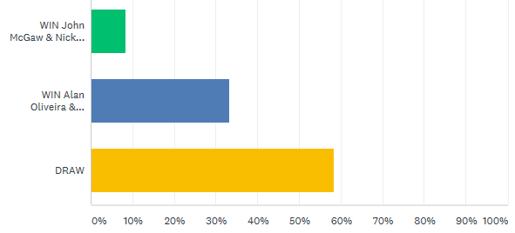

Colin & Karen won their first league match but how would they fair against Keith & Joao in week 2? Unfortunately a loss as Keith & Joao moved onto 4 points to help their bid for promotion.

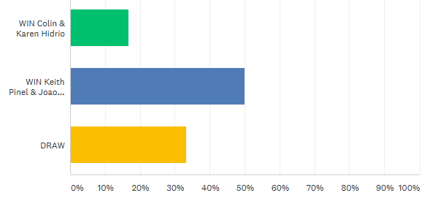

A good match between Harrison & Richard and Laurent & Matt finishing in a draw with Laurent & Matt winning the first 13 – 1.
Tim Jackson & Brandon De La Haye provided a shock in Division 1 by getting a draw with Alan & Mike despite losing the first game 13 – 2, well done guys.
With Mo having a slump in form so far this season how would herself & Stephen fair against Colin & Steve another team looking at a title shot.
The first game was another heavy win for Colin & Steve 13 – 1, but Mo & Stephen did put up a fight in game two just losing 13 – 11
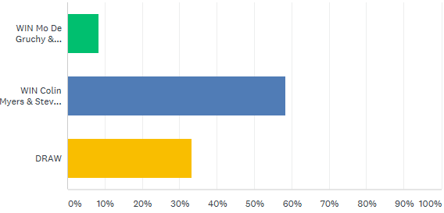

Outstanding Matches
Singles Premier League
Andrew Bellamy-Burt v Keith Pinel No Date
Andrew Bellamy-Burt v Toby Northern No Date
Singles Division 1
Callum Stewart v Joey Le Clech No Date
Paul Le Moine v Paul Bell Arranged 6th May
Cassie Stewart v Matt Ryan Arranged 25th April
Singles Division 2
Natasha Romeril v Mo De Gruchy No Date
Doubles Premier League
Paul Bell & David Le Gresley v David Ibitson & Matt Ryan No Date
Paul Bell & David Le Gresley v Andrew & Lorna Limbrick No Date
Matt Buesnel & Geoffroy Buffetrille v Callum Stewart & Andrew Bellamy-Burt No Date
Matt Buesnel & Geoffroy Buffetrille v Alex & Cassie Stewart No Date
Brian Harris & Paul Le Moine v James Gennoe & Jake Romeril No Date

Doubles Division 1
John McGaw & Nick Pallot v Laurent Pellaton & Matt Hutchings No Date
Joey Le Clech & Brendan Jones v Keith Pinel & Joao Rodrigues No Date
Joey Le Clech & Brendan Jones v Jean Stewart & Chris Le Gallais No Date
Daniel & James Villalard v Helene Retrosi & Natasha Romeril No Date

NEXT WEEK – FREE WEEK – Unlikely terrains will be available

Club email address - liberationpc@gmail.com

Club Website - www.liberationpetanque.co.uk

Kind Regards

Toby Northern

Chairman

Liberation Petanque Club

SPONSORED BY
Summer 2019
Week 6 – 8th May 2019
FREE WEEK

Club email address - liberationpc@gmail.com

Club Website - www.liberationpetanque.co.uk

Kind Regards

Toby Northern

Chairman

Liberation Petanque Club

Summer 2019
Week 7 – 15th May 2019
Doubles League
Well Jake Romeril hopes of retaining his Doubles Premier League title with his new partner James Gennoe are in complete tatters as Jake & James suffered their third straight defeat and added to that received a fanny certificate handed out by Jakes partner last year Mark Nicol and his new partner Dawn Buckley. With minus 49 on points difference relegation is looking the likely outcome.
Mark & Dawn though are the polar opposites winning all three so far and lead the way in the early part of the season.
Toby & Matt are close behind on 7 points from 9 after overcoming title rivals Neil & Ross, playing on the very challenging terrains this week some impressive (and some not so) placing. Toby & Matt came back from 5-1 down in the first game to win 13 – 5 helped by a carreaux from Matt scoring 5 points on one end and lead the way throughout the second game before Neil & Ross pulled in back to 11 – 9 and then had a chance to score big holding one Ross had three boules in hand and attempted to fire out both of Toby boule which were very close 2nd and 3rd boules, but missed both and then when attempting to place in with his last boule nudged Neil’s holding boule out to give the game and the match to Toby & Matt.
Geoffroy & Matt Buesnel could have scored heavily against Brian & Paul but Geoffroy was off form missing more fires than he had probably done all year but fortunately Matt was on form as the title challenges got the win to move onto four points with a match outstanding against Alex & Cassie.
Callum & Andrew remain undefeated but with a draw against newly promoted David & Paul are only on 5 points from a possible 9 to lose ground on the leaders.

Division 1
Helene & Natasha continue to lead the way with another win, but a close one over Tim & Branden however having played two more matches than other teams will surely be caught as Colin & Steve are blowing away the title of draw masters with three straight wins so far this season overcoming the ever improving James & Daniel.
Laurent & Matt won a tight match against Mo & Stephen winning the second game to 12 and Alan & Mike moved back into the top three with a win over Keith & Joao.
Jean & Chris beat Colin & Karen to get off the mark this season and move out of the relegation zone. This was their first win in the leagues since the 10th November to get their ususal one win a season. Now there’s a challenge Jean & Chris, can you get another one?

DON’T FORGET ISLAND SINGLES CHAMPIOSHIP NEXT WEEKEND 25TH MAY AT QUENNAVAIS
REMINDER – YOU MUST ARRANGE FIXTURES WITHIN THE TIME ALLOWED AND COPY IN THE CLUB TO ALL COMMUNICATION REGARDING THE ARRANGING OF FIXTURES

Summer 2019
Week 8 – 22nd May 2019
Singles League
The first double fixture of the season saw Alex Stewart pick up his first win of the season against fellow promoted player Laurent Pellaton. This result along with a draw with Andrew Bellamy-Burt moves Alex free of the relegation places. He was replaced by Keith Pinel who is now holding everyone up at the bottom of the league after draws with Toby Northern and Brian Harris, followed by a defeat in a catch up match with Andrew.
Matt Buesnel and Matt Pinel played out a close draw, with both players maintaining their un beaten run.
Laurent won his second match against Alice Ibitson who is in second place but having lost 3 of her 6 matches and only +1 will surely drop down the table once people play their catch up matches.
Toby is another player having played 6, he won his second game against Richard Williams to move into 4th place.
Division 1 continues to see David Ibitson struggle as a draw with wife Brigitte followed by a defeat to Paul Le Moine means he is still without a win from 6 matches with 4 draws and 2 defeats -30 points difference.
In contrast his doubles team mate Matt Ryan sits at the top with draw against Callum Stewart who is in 2nd place.
Joey Le Clech stretches his unbeaten record to 24 matches after beating Jake Romeril 13 – 4, 13 – 1, this was Jakes first defeat of the season. Brigitte occupies third place following another draw with Cassie Stewart who sits in the relegation zone but with matches to play.
Matt Hutchings is another player who remains unbeaten following a draw with Paul Le Moine. Paul Bell though finds himself on -1 point following two no shows and has some work to do now to get clear of relegation.

A very close division with another double header on the 5th June and a host of catch up matches to play.
Division 2 saw Andrew Limbick lose his 100% record with a draw against Daniel Villalard but did beat his son James (just) for another 4 points, so Andrew still sits top after Jean Stewart lost to newcomer Branden De La Haye his first league win at the club. Well Done Branden. Jean did beat Brendan Jones to stay second and three points off the top spot.
Another newcomer Tim Jackson, Branden team mate also won his first ever match over Daniel with a draw also against Stephen Stoneman.
Mo De Gruchy returned to form with her first points of the season drawing with Luke Canavan and beating Brendan Jones whose promotion hopes were given a battering with two defeats this week.

Club email address - liberationpc@gmail.com

Club Website - www.liberationpetanque.co.uk

Kind Regards

Toby Northern

Chairman

Liberation Petanque Club

Summer 2019
Week 9 – 29th May 2019
Doubles League
Andrew Bellamy-Burt & Callum Stewart went top of the league conceding just 17 points in four games as they first beat Andrew & Lorna Limbrick before handing out a certificate to Alex & Cassie Stewart winning 13 – 3, 13 – 0.
The were joined on 11 points by Toby Northern & Matt Pinel who could only draw against Matt Buesnel & Geoffroy despite winning the first game and leading 5 – 1 in the second. They followed this up with a win though over David Ibitson & Matt Ryan.
Mark & Dawn though did not play and as they are on 100% record so far are likely to return to the top spot once these are played.
David Le Gresley & Paul Bell maintain their 100% record, of draws that is as now 5 out of 5 with draws against Alex & Cassie and a very late finish against Brian & Paul. The later lost to David & Matt who moved clear of relegation as a result.
Wendy & Gary continue to do well as they drew with Neil & Ross to be in 5th place behind Neil & Ross.
In Division one two fanny certificates were handed out as Chris Le Gallais & Jean Stewart lost to Alan & Mike in the first game before recovering well to get a draw.
Experience pair Matt Hutchings and Laurent Pellaton handed one out to new boys Tim & Branden but this was after they lost the first game 13 – 12 for a draw.
Colin Myers & Steve Simpkin are one the teams of the moment with two more wins for 5 out of 5 after beating Tim & Branden and Keith Pinel & Joao Rodrigues. Two other teams on 100% record now as Joey Le Clech & Brendan Jones finally play a match, actually 2 winning both, against Keith & Joao and Alan & Mike. Alan & Craig stay on 3 wins from 3 as they did not play.

REMEMBER YOU MUST COPY IN THE CLUB WHEN CANCELLING OR REARRANGING FIXTURES AND A NEW DATE MUST BE AGREED WITHIN THE ALLOWED TIME – 4 WEEKS OR A PENALTY WILL APPLY.
NEXT WEEK – SINGLES LEAGUE – DOUBLE FIXTURE

Club email address - liberationpc@gmail.com

Club Website - www.liberationpetanque.co.uk

Toby Northern

Chairman

Liberation Petanque Club

Summer 2019
Week 10 –5th June 2019
Singles League
Matt Buesnel unbeaten start to the season was ended by Neil Selby who moved out of the relegation places as a result and despite the fact he then lost to Ross, 13 – 12, 13-12.
Brian Harris lost his unbeaten record also, to Toby, but he did beat Richard Williams and sits in 4th place. $Richard on the other hand remains bottom after also drawing with Alex Stewart who sits just above the relegation zone having played a match more than Keith Pinel despite losing to Keith.
Ross Payne is showing signs of passed glory as he drew with Geoffroy before beating Neil and alice, but then lost to Matt Pinel who moves top on 12 points (the same as Ross) but with a points difference of +54 as opposed to Ross’s +5 and having played a match less than Ross.
Andrew Bellamy moved third with a win over Toby but drew with Matt Pinel, losing the second game 13 – 1.
OUTSTANDING MATCHES PREMIER LEAGUE
Neil Selby v Geoffroy Buffetrille 10TH July
Geoffroy Buffetrille v Matt Buesnel No Date
Alice Ibitson v Andrew Bellamy-Burt No Date
Keith Pinel v Alice Ibitson No Date

Division 1
Callum Stewarts quest to return to Division 1 looks on track with 2 wins and a draw on the day, beating James Rondel and Joey Le Clech (who lost his 21 match!! unbeaten record as a result) before drawing with Paul Bell. Paul also drew with Jake Romeril but without a win sits bottom of the league.

Matt Ryan will be tough to beat and proved this again with maximum points by beating Brigitte and Paul Le Moine to move one point above Callum with a match in hand.
David Ibitson finally got his first win, over Harrison Marie and followed by a draw against Joey moved clear of the relegation places. Joey also beat Matt Hutchings to get his promotion charge back on track.
Matt Hutchings is proving tough to beat and has a good point’s difference but needs wins to move up the table. He drew with Jake but lost to Joey.
OUTSTANDING MATCHES PREMIER LEAGUE
Paul Le Moine v Paul Bell No Date
James Rondel v Cassie Stewart No Date
Paul Bell v Harrison Marie No Date
Callum Stewart v Jake Romeril 10th July
Matt Ryan v James Rondel No Date
Joey Le Clech v Paul Bell No Date
Harrison Marie v Matt Hutchings No Date

Division 2
Andrew Limbrick remains top after a up and down match against second placed Jean Stewart winning the first game 13 – 5 before losing the second 13 – 2.
James Villalard moved up to 3rd place and in with a chance of promotion with a win over Tim Jackson followed by a draw with Lorna Limbrick.
Brenden Jones sits in forth after beating Luke followed by 5 players all on 6 points. Lorna, Mo, Daniel, Branden and Tim.
Stephen and Natasha have several catch up matches ☹ including one against each other and sit in the relegation zone as a result.
OUTSTANDING MATCHES PREMIER LEAGUE
Lorna Limbrick v Natasha Romeril No Date
Natasha Romeril v Luke Canavan No Date
Lorna Limbrick v Stephen Stoneman No Date
Stephen Stoneman v Natasha Romeril No Date
Natasha Romeril v Brendan Jones No Date
Stephen Stoneman v Daniel Villalard No Date
Luke Canavan v Branden De La Haye 29th June

NEXT WEEK – DOUBLES LEAGUE – DOUBLE FIXTURE

Club email address - liberationpc@gmail.com

Club Website - www.liberationpetanque.co.uk

Kind Regards

Toby Northern

Chairman

Liberation Petanque Club

Summer 2019
Week 11 – 12th June 2019
Doubles League
Mark Nicol & Dawn Buckley look unstoppable as they made in 5 wins from 5, with wins over Matt Ryan & David Ibitson with Dawn placing exceptionally well, followed by a win over David Le Gresley & Paul Bell. Mark & Dawn still though have to play Matt Buesnel & Geoffroy in a catch up match as well as Ross & Neil, Toby & Matt and Andrew & Callum, who are all challenging for the title.
Toby & Matt Pinel kept up the pressure on Mark & Dawn, conceding just 6 points against David Le Gresley & Paul Bell, with Matt shooting exceptionally well. This was one of many unbeaten runs to have ended this week.
Another unbeaten record was Gary & Wendy who lost to Matt & Geoffroy before drawing with Matt Ryan & David Ibitson. The latter currently just above relegation with 5 points from 7 matches.
Alex & Cassie Stewart moved up to 7th place with a win over Andrew & Lorna Limbrick who are propping up the table and relegation favourites now with Karen & Eamonn who handed Jake & James their first win of the season. Jake & James though still in the relegation places despite their first win.
Matt & Geoffroy suffered a 13 – 1 loss but managed a draw against Alice & Brigitte so sit in 4th place now and 3 points off the top having played a match more.
Andrew & Callum occupy 2nd place on point’s difference above Matt & Toby whom they have to play in a catch up match.

OUTSTANDING PREMIER LEAGUE MATCHES
Eamonn & Karen Bougeard v Brigitte & Alice Ibitson No Date
James Gennoe & Jake Romeril v Wendy Ritzema & Gary Cowburn 26th June
Ross Payne & Neil Selby v Mark Nicol & Dawn Buckley No Date
Andrew & Lorna Limbrick v Eamonn & Karen Bougeard No Date
Mark Nicol & Dawn Buckley v Matt Buesnel & Geoffroy Buffetrille 24th June
Brian Harris & Paul Le Moine v Callum Stewart & Andrew Bellamy-Burt No Date
Andrew & Lorna Limbrick v James Gennoe & Jake Romeril No Date
Alex & Cassie Stewart v Brian Harris & Paul Le Moine No Date
Eamonn & Karen Bougeard v Ross Payne & Neil Selby No Date
Callum Stewart & Andrew BB v Matt Pinel & Toby Northern No Date

Division 1
Colin Myers & Steve Simpkin blew their 5 match winning streak losing both matches on the day. First against Jean & Chris, with the second game going to 12 and then to title rivals Joey & Brenden and again the second game went to 12. Despite this they still top the league.
Alan & Craig are though still on 100% record having beaten Mo & Stephen but have 3 outstanding matches to play! So sit in 3rd place, behind Laurent & Matt who beat Keith & Joao with another game going to 12 and then James & Daniel Villalard in a catch up match. Laurent & Matt now just one point off top spot with a match in hand against Jean & Chris.
Jean & Chris win over Colin & Steve helped them to 5 place and into contention for a promotion place.
John & Nick sit bottom of the leagues having only played two matches ☹ of which they have lost both.

OUTSTANDING DIVISION 1 LEAGUE MATCHES
John McGaw & Nick Pallot V Mo De Gruchy & Stephen Stoneman No Date
John McGaw & Nick Pallot v Keith Pinel & Joao Rodrigues No Date
John McGaw & Nick Pallot v Daniel & James Villalard No Date
John McGaw & Nick Pallot v Harrison Marie & Richard Williams No Date
John McGaw & Nick Pallot v Tim Jackson & Brandon De La Haye No Date
Alan Oliveira & Craig Kelly v Joey Le Clech & Brendan Jones No Date
Alan Oliveira & Craig Kelly V Harrison Marie & Richard Williams No Date
Alan Oliveira & Craig Kelly v Alan Mitchell & Mike Robinson No Date
Colin & Karen Hidrio v Joey Le Clech & Brendan Jones 24th June
Colin & Karen Hidrio v Alan Mitchell & Mike Robinson 11th June?
Colin & Karen Hidrio v Helene Retrosi & Natasha Romeril No Date
Joey Le Clech & Brendan Jones v Helene Retrosi & Natasha Romeril No Date
Harrison Marie & Richard Williams v Mo De Gruchy & Stephen Stoneman No Date
Jean Stewart & Chris Le Gallais v Laurent Pellaton & Matt Hutchings No Date

REMEMBER YOU MUST COPY IN THE CLUB WHEN CANCELLING OR REARRANGING FIXTURES AND A NEW DATE MUST BE AGREED WITHIN THE ALLOWED TIME – 4 WEEKS OR A PENALTY WILL APPLY.
NEXT WEEK – CLUB DOUBLES CUP

Club email address - liberationpc@gmail.com

Club Website - www.liberationpetanque.co.uk

Kind Regards

Toby Northern

Chairman

Liberation Petanque Club

2019

Liberation Petanque Club
Club Doubles Cup

14 teams entered this year playing 4 rounds under the Swiss system then going straight to the Semi Final stage.
2017 and 2018 champions Matt Pinel & Toby Northern started off where they finished last year with a big win, this time against James & Daniel Villalard winning 13 – 2.
Brian Harris & Paul Le Moine 2018 Runner’s up also started off well beating Paul Bel & David Le Gresley 13 – 3. But there were some close matches with Geoffroy Buffetrille & Matt Buesnel just beating Cassie & Jean Stewart 7 – 6 and Laurent Pellaton & Matt Hutchings beating Tim Jackson & Branden De La Haye 11 – 10.
Round two saw a big shock as Branden & Tim came back from 6 – 1 down against Toby & Matt to win on the last end 8 – 7.
Gary Cowburn & Wendy Ritzema who got to the mixed doubles open final lost their second successive match, this time to David Le Gresley & Paul Bell 2 – 7 and a few other low scores were wins for Andrew & Lorna Limbrick 8 – 5 over Colin & Karen Hidrio and the same score for Cassie & Jean over Daniel & James.
Another surprise win was Laurent & Matt who beat one of the tournament favourites Geoffroy Buffetrille & Matt Buesnel 10 – 7. Andrew Bellamy-Burt & Callum Stewart won a close match against Alan Oliveira & Craig Kelly 11 – 9.
Matt & Toby got back to usual cup form handing Cassie & Jean a heavy defeat 13 – 1 to keep their slim hopes of making the Semi-Finals alive. Andrew & Callum ended Geoffroy & Matt chances with a 13 – 6 win and Brian & Paul made it three from three with a 13 – 4 win over Laurent & Matt.
Two very close matches saw Ross Payne & Neil Selby edge Andrew & Lorna 12 – 11 and Gary & Wendy beat Daniel & James 8 – 7.
So going into the final round there were a number of teams with a shout of the Semi Finals.
A winner takes all match was between David Le Gresley & Paul Bell against Matt Hutchings & Laurent Pellaton which went to the final end by the closest of margins Laurent & Matt won 7 – 6.
Ross & Neil had a big win against Jean & Cassie 13 – 2 to go through and despite losing their last match to Andrew & Callum Brian & Paul also went through with a massive 12 BHN.
It was the BHN that did the 2017, 2018 champions no good as despite also winning 3 matches (along with 2nd, 3rd and 4th) with a points difference of +30 failed to go through to make it a hat-trick.
FINAL RANKING TABLE
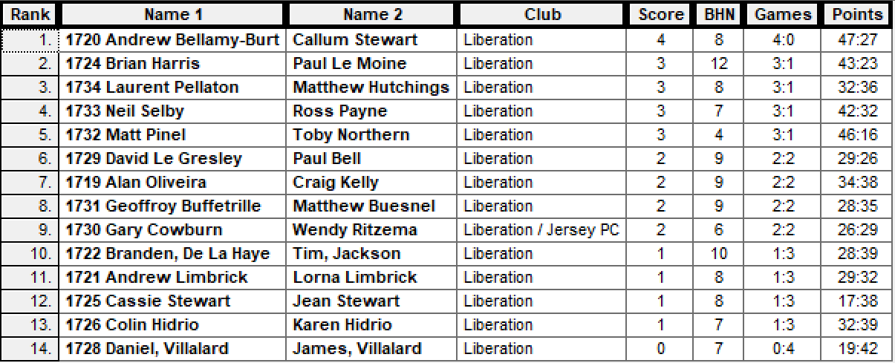

Semi – Finals
Ranked Ranked
1st Andrew Bellamy-B & Callum Stewart v Neil Selby & Ross Payne 4th
2nd Brian Harris & Paul Le Moine v Laurent Pellaton & Matt Hutchings 3rd

The Semi-Final one saw Ross & Neil open up a good lead going 9 – 4 up but then lost two four point ends not scoring again to lose 13 – 9.
Brian Harris & Paul Le Moine had already beaten Laurent Pellaton & Matt Hutchings 13 – 4 in round 3 so would have been confident. One big coche move saw Brian & Paul pick up big points and never looked in danger of losing as they almost repeated the score but for being timed out winning 12 – 4.
So Brian & Paul made the final for the second year running and for Brian his third final in five years. Brian & Paul only scored three points in the 2018 final so were hoping for a much better showing this year.
Indeed it was looking very close tied at 4 – 4 and with Andrew & Callum out of boules on the next end with Brian & Paul holding having only played one boule was looking good. However a strange shot choice saw Brian fire Paul’s boule out and they ended up losing the end and then the match without scoring another point as the 2014 winners Andrew Bellamy-Burt & Callum Stewart took their second Club Doubles title.
Laurent Pellaton and Matt Hutchings took third place with a 13 – 7 win over Ross & Neil for a good tournament for the Division 1 league team.
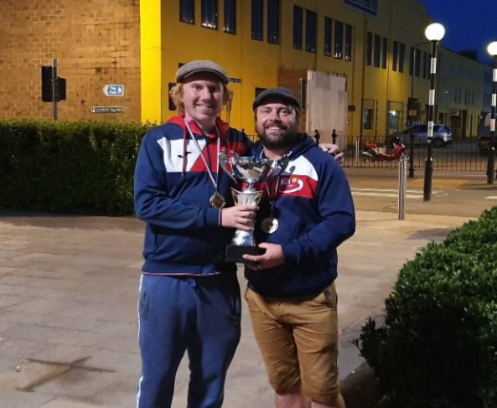
Special thanks to all those who helped prepare and set up and pack up at the end.

WEBSITE www.liberationpetanque.co.uk
EMAIL liberationpc@gmail.com

Kind Regards
Toby Northern
Chairman
Liberation Petanque Club

Summer 2019
Week 13 – 26th June 2019
Singles League
Things are tight at the top of the Premier League with Andrew taking top spot following a win over Neil Selby and a draw with Geoffroy but this is by just one point with second placed Matt Pinel having a match in hand, but will be disappointed at not being top after drawing with Richard who also drew with Andrew earlier in the season.
Ross Payne sits in third place after drawing with Matt Buesnel who gave the game away really by trying to shoot his own boule out and moving the coche which in the end cost him the first game. (Check your boules if they are similar). Matt is in fourth place as a result but also only played seven matches with an outstanding match against Geoffroy.
Toby retains fifth place despite beating Alex and is only three points off the top spot now.
Alex also drew with Brian who drops down the table to sixth place with Alex in a potential relegation place.
Laurent cup form is not translating to the league with two heavy defeats to Neil and Matt Buesnel and sits one place above Alex in tenth place with both players having played the full nine matches.
Keith and Geoffroy have both only played five matches this season so could change the leagues once they catch up. Alice also has two matches to play against Andrew and Keith.
Matt Ryan moved three points clear at the top of Division 1 following a big with over Harrison and with Callum drawing with Jake and having played an extra match doesn’t look as though anyone will catch him.
Paul Le Moine jumped into third place with a win over Paul Bell and could move above Callum with a match in hand.
Paul Bell moved off minus points (for the time being!) after a with over Matt Hutchings and Joey Le Clech missed out on the top three (for now) after a draw with Cassie.
Division two saw Andrew get just one point from two matches as he lost to Natasha Romeril in a match played in advance and drew with Luke but is still five points clear from Jean Stewart who has a match in hand so could close the gap, but Jean also drew with Lorna.
Big mover of the day was Tim Jackson who went from tenth to fifth place with a win over Mo who drops into the relegation places as a result. Tim now in with a shot of promotion.
Plenty of matches to play in this division with Stephen Stoneman having played just four matches could potentially move top if he wins the next five!

NEXT WEEK – DOUBLES LEAGUE – DOUBLE FIXTURE WEEK

Club email address - liberationpc@gmail.com

Club Website - www.liberationpetanque.co.uk

Kind Regards

Toby Northern

Chairman

Liberation Petanque Club

Summer 2019
Week 14 – 3rd July 2019
Doubles League
Prior to this week’s fixtures Mark & Dawn were blowing everyone away with 6 wins from 6 having also beat Island Doubles Champions Geoffroy & Matt Buesnel in a catch up match.
However they lost their 100% record and undefeated run on Monday when they lost to Neil & Ross.
Their first match was against Andrew & Callum who needed to win close the gap. Andrew & Callum took the first game 13 – 12 but suffered a heavy defeat in the second game for a draw.
Andrew & Callum then played Gary & Wendy who were looking at a top three finish themselves on current form. The games were not close by any means though as Andrew & Callum took the first 13 – 2 but then lost the second 13 – 4 for another draw.
Another team after the title was Matt Pinel & Toby but despite leading 7 nil missed chances to win 13 – 0 and ended up losing the first game 13 - 12 and it got worse in the second game as Brian & Paul made it two wins on the night by also beating Andrew & Lorna to move into contention for a top three finish.
Matt Buesnel & Geoffroy could not afford to drop any more points and played Eamonn & Karen Bougeard. But a difficult terrain saw them lose as Eamonn & Karen won their first Premier League match, well done. Matt & Geoffroy now 7 points off the top spot sitting in 7th in the league.
A relegation double header saw Matt Ryan & David play Alice & Brigitte, with three points needed by both teams. Matt & David won the first 13 – 0 as Alice & Brigitte keep up an impressive record of getting a certificate nearly every season. But full credit as they won the second game for a draw. They then beat David & Paul to move well clear of the relegation zone.
Andrew & Lorna who lost to Brian & Paul were fractions away from beating Neil & Ross just losing the second game 13 – 12 to remain bottom of the league.

OUTSTANDING MATCHES
Scheduled Date Date arranged
29th May Andrew & Lorna v Eamonn & Karen N/A (*)
12th June Brian & Paul v Andrew & Callum N/A
12th June Andrew & Lorna v James & Jake N/A
12th June Eamonn & Karen v Ross & Neil 8th July
12th June Matt & Toby v Andrew & Callum 8th July
3rd July Ross & Neil v Jake & James N/A
3rd July Matt & Toby v Alex & Cassie N/A
3rd July Mark & Dawn v Alex & Cassie N/A
3rd July James & Jake v Matt & Geoffroy 7th July
3rd July Eamonn & Karen v David & Matt N/A
(*) Passed the 4 week deadline to confirm new date

Division 1 saw Colin & Steve take maximum points with 2 wins, first against Colin & Karen Hidrio and then against Alan & Mike to move onto 21 points from 9 matches and 5 points clear of 2nd placed Helene & Natasha who lost to Alan & Mike and drew with Alan & Craig.
This ruined Alan & Craig’s 100% record but they have several matches outstanding having only played 5 matches.
Keith & Joao picked up 4 points from their two matches as they beat Harrison & Richard before drawing with Mo & Stephen despite handing them a 13 – 0 defeat in the first game.
Mo & Stephen did though beat Tim & Brandon to move out of the relegation zone with Tim & Branden bottom as a result.
John & Nick also played a rare match taking the three points from Jean & Chris.

OUTSTANDING MATCHES

15th May Alan & Craig v Joey & Brenden N/A (*)
29th May Alan & Craig v Harrison & Richard N/A (*)
12th June Alan & Craig v Alan & Mike N/A
3rd July Alan & Craig v Daniel & James N/A
15th May John & Nick v Harrison & Richard 8th July (*)
29th May John & Nick v Mo & Stephen N/A
12th June John & Nick v Tim & Brandon 10th July
12th June John & Nick v Keith & Joao N/A
3rd July John & Nick v Joey & Brendan N/A
12th June Helene & Natasha v Joey & Brendan N/A
3rd July Daniel & James v Tim & Brandon 24th July
3rd July Colin & Karen v Laurent & Matt N/A
3rd July Harrison & Richard v Jean & Chris N/A

(*) Passed the 4 week deadline to confirm new date

NEXT WEEK – SINGLES LEAGUE – DOUBLE FIXTURE WEEK

Club email address - liberationpc@gmail.com

Club Website - www.liberationpetanque.co.uk

Kind Regards

Toby Northern

Chairman

Liberation Petanque Club

Summer 2019
Week 15 – 10th July 2019
Singles League
Matt Pinel lost his first league match of the season to Toby Northern. Also big win for Andrew Bellamy who took all three points over Matt Buesnel and Geoffroy beat Richard.
Alice made it back to back wins to turn her season around with a win over Brian.
Laurent and Ross and Keith and Neil shared the spoils in their matches, with still a long way to go this season.

In Division 1 league leader Callum could only draw with Matt Hutchings but with second placed Matt Ryan losing to Joey with both these players aiming for at least a top three finish.
Harrison Marie won just his second match of the season against James Rondel who remains bottom of Division 1. Paul Le Moine kept up his pursuit of the top three with a win over Brigitte.
Elsewhere Paul Bell and David drew and Jake beat Cassie.

In Division 2 Natasha Romeril kept up her impressive form with a win over Branden and gained two points on league leader Andrew who drew with Brendan.
Draws for Daniel and James, Stephen and Jean and Lorna v Mo.

Club email address - liberationpc@gmail.com

Club Website - www.liberationpetanque.co.uk

Kind Regards

Toby Northern

Chairman

Liberation Petanque Club

Summer 2019
Week 16 – 17th July 2019
Club Singles Cup
27 players entered this year playing 5 rounds under the Swiss system before the knockout stages.
The current champion Andrew Bellamy-Burt almost fell at the first hurdle getting over the finishing line 11 – 10 against Mo De Gruchy to keep his hopes of another title on track.
A number of other close matches saw Ross Payne lose to Jean Stewart 12 – 10 a shock result matched by Matt Hutchings beating Callum Stewart. Wendy Ritzema beat Joey Le Clech 10 – 9 and Toby Northern beat Cassie Stewart 13 – 11.
New member Ivo Raitchev had a baptism of fire playing Mark Nicol, losing 13 – 1 but his doubles partner for our Doubles Open last week, Tom Le Sueur beat experience player Gary Cowburn 13 – 4.
Round 2 saw Mark continue by beating Neil Selby 13 – 6 and Andrew finding form against Branden De La Haye 13 – 4.
Toby came from 8 – 4 down against Keith Pinel to win 11 – 8. Ivo got his first win against Cassie Stewart and Tom beat Wendy 11 – 7.
Callum suffered another shock defeat this time to Stephen Stoneman but Ross Payne determined not to suffer the same fate beat Mo 10 – 5.
Big wins for Laurent over Jean 13 – 1 and Brian Harris 13 – 5 over James Villalard and Paul Le Moine made it two wins beating Matt Hutchings 10 – 8 despite not being keen on the quick format.
Paul though lost in round 3 to Ivo 9 – 8 and another close one was Brendan Jones who beat Doubles Open champion Paul Bell 11 – 10. Champion Andrew beat Toby and Geoffroy beat Laurent.
Tom Le Sueur lost his first match to Mark Nicol who joined Neil Selby on three wins.
Round 4 saw Neil Selby’s perfect use of time tactics out do Toby in a really close match with Neil winning 9 – 7 after Toby fired out the coche on the last end.
Mark beat Geoffroy and Andrew beat Brian as they became the only players on 4 wins. Ivo continued to shock as he overcame Gary Cowburn 10 – 8. Laurent beat Ross 11 – 10 to put Ross out of contention for a top 8 finish.
There were some surprisingly big wins for Paul Le Moine 13 – 2 over Jake Romeril and Tom Le Sueur 13 – 2 over Joey Le Clech. James Villalard got his second win 13 – 7 over Stephen Stoneman and Callum won his first match against Cassie.
The final round saw a host of players in with a chance of the top 8 but Mark Nicol finished top beating Andrew Bellamy-Burt 13 – 7.
Keith Pinels win over Ivo mean’t he jumped above Ivo into the top 8 finishing 6th with 4 wins from 5, just losing to Toby. Toby beat Joey to finish on 3 wins with a BHN of 15, one short of IVO who ended in 8th despite a minus 10 points difference compared to Toby’s plus 3.
Tom Le Sueur beat James to finish 3rd. Paul Le Moine obviously did like to quick format in the end as he beat Geoffroy 12 – 9 to finish 5th place, despite this Geoffroy finished 7th.
Neil Selby made 4th place in a head to head qualifier against Laurent winning 13 – 3, Laurent losing out as a result.

SWISS RESULTS BELOW
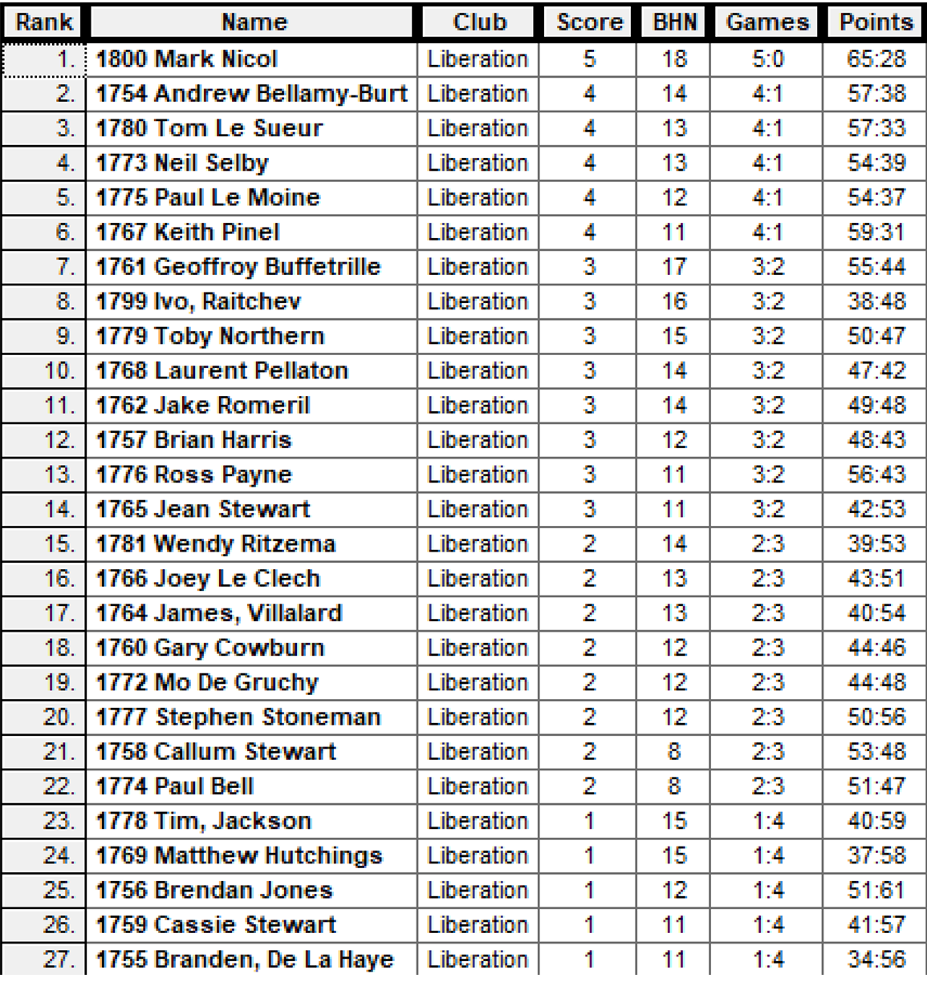

So the Quarter Finals were as follows:

Ranked Ranked
1st Mark Nicol v Ivo Raitchev 8th
2nd Andrew Bellamy-Burt v Geoffroy Buffetrille 7th
3rd Tom Le Sueur v Keith Pinel 6th
4th Neil Selby v Le Moine 5th

So Ivo played Mark Nicol again having lost 13 – 1 in round one and fairly new to the sport his chances were not rated very highly, however his excellent placing quickly gave him a 7 – 2 lead. Experience and skill though saw Mark through 13 – 8.
Andrew was 9 – 2 down to Geoffroy who was shooting everything out, but as this dried up Andrew came back in style to win 12 – 9. Another close finish saw Keith Pinel win 13 – 10 on the final end against Tom. Neil Selby made the Semi-Finals by beating Paul Le Moine 13 – 6.

Semi – Finals
Ranked Ranked
1st Mark Nicol v Neil Selby 4th
2nd Andrew Bellamy-Burt v Keith Pinel 6th

The Semi-Final one saw Neil shoot exceptionally well taking all three of Mark’s boules out on one end, combined with excellent placing made for a much closer match than the Round 2 match which Mark won 13 – 6. Finely balanced at 10 – 10 Neil placed his 2nd boule next to the coche. Mark attempted to shoot but moved the coche in Neil’s favour leaving him 2 metres to place in for 3 and the match, which he did.
Andrew was on top form against Keith and he needed to be, but again on the final end with Andrew 12 – 9 up left the end open for Keith to get three and tie, but Keith dropped his second boule just short, he then tried to push it on but missed meaning Andrew made the final again 12 - 10.
Keith Pinel took third place for a great tournament.
In the Final Neil nailed the coche with his first boule only for Andrew to shoot it out and the first few ends where really close before Neil’s excellent shooting against Mark failed him in the final with Andrew running clear for a 13 – 3 win.
This is Andrew’s third success in this competition and he is the first player to also retain the trophy.
Andrew has now won both club competitions this year having won the Club Doubles Cup with Callum Stewart in June.

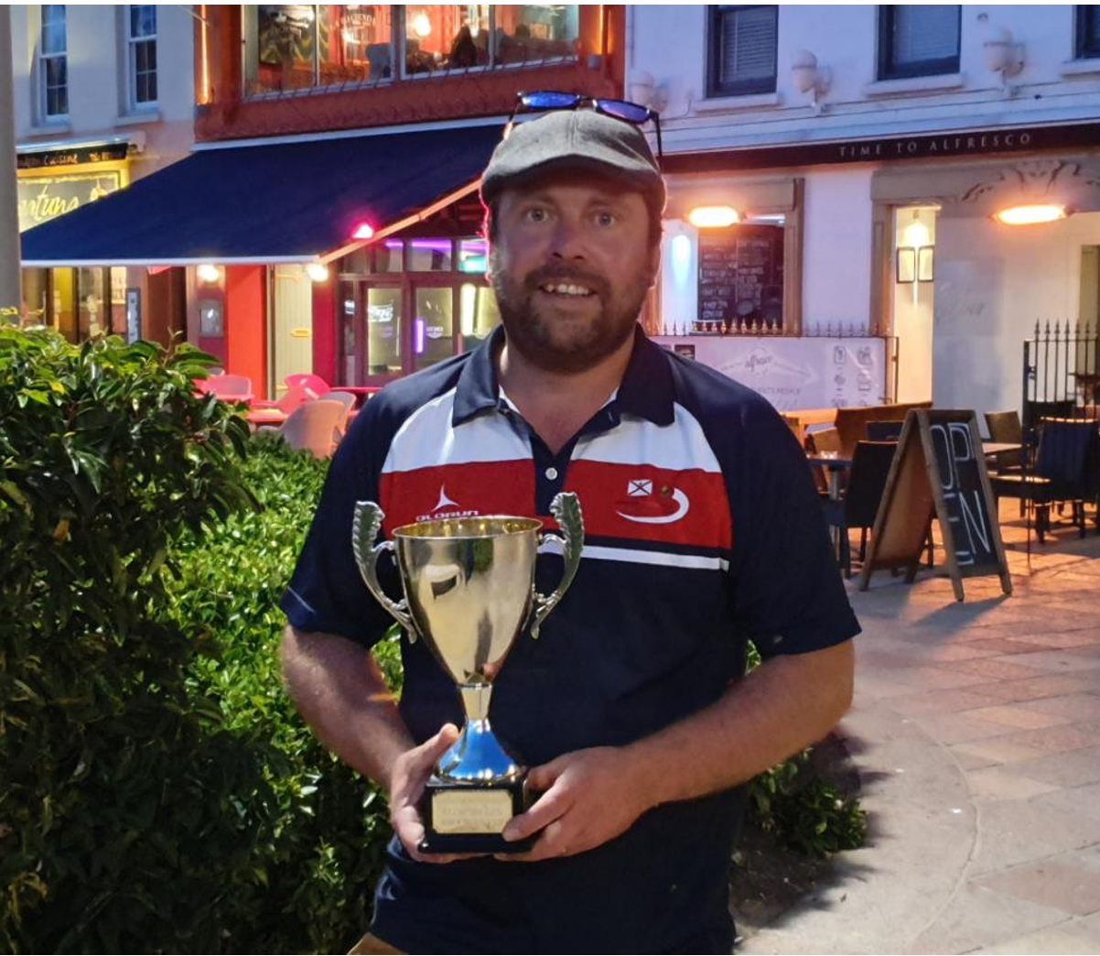

Special thanks to Ross Payne who helped prepare and set up and pack up at the end.
Club email address - liberationpc@gmail.com
Club Website - www.liberationpetanque.co.uk

Kind Regards
Toby Northern
Chairman
Liberation Petanque Club

Summer 2019
Week 17 – 24th July 2019
FREE WEEK

Club email address - liberationpc@gmail.com

Club Website - www.liberationpetanque.co.uk

Kind Regards

Toby Northern

Chairman

Liberation Petanque Club

Week 18
31st July 2019
Doubles League

Dawn & Mark are edging closer to the Doubles Premier League title despite a scare against Brian & Paul. The latter leading 11 -6 in the first game only to lose two ends later. Brian & Paul then lead 6 – 0 in the second game before losing 13 – 6. This result leaves Dawn & Mark two points clear of second placed Andrew & Callum who have played a match more.
Andrew & Callum won two matches on the day, first against Alice & Brigitte, a match played in advance and then they also beat Brian & Paul with the latter gaining just 8 points.
Toby & Matt played a catch up match handing out a certificate to Alex & Cassie on their way to a win although the second game was much closer.
Toby & Matt still have Mark & Dawn to play a win their could make it an interesting finish.
Ross & Neil saw then chances of the title vitually ended with a draw against Island Doubles champions Matt & Geoffroy who also now have little chance of beating those above them for another disappointing league season for the pair.
Eamonn & Karen moved clear of relegation following a big win over releagtion rivals Paul & David who now look certain for the drop with just 5 points from 11 matches.
Division 1 has seen a number of teams fall foul of the rules resulting in lost points. The leaders though are currently Alan & Craig by just one point over Colin & Steve who they play next but Alan & Craig have played a match more.
Alan & Craig won convincingly against newcomers Tim & Brandon building up an impressive +90 points difference.
Alan & Mikes hopes of promotion took a big hit against rivals Laurent & Matt who move into third place after winning the second game 13 – 12!
Mo & Stephen gained a good draw against Chris & Jean, with the latter losing a catch up match to Harrison & Richard. The was Harrison & Richards second win of the day after also beating Brendan & Joey to move clear of relegation.

Just three doubles weeks to go 14th & 28th August and 11th September.

Next Week Singles Leage

Club email address - liberationpc@gmail.com

Club Website - www.liberationpetanque.co.uk

Kind Regards

Toby Northern

Chairman

Liberation Petanque Club

Week 19
7th August 2019
Singles League

Andrew Bellamy-Burt remains top of the league despite a draw against Ross Payne with both players placing off the terrain in the final end of the second game.
Andrew did though beat Laurent as he finishes the season early as has bye in the final scheduled week on the 4th September. Andrew now has to wait on Matt Pinel who is the only person who can catch Andrew, Matt having three outstanding matches really needs to win them all for the title.
Geoffroy chance of the title ended with a draw against Toby, having won the first game 13 – 5, lost the second 13 – 3 and now cannot catch Andrew.
Toby remaining second for the time being and stays above Ross on points difference after Ross also drew with Keith Pinel and despite being in third has a -2 points difference to Toby’s +23.
Toby drew his match in advance against Neil missing a fire for the match and Matt Buesnel drew with Richard.
With all the matches scheduled fully upto date in Division 1 the table gives a good indication of the final placings.
Division 1 saw Callum go top after a win over title rival Paul Le Moine, this combined with Matt Ryan drawing with Jake means Callum is one point clear after the battle of the top four this week.
Joey gave himself a good chance of stealing a promotion place with a win over James Rondel who is the first person in Division 1 to be relegated. Joey is just one point off third placed Paul Le Moine and just three points off top spot.
Paul Bell gave him the best chanmce of survival with a win over Cassie depsite being 5 nil down after two ends in the first game. Paul now just one point off safety with a much better points difference than Cassie who is one point above Paul. Cassie plays Matt Hutchings in the final week of the season with Matt also one point off Cassie (and Harrison Marie).
Paul Bell plays Matt Ryan and Harrison who lost to Brigitte plays Paul Le Moine. Three huge matches determining promotions and relegations, with Callum needing a win against David Ibitson for the title.

Division 2 though is all sown up as Natasha and Andrew have already played each other in a match scheduled for the 4th September, with Natasha winning this one.
So Natasha just needed to beat James Villalard for the title, James though was giving her a tough time and leading 12 – 11 James was out of boules with Natasha holding one point, placing for ther game unfortunately Natasha knocked James boule into the holding position fo the game and although Natasha did get a draw had to then wait on Andrew’s result against Branden.
Andrew though took the title with a win, his second Division 2 title, Congratulations Andrew. Natasha finishing 2nd place.
The final promotion spot is up for grabs as Jean lost the second game against Daniel 13 – 12 for a draw so is just one point above Brendan Jones and James Villalard with one match to play.
Brendan also drew, against Tim as he missed his chance of moving into the top three.
A promotion match of the week will be James Villalard against Jean Stewart with James needing a win and a draw for Jean could see Brendan Jones take the final promotion spot with a win over Lorna.
The bottom three still to be decided.
Next Week Doubles Leage

Club email address - liberationpc@gmail.com

Club Website - www.liberationpetanque.co.uk

Kind Regards

Toby Northern

Chairman

Liberation Petanque Club

Week 20
14th August 2019
Doubles League

The big match of the week saw Matt & Toby try and put the pressure on Dawn & Mark by beating them which was their only chance of being able to catch them in the title race.
The first game saw Toby & Matt race into a 10 – 0 lead after 5 ends before Dawn & Mark pulled back 4 points but that was it as game one ended 13 – 4. The second game was much close but tied at 5 – 5 Matt & Toby picked up 4 points and although Dawn & Mark pulled back to 9 Matt & Toby got the win they needed meaning there is now just one point separating them.
The title tough is still in Dawn & Mark hands as if they win their final three matches against Andrew & Lorna, Alex & Cassie and Gary & Wendy they will win the league title.
Bottom team Andrew & Lorna were hoping to gain some points with a big result over Matt & Geoffroy unfortunately the result was far from it as they lost 13 – 2, 13 – 0. This was the 5th 13 – 0 loss in the Premier League so far (not all Andrew & Lorna’s!)
Ross & Neil played David & Matt with the latter needing points to avoid relegation and Ross & Neil hoping for a medal position. This was a long match and the scores showed why with Ross & Neil taking the first 13 – 12 and Matt & David taking the second 13 – 10. This match was not as close or nearly as long as Brian & Paul and Wendy & Gary who finished around 8.15 with the match ending with a 13 – 12 win for each team.
James & Jake needed a win over Paul & David to get clear of relegation but they just pulled off a draw winning the second game 13 – 12, meaning Paul & David remain in the relegation zone with Andrew & Lorna and alex & Cassie.
Division 1 saw Jean & Chris keep their hopes of promotion alive with a good win over Daniel & James. This was the only scheduled match played in Division 1, however Colin & Steve maintained they place at the top of Division 1 with a win over Natasha & Helene in a catch up match.
NEXT WEEK – CLUB SUPER 7’s CUP

Club email address - liberationpc@gmail.com

Club Website - www.liberationpetanque.co.uk

Kind Regards

Toby Northern

Chairman

Liberation Petanque Club

2019
SUPER 7’s CUP
21st August 2019

The last club cup of the year saw a 50% increase in entries with 24 players taking part compared to 16 in 2018.
So, 7 Rounds, of matches played and in each round players played just 7 ends. This meant there were some close scores as well as some very small points scored.
Round 1 saw some big matches as Ross Payne took on doubles partner Neil Selby with the latter running out comfortable winner 10 – 3. The Premier Leagues Laurent Pellaton took on Division 1 but double Island Triples Winner in 2019 Callum Stewart. It was the Premier League player though taking the match 7 – 4.
There were big wins for Paul Bell, 10 – 1 over Jean Stewart and Toby Northern 9 – 1 over Tom Le Sueur.
Andrew Bellamy-Burt just beat newcomer Branden De La Haye 7 – 6 and Brian Harris beat Gary Cowburn 5 – 4.
Round 2 saw Andrew Limbrick beat Geoffroy Buffetrille (2018 champion) 5 – 3. Last year’s 4th place finisher Richard Williams beat Laurent 7 – 5 to get revenge over his 3rd place play off opponent in 2018.
Paul Bell made in back to back 10 – 1 wins this time over Toby. Ross Payne recovered from his round 1 defeat to beat Tom Le Sueur 10 – 2. David Le Gresley beat Brian Harris and Neil beat Wendy Ritzema but two shocks from doubles pair Branden and Tim who beat James Rondel and Gary Cowburn respectively.
Round 3 saw Lorna Limbrick make it 2 wins from 3 over Toby. Neil beat Andrew 7 – 6 to make it 3 from 3. Callum beat European Triples partner Ross 8 – 2. Cassie Stewart made it back to back wins beating Wendy Ritzema.

Round 4
Lorna won big against Brian Harris 10 – 3 and Richard and Neil made it 4 from 4 with wins over Andrew Limbrick and David Le Gresley respectively.
Toby pulled off a great win over Gary Cowburn losing 4 -2 after six ends placed three perfect shots for a three to win 5 – 4 and move back into contention.
Andrew Bellamy-B won by one point for the second time, this time against Cassie 5 – 4. Mo De Gruchy won big against James V 8 – 1.
Round 5
Richard Williams topped the rankings after round 5 as the only player to win all his matches by beating Neil Selby 6 – 5. Another set of close matches saw
Geoffroy beat Callum 5 – 4 Wendy beat Paul Bell 5 – 4 Brian beat Jean 6 -5 James Rondel beat Daniel 6 – 5 James V beat Tom 7 – 6
Round 5 also saw Lorna make it 4 wins from 5 and comfortably sitting in the top 8 qualifying positions after a win over David Le Gresley 9 – 5.
Round 6
Richard Williams was certainly on a roll making it 6 from 6 this time with a 7 – 5 win over Andrew Bellamy-Burt. Neil won his 5th from 6 against Lorna and Callum made it 4 wins with a 9 – 1 win over David. Toby beat Laurent 6 – 3 to also move on to 4 wins as did Brian with a win over Andrew L.
Good wins also for James Rondel, 6 – 1 over Cassie, James V 5 – 4 over Branden, Mo 6 – 3 over Tim. This round also saw a rare double figure score as Geoffroy beat Wendy 11 – 2.
The final Round (7) saw a number of players still in with a chance of making the top 8 and qualifying for the Quarter Finals.
Richard Williams finally lost, to Geoffroy with the latter topping the rankings as a result with Richard finishing second.
Toby Northern beat Neil Selby 8 – 3 from 3 – 0 down to finish 5th with Neil retaining his third place despite the defeat.
Despite the third lowest BHN score of 20 Brian Harris beat Andrew Bellamy-B to finish on 5 wins and 6th place. This meant Andrew was one of three players on 4 wins to miss out on the top 8 finishing 10th by 1 BHN point.
Lorna Limbrick lost heavily to Callum Stewart 12 – 3 and this was ultimately her downfall as missed out on 8th place on points difference by 5 points and to make it worse it was to husband Andrew whose 6 – 4 win over Wendy meant he finished 8th. Callum though finished with the best points difference of +32!!!
Paul Bell beat doubles partner David 6 – 2 to also finish on 4 wins but missed out with a BHN of 26, in fact David’s loss also meant he missed out on the top 8 losing his last 4 matches after winning the first 3!
Tom Le Sueur won his last match against Jean Stewart to see who finished bottom. Mo De Gruchy gave Laurent a scare just losing 5 – 3 but ended with 3 wins which was a good performance in a very strong field.

FINAL RANKINGS
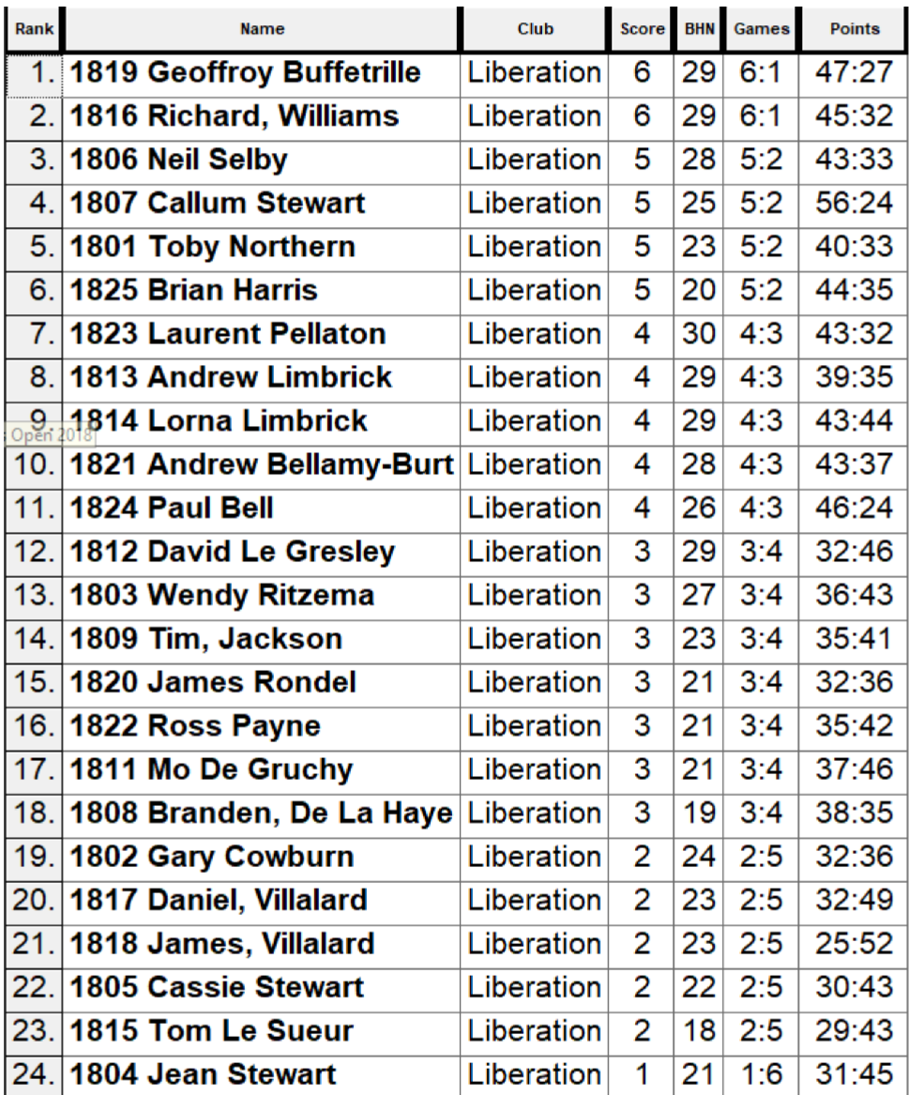

QUARTER FINALS
Ranked 1st Geoffroy Buffetrille v Andrew Limbrick Ranked 8th
Ranked 2nd Richard Williams v Laurent Pellaton Ranked 7th
Ranked 3rd Neil Selby v Brian Harris Ranked 6th
Ranked 4th Callum Stewart v Toby Northern Ranked 5th

Geoffroy versus Andrew was a repeat of Round 2 which saw Andrew win 5 – 3, Geoffroy’s only loss. However, experience knockout stage player Geoffroy won this time 6 – 2. Geoffroy was the only top four finisher to go through though as Richard Williams lost 6 – 5 to Laurent a player he beat in Round 2.
Neil Selby got out done by the terrains on one end as his boule rolled back past Brian’s boule into a whole on his way to defeat in another close one 6 – 5 to Brian. Toby though never looked in doubt taking a 5 nil lead and leading 6 – 1 after 6 ends resulting in Callum conceding defeat.

SEMI FINALS
Ranked 1st Geoffroy Buffetrille v Toby Northern Ranked 5th
Ranked 6th Brian Harris v Laurent Pellaton Ranked 7th
Toby again looked assured taking an early lead with some good shooting and placing and just with the result against Callum had an unassailable lead after 6 ends leading 6 – 2, but Toby and Geoffroy played the last end with Toby picking up another three points to win 9 – 2.
The second semi-final was much closer with Brian and Laurent tied 4 – 4 after 5 ends. The next end saw some great play from Brian as he fired all three of Laurent’s boules including two carreaux to pick up two points and lead 6 – 4 with one end to go. In the final end Laurent took Brian’s boule out to be holding 2 with Brian having one boule to play. Brian though placed through Laurent’s boule to get the final point for a 7 – 4 win.
In the Third Place Play-Off Geoffroy beat Laurent for the second time in the competition, this time 7 – 2 for another top three finish with Laurent having a third place in 2018 and a fourth place in 2019.
The final saw two top Premier League players take part, with the crowd shouting for Brian to win a determined Toby, never let up picking up 2 points of each of the first three ends with some excellent placing and shooting and in fact was 9 – 0 after 5 ends picking up another two points to win the title with 2nd ends to play.
The pair continued though with Toby making it 10 – 0 before Brian got 1 point on the last end as Toby cruised through the knockout stages conceding just 4 points against three of the Islands top players over his Quarter, Semi and Final matches.
Very well done also to Lorna Limbrick who finished 9th with 4 wins including wins over the two finalists!!
Well done to everyone taking partner we hope you enjoyed the club’s unique competition created by club chairman Toby Northern.
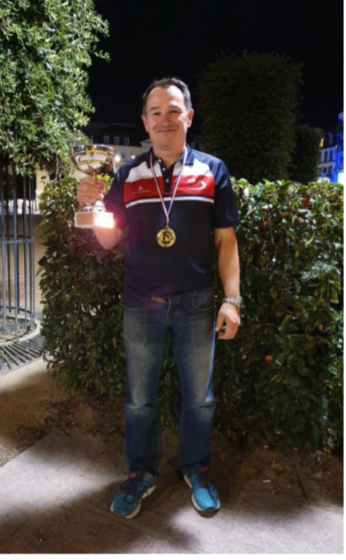
Thank you to everyone for supporting the competitions this year your support has been amazing.

NEXT WEEK – Doubles League
Club email address - liberationpc@gmail.com Club
Website - www.liberationpetanque.co.uk

Kind Regards
Toby Northern
Chairman
Liberation Petanque Club

SPONSORED BY


Summer 2019
Week 22 – 28th August 2019
Doubles League
The penultimate Doubles League matches were played with still plenty at stake. The top three all won in the Premier League so despite Matt & Toby beating Gary & Wendy and Andrew & Callum beating Jake & James, Mark & Dawns heavy win over Andrew & Lorna means all the have to do is win their last match of the season against Gary Cowburn & Wendy Ritzema and they will win the league.
If they draw or lose that would give Matt & Toby an opportunity to pip them to the title if they could beat Andrew & Lorna. Andrew & Callum really need Mark & Dawn to lose (due to points difference) and Matt & Toby to draw or lose as well as them winning their last match against who cannot now make the top three but could affect the outcome.
Ross & Neil beat David Le Gresley & Paul Bell, who as a result become the second team to be relegated after Andrew & Lorna.
David Ibitson & Matt Ryan drew with Geoffroy Buffetrille & Matt Buesnel, ending the latters top three chance but did nothing for their survival hopes as they must win their last match against Andrew & Lorna on the 11th September and hope Alex & Cassie and Brigitte & Alice drop points.
Alex & Cassie helped their cause by beating Eamonn & Karen and they also have a catch up against Gary & Wendy to play. Realistically David & Matt need Alex & Cassie to beat Alice & Brigitte in a catch up match to have any chance of survival.
Jake Romeril & James Gennoe could though be pulled into the bottom three as they have a -88 points difference after another heavy defeat this week to Andrew & Callum so a loss to Alex & Cassie in another relegation double header could see them relegated.
Brian & Paul heading for a midtable finish after a win over Alice & Brigitte.
Division 1 has seen quite a few catch up matches played but not many scheduled ones. League leaders Colin Myers & Steve Simpkin maintained their lead after a very good win over third placed Laurent Pellaton & Matt Hutchings but Colin & Steve can still be pipped to the title if they fail to beat John McGaw & Nick Pallot and Alan Oliveria & Craig Kelly win their final two matches against Keith Pinel & Joao Rodrigues (catch up) and Laurent & Matt.
Laurent & Matt need the points to secure promotion though as Harrison Marie & Richard Williams are tied with them on 19 points and only 4 points difference separates them after they beat Alan Mitchel & Mike Robinson who themselves are only one point of off the top three.
However, Joey Le Clech & Brendan Jones got a couple of wins this week and are also on 18 points but with a match in hand on the teams above and below. They have to play Mo & Stephen, Daniel & James and Tim & Branden on the last week of the season.
But also Jean Stewart & Chris Le Gallais on 17 points and Helene Retrosi & Natasha Romeril on 16 points could also make that third spot! So an exciting finish is on its way.
Outstanding Matches
Premier League
Matt Pinel & Toby Northern v Andrew & Lorna Limbrick 3rd Sept
Gary Cowburn & Wendy Ritzema v Alex & Cassie Stewart 4th Sept
Alice & Brigitte Ibitson v Alex & Cassie Stewart 31st Aug
Division 1
John McGaw & Nick Pallot v Colin & Karen Hidrion 4th Sept
John McGaw & Nick Pallot v Natasha Romeril & Helene Retrosi No Date
Laurent Pellaton & Matt Hutchings v Natasha Romeril & Helene Retrosi No Date
Mo De Gruchy & Stephen Stoneman v Joey Le Clech & Brendan Jones No Date
Daniel & James Villalard v Joey Le Clech & Brendan Jones 18th Sept
Colin & Karen Hidrio v Harrison Marie & Richard Williams No Date

Club email address - liberationpc@gmail.com

Club Website - www.liberationpetanque.co.uk

Kind Regards

Toby Northern

Chairman

Liberation Petanque Club

Summer 2019
Week 23 – 4th September 2019
Singles League
The final scheduled fixture week for the Singles League saw titles and relegations settled.
The Premier League title is in the balance as Matt Pinel win over Alice Ibitson means he just needs to win his final match, a catch up against Brian Harris to pip Andrew Bellamy-Burt to the title on point’s difference. Will he do it?
Andrew is guaranteed at least a top two, with Geoffroy taking third place following a win over Alex Stewart.
Toby Northern needed to beat Matt Buesnel to prevent dropping a several places with Matt and Ross able to jump above him, unfortunately despite winning the first match a bit of bad luck in the second game with a bizarre ricochet giving Matt 3 points helped him get a draw.
Ross Played Richard Williams who needed to beat Ross and Neil Selby in a catch up match to avoid the drop in his first season in the top flight. With Ross leading all the way in the first game despite giving Richard his first three points, Ross only just winning 13 – 12, but a much more comfortable result in the second for the win.
Neil Selby needed a win over Brian and Richard to avoid possible relegation in two relegation double headers with a least one of these three likely to go down. Neil though lost to Brian whose shooting was on top form, this ensured Brian’s safety. Neil though did beat Richard in the catch up match which ensured his safety whilst relegating Richard after just one season in the top flight.
Another relegation double header was Laurent v Keith, with Laurent needing to win to give himself a chance of staying up with Keith still having a catch up match v Matt Buesnel scheduled for the 22nd September (last day of the season!). Laurent did his part with a good win, however if Keith Beats Matt Buesnel he will stay up with the better points difference so a nervous wait for Laurent.
In Division 1, Callum Stewart just needed to beat David Ibitson to win the Division 1 title with Matt Ryan, Paul Le Moine and Joey Le Clech all still able to win the title.
Callum did just that, making it look easy as he also finished the season undefeated and therefore returns to the Premier League at the first time of asking.
Matt Ryan played Paul Bell who despite having a 6 point deduction could still have survived relegation with a win over Matt. Paul did win the first game ending Matt’s title hopes, but he did recover to get the draw to finish Runner Up. This combined with Harrison’s result below meant Paul was relegated.
Paul Le Moine played another relegation candidate in Harrison Marie. With Joey playing Brigitte Ibitson.
On one end in the match between Paul and Harrison it when it was tied at 11 – 11, Harrison put his second boule on the coche but Paul fired it, but the coche stayed in (Just! At 13 metres) and Harrison was holding 2. Paul placed a great shot to within a few inches of the coche only to see Harrison produce a great fire at 13 metres to take two points and the first game. This ended Paul’s hopes of promotion despite him winning the second game.
Cassie Stewart played Matt Hutchings with both players needing a win to stay up but a big defeat means Cassie will drop into the bottom division.
Jake Romeril win over already relegated James Rondel wasn’t enough for the experienced player to get promotion to the Premier League in a disappointing season for Jake.
Division 2 had already been won by Andrew Limbrick with Natasha Romeril finishing second. Third place though was up for grabs with Jean Stewart, Brendan Jones and James Villalard all hoping to get that final spot.
The big match was therefore Jean v James, if Jean drew she would be promoted, if James won he would go up difference. The first game though was won comfortably by Jean 13 – 5 so although James won the second 13 – 12 Jean takes that final spot swapping places with her daughter Cassie.
At the other end of the table Luke Canavan’s match v Stephen Stoneman was postponed but will decide a relegation place or two as both need to win to avoid the drop.
With Mo De Gruchy and Daniel Villalard having already their match meant Brandon De La Haye knew a win against Doubles League teammate Tim Jackson would see him safe and in fact move him above Tim, so more than just bragging rights was up for grabs in this match. However Tim proved the stronger player this season winning the match as Brandon ended in the bottom three.

FINAL SCHEDULED WEEK – NEXT WEEK IS DOUBLES LEAGUE – WED 11TH SEPTEMBER 2019.

Club email address - liberationpc@gmail.com

Club Website - www.liberationpetanque.co.uk

Kind Regards

Toby Northern

Chairman

Liberation Petanque Club

Summer 2019
Week 24 – 11th September 2019
Doubles League
The final scheduled Doubles League saw Dawn & Mark needing a draw to win the league, if they didn’t Andrew & Callum could pinch the title, but they had a tough match against Neil & Ross.
Dawn & Mark lost the first game after giving away a 6 on one end the Gary & Wendy unfortunately for Andrew & Callum when leading 8 – 7 they also lost a big end, losing 5 points as Neil 7 Ross then moved into a 12 – 8 lead and held this to win the first game, this meant that due to points difference Dawn & Mark had won the title before they played their last game. They went on to win this game as did Andrew and Callum with both teams getting a draw. This also meant that Matt & Toby finished runner up for the second season in a row after they beat Alice & Brigitte.
Relegation is in the balance as David & Matt need a draw from their outstanding match against Andrew & Lorna to move above Alex & Cassie who lost their last match of the season to Jake & James whose form turned a corner just in time to avoid relegation.
Geoffroy & Matt won their last match against David & Paul to finish fourth above Neil & Ross on points difference but it also meant that David & Paul joined Andrew & Lorna in being relegated.
So, two outstanding matches in the Premier League
David & Matt v Andrew & Lorna
Brian & Paul v Eamonn & Karen
Division 1
The title was in the balance prior to this week and Colin & Steve could have blown it losing their final match against John & Nick, however at late result from Alan & Craig confirming a draw with Joao & Keith and then their loss this week to Laurent & Matt meant Colin & Steve are this years Division 1 Champions, congratulations to the pair, well deserved.
Alan & Craig’s defeat actually means they may miss out on promotion ending the season on 24 points, if the final outstanding matches go against them. This is after their loss to Laurent & Matt who are just 2 points behind them on 22 points and still have Helene & Natasha to play.
Brendan & Joey win over Brandon & Tim means they are also on 22 points and they still have Daniel & James to play. Chris & Jean also could do it being a further 2 points back on 20 points could get third place with a win over Joao & Keith if the other results also go their way so an exciting end to the season.
Alan & Mike ended mid table after a draw against Mo & Stephen, which leaves the latter in danger of dropping into the bottom three if Daniel & James get at least a draw against Brendan & Joey.
Commiserations to Brandon & Tim finishing bottom, but playing their first season will only get better. Also, to Colin & Karen who join them in the bottom three.

So, 4 outstanding matches in Division 1.
Helene & Natasha v Laurent & Matt
Helene & Natasha v John & Nick
Colin & Karen v Harrison & Richard
Keith & Joao v Chris & Jean

Club email address - liberationpc@gmail.com

Club Website - www.liberationpetanque.co.uk

Kind Regards

Toby Northern

Chairman

Liberation Petanque Club

