Preschool Supplies List 2017-2018

*When Labeling items please label with first and last name in CAPITAL letters*

These are the items your child will need to bring with them to school every day:
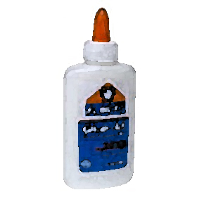
1 Lunchbox (please label)
1 Bag/Container for Daily Snack (please label; can be a ziplock bag, a small Tupperware, etc.)
1 Plastic or Stainless Steel Water Bottle 12-24oz (please label)
1 Backpack (please label)
1 Small Blanket (please label)
1 Small Pillow (please label)
1 Small Stuffed Animal (please label)

Please bring the following items to Open House in a labeled trash bag:
2 Changes of Clothes in gallon sized ziplock bag (please label)
1 Machine Washable Sleeping Mat (please label)
1 Box of Beginner Crayola Crayons
1 Pack of Construction Paper (multi colored)
1 Pack of Standard Weight Page Protectors
4 Elmer’s Glue Sticks
1 Bottle of Elmer's Glue
1 Pair of Blunt Scissors (please do not label)
1 Box of Gallon Ziploc Bags
2 Three-Pronged PLASTIC Pocket Folders (please do not label)
4 Rolls of Paper Towels (or more)
4 Containers of Clorox Wipes (or more)
2 Bottles of Foaming Hand Soap
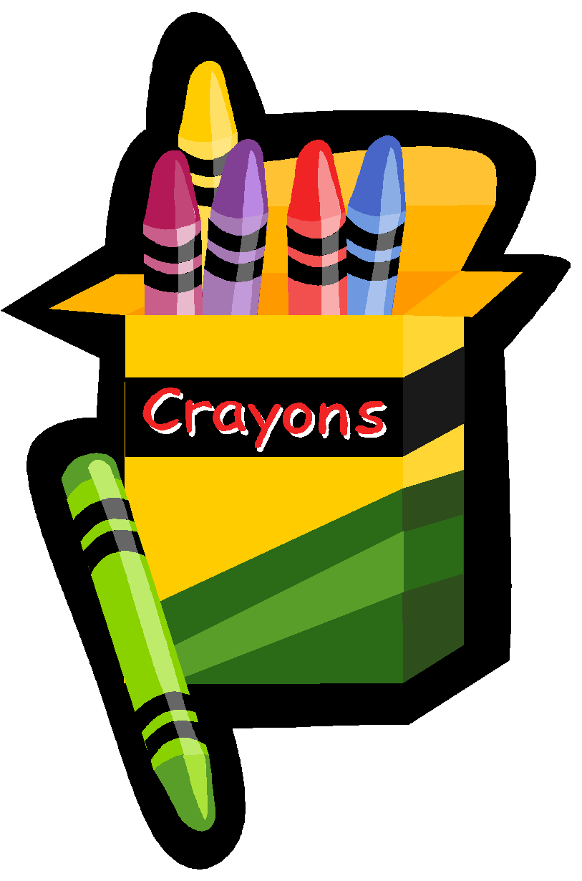
Optional: 1 Gift Card (Our Preschool Program includes Art & Science investigations throughout the year which require the teachers to purchase supplies as needed. If you are able to, a suggested donation of a $25 Amazon or Walmart gift card would be most appreciated. Mahalo!)

