Before you start: Save your document as a PDF
1. Click “Save As,” and choose a location to save your document.
2. Name your file, then in “Save as type” choose PDF. Click Save.
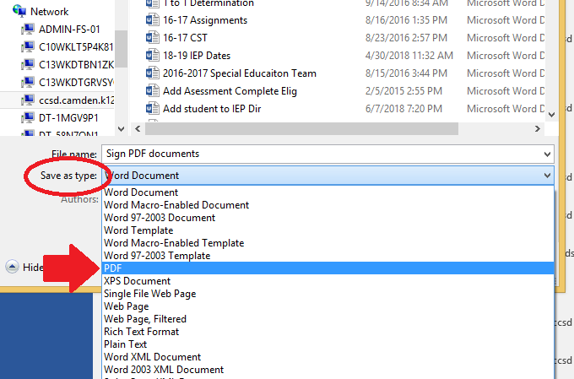

To add your written signature to PDF documents:
1. Sign a piece of plain, white paper.
2. Take a picture of your signature and email it to yourself.
3. Open the picture. At the top, choose “Open” and choose “Paint.”
4. At the top, click “View” and zoom out until you can see your signature at a normal size.
5. Click “Home” and choose the Select tool. Draw a box around your signature and click Crop.
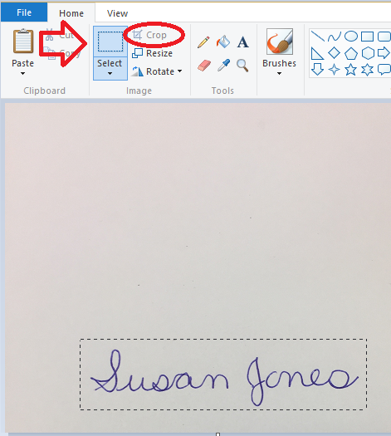
6. Click “File” and choose Save As. Choose a location to save your signature, name the file, and click Save.
7. Open the PDF that you want to sign. Look for and click the option that says “Fill & Sign.” This may be on the right side, or at the top of the document.
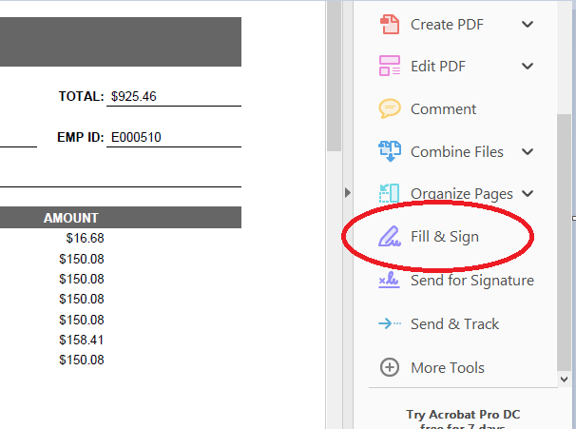

8. At the top, click “Sign” and choose Add Signature. (If there is already a signature there, click the minus next to that signature.)
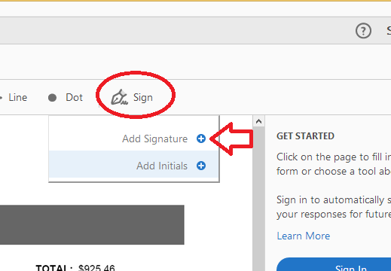

9. In the box that appears, Click the Image icon. Search for and select your saved signature. Then click Apply.
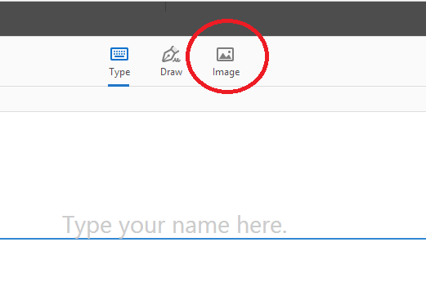
10. Now the signature is attached to your cursor. Scroll to where you want to place the signature and click to put it there. Once you click, you can move the corner of the box to adjust the size of the signature.
11. Click “File” and choose Save As to save your signed document.

NEXT TIME: The next time you need to sign a PDF
1. Click “Fill & Sign”
2. Click Sign
3. Your signature will be there. Click it and place it on your document, then save your signed document.
