FIFTH SUNDAY OF EASTER
MAY 18 & 19, 2019
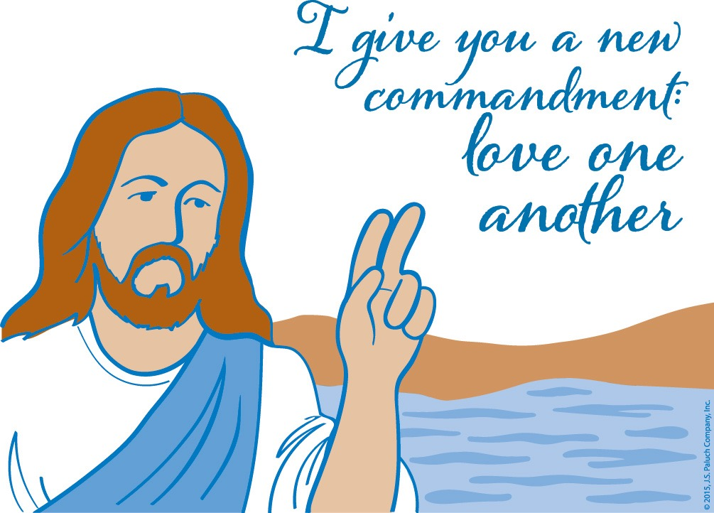
MISSIONARIES OF MERCY

Paul’s back! After last week’s “violent abuse,” opponents organized a lynch mob that beat Paul nearly to death. But call Paul the “energizing evangelist,” transforming deadly cruelty into life-giving zeal. Paul’s past courage should inspire our commitment; Revelation’s future “new heaven, new earth” should inspire our optimism. But Revelation’s present assurance, “Behold, God’s dwelling is with the human race,” because Pope Francis declared that the Church’s credibility is completely dependent on our showing unconditional mercy. Mercy, said Francis, makes the Church, the world, and everyone young again, reawakened to life’s noblest virtues. Fittingly, in today’s Gospel, Jesus reinforces that theme: “This is how all will know you are my disciples, if you have love for one another.”

LAWS AND RULES
By Dennis Tavares

Ignorance of a traffic law is no excuse in traffic court. Lack of knowledge of a law or rule is not the only thing that causes trouble or disaster. What we know that ain’t so also causes problems. Whether we don’t know that marijuana affects our reaction time, or think that it doesn’t, will not make any difference, if we need to make a quick change of driving course and end up in a collision. The same is true for navigating to heaven. There are many false ideas about the Catholic Church that keep people away from becoming disciples. Fortunately, many have overcome this and “crossed the Tiber River“ into St. Peter’s world, which has the Sacraments and Graces to help us get to heaven safely. So why tempt fate? Why hesitate? Let Peter navigate as he has the only keys to heaven’s gate.

PRAY FOR OUR FAMILY AND FRIENDS THAT ARE IN THE MILITARY SERVICE
Rebecca Sánchez, José Araiza Jr., Edgar Toscano, Marina González, Alondra Jara, Sonia Jara, Jason Lorenz,
Matt Mill & Jared Schroeder

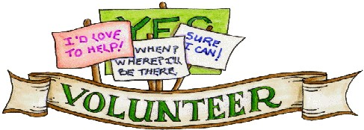

Being a Church Volunteer:

Why is it important?

Do you want to know what really keeps a church alive and prosperous? Many people would say that it is the Pastor. People firmly believe that the role of the Pastor is extremely important; however, Church volunteerism is the lifeblood of any church.
Think about it. It takes a lot of work to make a church function. Without the efforts of many spirit-filled believers any church would fall apart. The Pastor and other salaried staff can’t do it alone.
There are some people that just come to church weekend after weekend and they never make any type of contribution. This is a sad reality. People take and they take, but they never give back. Realize that there are some people who need to sit, receive and experience the love of God before they can participate in any manner.
No matter what our gifting or aptitude, there are plenty of ways for us to serve God and his people. We don’t need to be a Minister or Worship Leader in order to make an impact in our local church. Every role is important to the development of God’s kingdom.
Is volunteering in church a huge time commitment? That is not necessarily the truth. Our service doesn’t have to be an ongoing thing. We can serve on a rotational basis and still make an impact.
Getting involved is as simple as opening our mouth. If we see an area you want to participate in, find the person in charge and say something. Let them know from the beginning how much time we are able to commit. There is a spot for all.
If we want to see our church grow and prosper, then let us encourage one another to volunteer and give our time. Our church does so much for us spiritually and sometimes naturally. Start giving our time and we’ll begin to see God bless us and our church.

SPECIAL ALTAR SERVERS TRAINING
ON MAY 23RD, 2019 FROM 5:30PM - 6:30PM,
FATHER ANDRE WILL CONDUCT A SPECIAL TRAINING FOR ALTAR SERVERS.
EVERYONE IS INVITED WHO WOULD LIKE TO SERVE OUR CHURCH.
SEE YOU THERE!!

OLGC’S MEMORIAL TREE
In the vestibule of the Church, on the southern wall, is a beautiful Memorial Tree.
Its bright leaves represent permanent memorials to the departed of our Parish.
For the sum of $200.00, you can give to the Parish Secretary, the correct spelling and dates of the departed and in due time the leaf is printed and attached to the tree: a permanent reminder of a loved one who is gone.
For more information, call the Parish Office at
964-0229.

READINGS OF THE WEEK

Monday: Acts 14: 5-18; Ps 115: 1-4, 15-16; Jn 14: 21-26
Tuesday: Acts 14: 19-28; Ps 145: 10-13ab, 21; Jn 14: 27-31a
Wednesday: Acts 15: 1-6; Ps 122: 1-5; Jn 15: 1-8
Thursday: Acts 15: 7-21; Ps 96: 1-3, 10; Jn 15: 9-11
Friday: Acts 15: 22-31; Ps 57: 8-10, 12; Jn 15: 12- 17
Saturday: Acts 16: 1-10; Ps 100: 1b-3, 5; Jn 15: 18-21
Sunday: Acts 15: 1-2, 22-29; Ps 67: 2-3, 5, 6, 8;
Rv 21: 10-14, 22-23; Jn 14: 23-29

VERY IMPORTANT MESSAGE

WE ARE UPDATING OUR PARISH REGISTRATION LIST.
PLEASE TAKE A FORM AND GIVE US YOUR CURRENT INFORMATION.
YOU CAN PUT IT IN THE COLLECTION BASKET, RETURN IT TO THE OFFICE, CALL US AT 707-964-0229 OR E-MAIL US AT olgcinfb@gmail.com.

KNIGHTS OF COLUMBUS

FATHER’S DAY BARBEQUE TRI-TIP ROAST SALE
SATURDAY, JUNE 15TH, 2019
PRE-SALE ORDERS, PLEASE CALL 707-480-4614
MARINATED BBQ’D, READY TO EAT
AT $25.00 EACH.

MASS INTENTIONS
MAY 22 - 26, 2019
Wednesday (22)  Thursday (23)  Friday (24)  Saturday (25)  Sunday (26) | 12:05pm  12:05pm  12:05pm  5:00pm  6:30pm  8:00am  10:00am | Edward & Marian Lotten †  Alberta & Robert Wooden †  Epifanio Rentería †  Angeles Rentería †  Fred & Clara White †  Edgar Rosas (birthday)  Gabriel Rodríguez †  Brianda Venegas †  Missa Pro Populi  All 2019 Graduates from FBHS  José, Ubaldo & Rogelia Muñoz †

PLEASE PRAY FOR OUR SICK PARISHIONERS
Frank Richards, Richard Braga, Lisa Wright, Ricardo Contreras, Florencia Chávez, Refugio Yáñez, Tarcicio García, Sofía García, María de Jesús Mendoza, Antonio Cazares, Ana García, Ryan Moore, Jane Vartanian, Marianne Brannan, Lilia Parrish, Nancy Smith, Julián Palomar, Luisa Martínez, Jennifer Vera, John Braet, Kim Koskinen, Margaret Valencia, Matthew Marcoulier, Dennis Tavares, Jose Freitas, Alfredo Sousa, Juana Ar reguín, Aron Yasskin, Victoria Walzer, Fidela Yáñez Jara, Erika Ramos, Bill Gibson, Carla Tomas, Erasmo Yáñez, Memo Soria, Patricia Vargas, Fidela Yáñez, Elvia Flores, Yonel Ruíz, Angie Freitas, Russel Bryant, Derrick Heater, Luis Angel, Juan Barrera-Terán, Gabriel Hurtado, Gerald Butler, Helen Reynolds, Toni Clark, Ann Gallagher, Brianna Lopez, Margaret Milliken, Gina Pivirotto, Nick Quin, Mary Servis, Denis Sousa, Victor Venegas, Matty Walker, Charles Lorenz, Rebecca Lorenz, Ofelia Ibarra, Leonardo Naal, Gina Leal.

WEEKLY COLLECTION
MAY 11 & 12, 2019…..$2,309.00
MAINTENANCE FUND….$713.00
THIS WEEKEND’S SECOND COLLECTION:
CATHOLIC HOME MISSIONS.
NEXT WEEKEND’S SECOND COLLECTION:
YOUTH MINISTRY.
THANK YOU
FOR YOUR SUPPORT & CHRISTIAN GENEROSITY.

