Kids SmART, Inc.
SPRING BREAK CAMP
@ Emory
Kids SmART, Inc. is excited to offer our Spring Break program to you this upcoming break! Below is a brief overview of what we have planned to keep your children entertained and having fun throughout their entire break.
Please call 720-550-6728 or email admin@kids-smart.com to get signed up, or with any questions you may have.
Remember: We accept ALL forms of government subsidies and offer additional discounts to families that qualify.
********************************************************************************
Date Overview Cost
Mon, March 25 FT: Swim @ Ridge Rec 11a-3p $45
Tues, March 26 Theme: What Grows in CO $35
Wed, March 27 FT: Lunch @ Tapatio 10-1 $45
Thurs, March 28 Theme: CO Road Trip $35
Fri, March 29 OUTREACH: Bricks for Kids 930a $45

Pay/sign-up by 2/25 and receive 10% off!
********************************************************************************
Hours: 6:30a-6:00p Ages: 5-14
Location: Emory Elementary (1275 S. Teller St., Lakewood) - cafeteria

Things to Bring Everyday: - Breakfast - AM Snack - warm clothing
- SACK Lunch - Swimsuit/towel on Monday!

Register/Pay by Feb 25 to ensure a spot!
(MUST schedule and pay by March 20th to receive scheduled rate; drop-in rate is +$5/day)

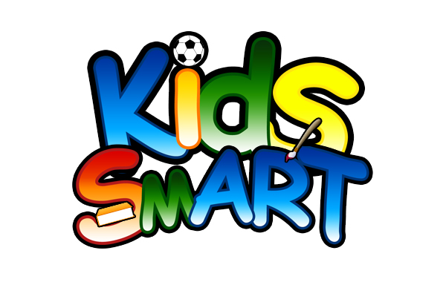
Kids SmART, Inc. also offers an on-site Before and After School Programs.

Visit us online at www.kids-smart.com for more information

