SUNDAY | MONDAY | TUESDAY | WEDNESDAY | THURSDAY | FRIDAY | SATURDAY
 |  |  |  | 1  BINGO  Social Circle and Apple Cider | 2  Painting  Music with Greg and Michael | 3  Hallmark Movie  Draw/Color
4  Golden Girls  Puzzles | 5  BINGO  Devotion with Randy & Shelaine | 6  Puzzles  Social Circle & Hot Cocoa | 7  Flag Craft  Music with Taylor Grace | 8  TRIVIA  Popcorn | 9  Veteran’s Day Program  Music with Mike Darling | 10  Andy Griffith  Bean Bag Toss
11  Hallmark Movie  Ring Toss | 12  Balloon Ball  Dan and Bart | 13  Manicures  Bible Blurt | 14  Paint  Singing and Devotion with Mr. Howard | 15  BINGO  Social Circle and Hot Cocoa | 16  Bible Blurt  Music with the Hallmarks | 17  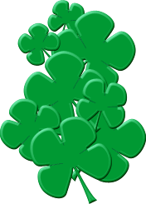  TV Land  Puzzles
18  Andy Griffith  Draw/Color | 19  BINGO  Karaoke | 20  Puzzles  Thanksgiving Trivia | 21  Craft  Singing (Eastern Sky) | 22  Happy Thanksgiving!  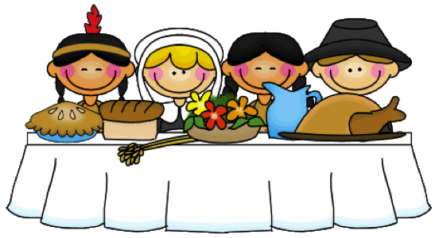 | 23  Price is Right  Bingo | 24  Hallmark Movie  Balloon Ball
25  TV LAND  Puzzles | 26  Bible Blurt  Music (Moon Tree Band) | 27  Manicures  Social Circle | 28  Anna Thorn  Music w/ Martens | 29  Rhyme Time  Caramel Apples | 30  Music with Erik Smallwood  Music with Mike Mann | 