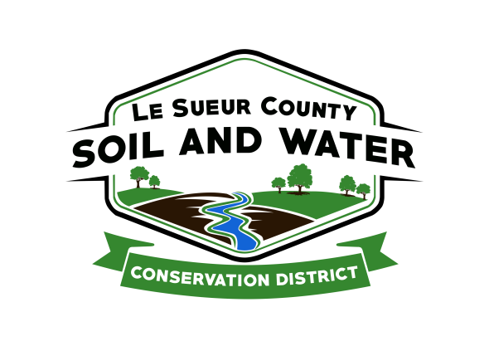

Le Sueur County Soil & Water Conservation District

Le Sueur County SWCD Tel. (507) 419-0365
181 W Minnesota St Website: www.lesueurswcd.org
Le Center, MN 56057

Minutes from August 12, 2021 regular board meeting of the Le Sueur County SWCD Board of Supervisors. Le Sueur County Justice Center, Le Center, MN.

Meeting was called to order by Chairman Struck at 9:00 am.

Members absent: Chairman, Jim Struck
Vice-Chairman, Greg Entinger
Secretary, Earle Traxler
Treasurer, Cletus Gregor
PR&I, Glendon Braun

Others present: District Manager, Mike Schultz
District Conservationist, Steve Breaker
Ditch Specialist, Nik Kadel
District Technician, Joe Jirik
Resource Technician, Karl Schmidtke
Program Specialist, Sue Prchal

The Pledge of Allegiance was recited.

Secretary’s report from July 13, 2021 was read and approved.

Motion by Entinger, second by Traxler to encumber $7200.00 for contract #cc-2021-1 for Nathan Ebert 80 acres of cover crops.
Affirmative: All
Opposed: None
Motion carried

Motion by Traxler, second by Braun to encumber $7200.00 for contract #cc-2021-3 for John T. Hoefs 80 acres of cover crops.
Affirmative: All
Opposed: None
Motion carried

Motion by Entinger, second by Traxler to encumber $6030.00 for contract #cc-2021-2 for Bryan Kaisershot 67 acres of cover crops.
Affirmative: All
Opposed: None
Motion carried
Motion by Entinger, second by Traxler to encumber $38,862.90 for contract #JG-2021-2 for Rod Traxler tile outlet protection project.
Affirmative: All
Opposed: None
Motion carried

Motion by Traxler, second by Entinger to pay $4472.81 to Mike Schwamberger for completion of contract #JG-Match-2021-2, sediment basins.
Affirmative: All
Opposed: None
Motion carried

Mike discussed the Memorandum of Understanding that is being put together between the SWCD and Le Sueur County.

Mike, Sue & Cletus will be meeting with the Le Sueur County Commissioners on Monday, August 16, 2021 to discuss the 2022 budget.

There will be an in person Area 6 meeting on Tuesday, September 21, 2021 in New Ulm at Turner Hall. More information will be available at the September board meeting.

Nik gave the board updates on the county ditches such as improvements, tree removal, replacing culverts, repairs and redetermination of benefits.

Mike and Steve discussed Covid-19. With the new delta variant spreading, USDA will keep doors to enter into the building locked, masks will be worn by federal employees and amount of staff working in office has been reduced.

Mike has been meeting with Le Sueur County discussing dollars that the county received from the federal government for Covid-19 to be used to benefit the public. Clean water projects have been brought up to use the dollars on.

Steve gave the NRCS report. He talked about the opening up of CRP land for haying, increased CRP rates, re-enrollments of CRP and EQIP.

There being no further business, meeting adjourned at 10:27 am.

__________________________ _____________________________________________
Date District Secretary

