

SUMMER – 2021 SEASON
WEEK 6 – 12th May 2021
DOUBLES LEAGUE

Well Week 4 was all about the draws, how would it turn out this week? Would the first proper rain of the season affect performances.

The big match of the week was probably Andrew & Callum against Geoffroy & Matt Buesnel. Matt Buesnel rich vain of form continued in the doubles with a great team performance handing Andrew & Callum a massive defeat 13 – 4, 13 – 0.

Gavin & James have had a good start to the season but played one of the toughest teams to beat in Colin & Steve. Gavin & James though had an even bigger win than Geoffroy & Matt winning 13 – 3, 13 – 0.

In the Premier League defending champions Matt Pinel & Laurent took on Alice & Brigitte who were continuing their struggles from the winter season. Well Laurent & Matt remain top of the league with another win, but only on points difference over Gavin & James.

Could Brian & Paul turnaround their early season struggles against Alan & Joey, the answer was yes as they won their first match of the season moving up to fourth place as a result. Would Gary & Wendy take points off one of the pre-season favourites in Neil & Ross. Well yes they did but only just after losing the first game Gary & Wendy took the second one 13 – 12 for their first point of the season with Neil & Ross, now having drawn all three matches.

In Division 1 Alex & Jean lead the way on 4 points, but could they make it 7 points with a win over John & Nick? Not this time as draw specialist John & Nick shared the spoils winning the second game 13 – 11.

Brandon & Tim and Matt & Mo both with just a draw to their name could one get their first win and catapult them up the table. Another draw here with big game scores either way 13 – 2 to Brandon & Tim and then 13 – 5 to Matt & Mo.

Kat & Paul were expected to get the three points against Daniel & James, but a very close match ended with a Daniel and James second game win 13 – 9 for a valuable draw.

Alex & Jean still top the table with Alan & Mike in second having only played one match so far.

NEXT WEEK - SINGLES LEAGUE

Club email address - liberationpc@gmail.com

Club Website - www.liberationpetanque.co.uk

Kind Regards

Toby Northern

Chairman

Liberation Petanque Club

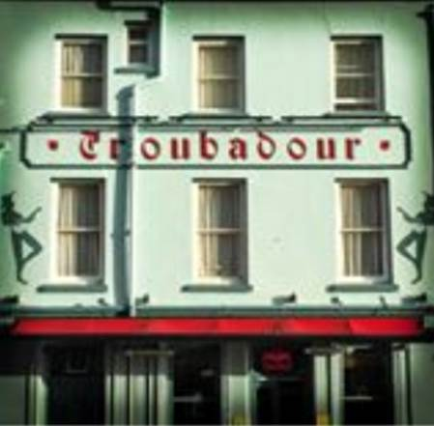
SPONSORED BY

