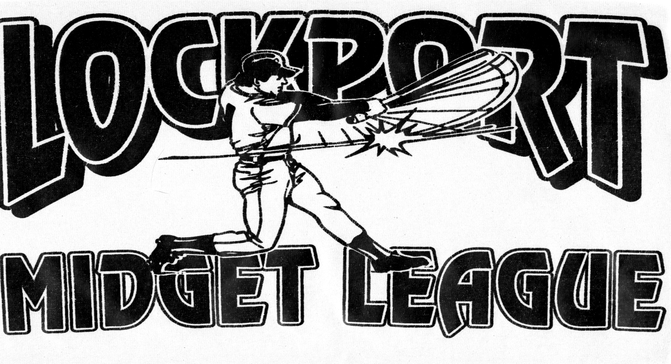
www.lockportmidgetbaseballleague.com

Rules & Regulations

2017

Lockport Midget Baseball League
P.O. Box 1506
Lockport, NY 14094

Serving Lockport and the Surrounding Community since 1939

2017 LMBL

Code of Conduct
As a member of the Lockport Midget Baseball League, I pledge myself to:
- Demonstrate at all time the highest ideals of good sportsmanship.
- Give my best effort no matter what the score or playing conditions may be.
- Respect all league officials, rules, opposing players, spectators, sponsors, the Lockport Midget Baseball League, and myself.
- Carry on the ideals of fair play and clean competition that have been established by the Lockport Midget Baseball League

General Rules
1. If the City of Lockport’s Highway and Parks Department, other Town Parks Department and Roy-Hart deem a diamond as unplayable, then under no circumstances will any team be permitted to use or work on the diamond.

2. Sponsors are allowed to furnish uniforms, for their Teams at any time. We encourage Teams to Seek out Sponsors to Defray the Costs.

3. Anyone indebted to the league for money and equipment at the end of the year will not be accepted for consideration in any capacity in the Lockport Midget Baseball League in the future.

4. Spectators are not allowed on player benches during a game.

Rules & Regulations Governing Board of Directors
1. Officers and Directors of the Lockport Midget Baseball League shall attend all Board of Directors meetings and determine the directions and courses of action regarding the operation of the League.

2. The Lockport Midget Baseball League will control team franchises from year to year.
A. Entry Fee will be $1,300.00 per“A”LeagueTeam. Per “B” League Team $1200.
B. We encourage teams to seek out sponsors to defray the costs.

3. League Presidents will handle any protests and disciplinary action concerning Players, Managers, and Spectators.
A. The rules committee, upon request of League Presidents, will act as an advisory board concerning disciplinary actions and protests.
B. All protests must be mailed or delivered to the League President within 24 hours of the completion of the game, exclusive of Sundays and Holidays.
1.) A $10.00 fee must accompany the protest. If the protest is upheld, the fee will be returned to the Manager. If the protest is defeated the fee will be remanded to the League Treasure.
2.) Coaches/Manager may attend Board Meetings with permission of the League Presidents, where they fail to resolve problems at the President’s level. The President however, must be in attendance at that meeting.

4. The Awards Committee will select a Most Valuable Player and any other awards deemed appropriate for both Leagues.
A.TheLeague Presidents will conduct voting amongst Managers/Coaches in order to present the top selections for Most Valuable Player.
B. Votes will be tabulated by the Awards Committee and will remain confidential until the annual Banquet.
C. The members of the Awards Committee will select special awards.

1
Rules & Regulations Governing Players
1. All players must RESIDE in the City of Lockport or any town approved by the Lockport Midget Baseball League Board of Directors.
A. Lockport Midget Baseball League Teams must have only players that reside in your City or Town, except for Special Circumstance(s) that must be approved by the Board of Directors.
B. If a Player and/or Team want an exception to the Residency Rule, they must put their request in writing, with reasons why an exception should be made. This request should then be forwarded to the appropriate League President for presentation to the Board of Directors.

2. All Players must meet the following guidelines regarding age.
A. In the “A” League, a Player who reaches their 18th birthday before September 1st will be considered eligible for play.
B. In the “B” League, a Player who reaches their 15th birthday before September 1st will be considered eligible for play.
1.) Any Player may apply for a waiver to the age rule. All eligibility rulings will be made by the Rules Committee

3. All members of high school varsity and junior varsity teams are eligible for play as long as the respective school do not have a game or practice on a Lockport Midget Baseball League game or practice day.

4. If a Player is released from a Team, he cannot be re-signed by that Team in the same season or play with another Team until he has signed a new contract and been approved by the League President.

5. All Players must wear full uniforms provided by the sponsors and the Lockport Midget Baseball League
A. Player not wearing full uniforms will not be allowed to play.

6. No Catchers shall be permitted to take his/her position during the game without a CUP and full catcher’s equipment on.

7. All other Players should wear a protective cup and use proper equipment at all times.
A. A Player warming up a pitcher must wear a helmet and a mask.

8. Any Player ejected from a game by an umpire for UNSPORTSMANLIKE Conduct,maybe Suspended for the next scheduled game, and must be in attendance at that game, on the bench and in uniform. The Rules Committee will act as an Advisory Board concerning Disciplinary Actions.

9. The Board of Director’s reserves the right to the final determination of the eligibility of any Player in the League.

10. Any Player using a name other than his own will be barred from further participation in the League.

11. If a Manager, Coach or league member claims a Player is ineligible, they must enter a written protest before the next scheduled game to the President of their respective League.
A. If the protest is upheld, all games in which the ineligible Player participated will be forfeited.

12. All Players are responsible for returning all League uniforms and equipment at the completion of their playing season.

13. Players must remain on the bench with their team during games, except for warming up.

2

Rules & Regulations Governing Umpires
1. Umpires are delegated full responsibility of all games and are required to enforce all Rules &Regulations of the Lockport Midget Baseball League and the Lockport Umpires Association.

2. Umpires are required to carry proper equipment.

3. Umpires will have the responsibility, along with League Presidents, in determining whether or not playing fields and equipment are suitable for use.
A. If the playing field is declared fit before game time, the contest is to be played as scheduled.
4. An umpire must sign the home team’s scorebook certifying the game’s outcome.

Rules & Regulations Governing Coaches/Managers
1. Every team must have 1 Manager and at least 1 Assistant Manager that are at least 18 years of age, who may act as Coaches.
A. Younger Assistant Manager/Coaches may help in the “B” League, with approval from the Board of Directors.

2. The Team Manager/Coach will have to right to suspend a player for due cause on or off the field during a Lockport Midget Baseball League activity for a maximum of one (1) game.
A. Any further violations by a player will result in a penalty assessed by the respective League President. Violations must be reported in writing.

3. Special Rule will apply concerning Players Playing Time.
A. All Players must playat least 3 CONSECUTIVE DEFENSIVE INNINGS and 1 at BAT in the Regular Season Only.
B. DOUBLE HEADERS - 2 FIVE INN Games Equal a Double Header. ALL PLAYERS must get at least one at BAT.
4. Special Pitching Rules.
A.) ANY pitcher that pitches more than four (4) innings in a game is ineligible to pitch again until he or she has had three (3) full days of rest.
3.)Most Innings a PITCHER can PITCHin a GAME is CAPPED at 7 INNINGS.
4.) Any Player who Pitches for a travel team shall not pitch in excess of eight (8) innings during the week for their respective league team, regardless of when he last Pitched or his Team’s Season Ends.
a.) No more than a maximum of three of the eight (8) innings can be pitched on a Friday.
b.) A pitch thrown will constitute one (1) inning pitched.
c.) In the “A” League, extra innings do not count towards the twelve (12) innings limit.
d.) Any Manager or Coach will have the right to submit a Protest if they feel that that inning rulehas been violated and will receive disposition of the complaint without delay.

5. Only a manager, coaches or eligible players may act as bases coaches.

6. Any injury to a player must be reported to the League President of their respective division within a reasonable time period so that action can be taken on any claim.
A. The manager’s primary responsibility is for the safety and well being of all players.

7. Winning Managers/Coaches can text, e-mail or call the final score of their game. Complete Pitcher’s InningsForm every Game and keep on you. Standings will be posted on the web site.

8. ALL Team Managers must have their HIGH SHOOL RULES BOOK and their HOUSE RULES with them at ALL GAMES

3

Rules & Regulations Governing Teams
1. Player Registration Forms and Contracts must be delivered to the League Presidents before a player is considered eligible for play.

2. Any teams knowingly using a player under any name other than his own will forfeit all games in which the player participated.

3. In the event of player shortages the following rules will apply.
A. In the “A” League, the Lockport team will be assigned players from the Lockport team from the “B” League to draw from.
i. Out of Town teams should use their respective “B” LeagueTeams, if possible.
ii. Players brought up must NOT be used as Pitchers.
iii. Players used in the “B” League that are Catchers may be used as Catchers in the “A” League.
B. In the “B” League, the League President will assign players from LLL and or An-Jo League(Starting in July) under a previous agreement..
1.) Out of town teams should use players from the respective town leagues.
2.) These players may NOT be used as Pitchers or Catchers.
C. Players that are Called Up may not play in more innings than any Roster Player, but must play in at least three CONSECUTIVEDEFENSIVE (3) innings and 1 at Bat.

4. All Teams must allow other teams to use their equipment in case of equipment failure.
A. It is the responsibility of the Coach/Manager to insure that all equipment is in good working order.
B. Equipment in need of repair or replacement should be reported to the League President.

5. Batting or Throwing of baseballs shall not be permitted near the sidelines or outfield during the process of the game.

6. All Teams of the Lockport Midget Baseball League will be responsible leaving the bench area free of garbage and debris.

Games
1. The Lockport Midget Baseball League season will consist of all regular scheduled games, including playoffs as determined by the League Presidents of the respective divisions.
A. TheTeam with the best record inthe standings at the end of the regular season will be the home team during the playoffs. Tie Breakers: 1. Head to Head 2.Fewest Runs Against/Allowed.
1.) Any game which decides a league championship must be contested, if possible.
B. In the finals, a best of three championship games will be played.
1.) The team with the best record will be given the home field advantage for games 1 and 3, if needed.
2.) The Official High School Rules with the exception of these House Rules will govern all Lockport Midget Baseball League games.
C. The umpire will determine ground rules at the respective fields.
1.) A copy of high school ground rules for all diamonds must be in the possession of the League Presidents prior to the start of the 1st scheduled game.
D. Substitutions do not have to be reported to the umpire, only the opposing team scorekeeper.
E. Teams will be ready for play within 3 minutes from the final out of the preceding ½ inning.
1.) Umpire discretion will be used in unusual circumstances.
a.) If in the umpire’s opinion, the game is intentionally delayed; the game may be subject to forfeit.

2. All “A” & “B” League games will start promptly at 6:00 PM as scheduled
A. The visiting teams must have the field thirty (30) minutes prior to the start of the game.
B. Each team will have a fifteen (15) minute grace period after the starting time before a forfeit is declared.
C. All Playoff Games will start at 5:30 PM, unless otherwise declared by the League Presidents.
4
3. Managers must submit a line-up card to the umpire and the opposing manager prior to the start of the game.

4. The Home Team will supply all game balls for use during games.

5. The umpire may call a game for rain, darkness or other reason that could subject players to injury.

6. All incomplete games are subject to the following criteria.
A. If a game does not go 4 ½ innings, the game will be replayed as a new game.
B. If a game goes 4 ½ innings and is called with the home team ahead, the game will be considered complete.
C. If a game goes less than 5 innings with the visiting team ahead, the game will be rescheduled and played as a new game.
D. TheLeague President may cancel a game, if it has no effect on the final standings.
E. Games ending in a tie score when 5 or more innings have been completed; it will be considered a tie.
F. Make up games are to be scheduled as follows.
1. Make up games can be rescheduled on different days, with permission of the League President
7. Guidelines for Cancellation of Games
A. Any CANCELLATION of a Game must be done in consultation with the League Presidents.
1. ‘A’ League President: RAMON RODRIGUEZ (998-6801)
2. ‘B’ League president:
B. If YOU (Home Team) believe a game should be Rained Out, you need to call League President at least two (2) hours Prior to scheduled Game Time.
C. If a Game is necessary to be Cancelled due to rain within the 2 hour time frame, you still need to call League President.
D. No Games can be Cancelled after 12:00 PM for any reason, other than WEATHER or SPECIAL IRCUMSTANCES.
E. Since there is a Call Up System, a Team cannot Cancel a game because of not enough Players.
F. The two (2) Team Managers/Coaches and the Umpire Assigner will be advised of the date and time for such
games and if not played as scheduled, both teams will be credited with a loss.
1.)If one team fields a team for such a game, the forfeit rule will be in effect.
REMEMBER:A game cannot be cancelled without first consulting with appropriate League President.The League President will then be the person to contact Lockport Umpires Association to inform them of cancellation. League President of each League will have full authority and responsibility for the rescheduling of postponed games.
8.Playoff Rules:
A. Players must Play in 1/3 of Regular Season Games Team Played to be Eligible to Play in the Playoffs.
B. All playoff games must go to completion (7 innings) unless the mercy rule comes into effect.
1.) Any games called because of rain or darkness after 5 innings of play will be considered a suspended game and completed from the point of suspension at a later date.
2.) Any game that does not complete 5 innings will be considered no game and will be played in its entirety.
9. In the “A” League, a 10 run mercy rule is in effect after 5 innings, in regular season games.
10. In the “B” League, a 15 run mercy rule is in effect after 5 innings, in regular season games.
11. In both Divisions, an EH (extra hitter) may be used (10th player), by either ^{t}eam.
A. Once the EH rule is invoked, 10 players must remain in the game for that team.
B.SPEED UP RULE: COURTESY RUNNERS for “P” AND “C” ONLY. RUNNER mustbe a PLAYER notinthe LINEUP atthetime. If more than 1 Player on the Bench you can ONLY usethat Player as RUNNER ONCE per GAME. If NO PLAYER(S) on the Bench than use Last OUT.

5

Supplemental Draft Rules If Applicable (For Lockport Teams Only)
1. A draft system will be established in both the “A” and “B” League.
A. Registration for the Lockport Midget Baseball League will be open to any player qualifying under player rule 2.
B. All graduates from the “B” League will be placed in the draft by means of the annual registration.
C. Once a team drafts a player, their playing rights belong to that team until their eligibility expires or is changed by the Board of Directors.
D. New players registered after the draft, may be subjected to a supplemental draft.
1.) Player placed in the Supplemental Draft, will be placed on teams, in order of registration, as needed
E. All new “B” League registrants are subject to tryouts before the draft process
F. Any player, who is drafted and goes to another league, will have his/her eligibility for the following year decided by members of the League Committee.
2. Each Manager/Coach in each of the respective leagues will receive a list of eligible players.
A. At a Managers/Coaches Meeting, designated to draft players for respective teams, each player will be evaluated according to strengths, weaknesses and positions.
B. Managers/Coaches will be then given an opportunity to study the list of draft eligible players.
C. Each team will receive a first and a second round draft pick, based on the results of the previous season.
1.) The last placed team will have first pick, the second to last place team will have the second pick and so on until all players are selected and teams rosters are filled.
a.) If a coach of a team has a son or daughter, or other relative that should enter draft, that player will be placed in the 3rd position of the coach’s respective team.
3.) Remaining players will be drafted based on the needs of each team and the number of returning players.
A. Remaining draft picks will then be filled by team needs, in order of those needs
4. The Board of Directors will determine final cutting date and team limit. A. Players released willbe placed ina pool of eligible players. They will be considered 1st for team openings.
C. No player may be added to a team roster after July 1st of the current year, without prior approval of the League Committee.

