5/7/2017 A Hot Time in the Old Town Next Year?

We remember from past articles that President Donald Trump's date of conception was calculated to be on or around the Hebrew Day of Trumpets in 1945 by subtracting 280 days from his birth date. It was noted that it might be significant that his name was "Trump" and the date of his conception was calculated to be the Hebrew Day of Trumpets.

Ancient Babylon had 36 gods which were each individually represented by numbers from 1 to 36. The numbers were placed on amulets, "lucky charms", and worn around the neck. The numbers on each row and each column on the Babylonian Magic Square added up to 111. All of the numbers, from 1 to 36, added up to 666.

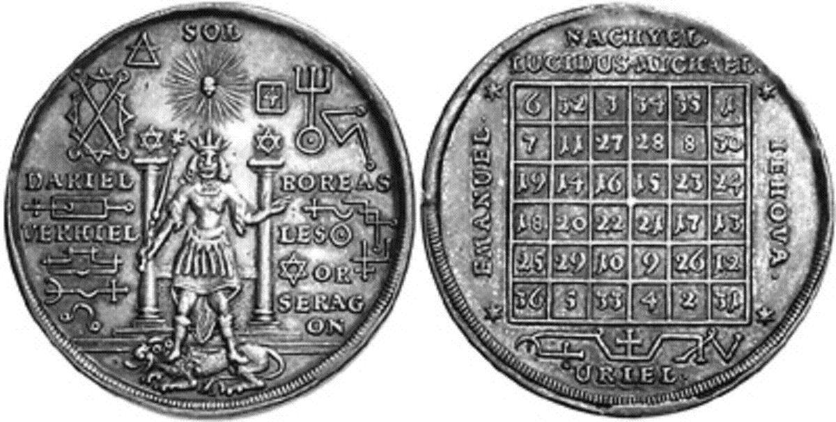
Above: A Babylonian Magic Square amulet with 36 numbered gods that add up to 666

Babylon's Doubles

For some reason the judgment of Babylon is associated with a doubling. It has been shown in previous articles that the number 72 is related to ancient Babylon via the number 36 being doubled. The judgments that are meted out to Babylon the great in the last days are doubled to her. Remember it was the twin world trade towers that fell on 9/11/2001.

Revelation 14:8 And there followed another angel, saying, Babylon is fallen, is fallen, that great city, because she made all nations drink of the wine of the wrath of her fornication.

Concerning modern Babylon and the doubling of her judgment:

Revelation 18:6 Reward her even as she rewarded you, and double unto her double according to her works: in the cup which she hath filled fill to her double.

The graphic below shows an interesting doubling of 36 years of time from the birth of President Donald Trump and its precise timing relationship with modern Israel's 70th year and Islam's month of Ramadan next year in 2018.

Considering that Donald Trump's date of conception was on or around YaHuWaH 's Day of Trumpets, we need to pay attention to the exacting time relationships revealed by our Creator Elohim in the graphic below.

Next year Ramadan begins 5/15/2018 at sunset and ends 6/14/2018 at sunset.

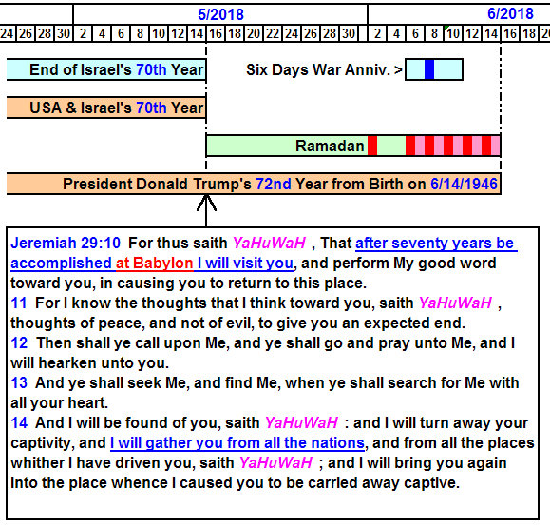
Above: YaHuWaH Elohim said that He's coming for a visit sometime after 5/14/2018.
The world is going to be a very undesirable place to live in the near future.

He will cause His people to want to leave the nations and return to Israel, perhaps via the same way that they wanted to leave Europe at the end of World War II.

Will it be a Hot Time in the Old Town Next Year?

The name "Ramadan" means "scorching heat".

Babylon will be burned with fire.

Revelation 18:9 And the kings of the earth, who have committed fornication and lived deliciously with her, shall bewail her, and lament for her, when they shall see the smoke of her burning, 10 Standing afar off for the fear of her torment, saying, Alas, alas, that great city Babylon, that mighty city! for in one hour is thy judgment come.

Babylon the great came into existence on 7/16/1945 with the First Fruits of the Manhattan Project, the Trinity Test. Her 72nd inclusive year of existence will end on 7/15/2017, but her nurturing of Israel for 70 years, which is the time requirement set by YaHuWaH Elohim for His visit, will not end until 5/14/2018.

