SPECIAL MEETING

NOVEMBER 6, 2024

Three (3) Public Hearings and a Special Meeting of the Town Board of the Town of Hampton, County of Washington and the State of New York was held at the Town Hall, 2629 State Route 22A, Hampton, New York on the 6th day of November, 2024.

PRESENT: David K. O’Brien------------Supervisor

Donald Sady----------------- Councilman

Tamme Taran----------------Councilwoman

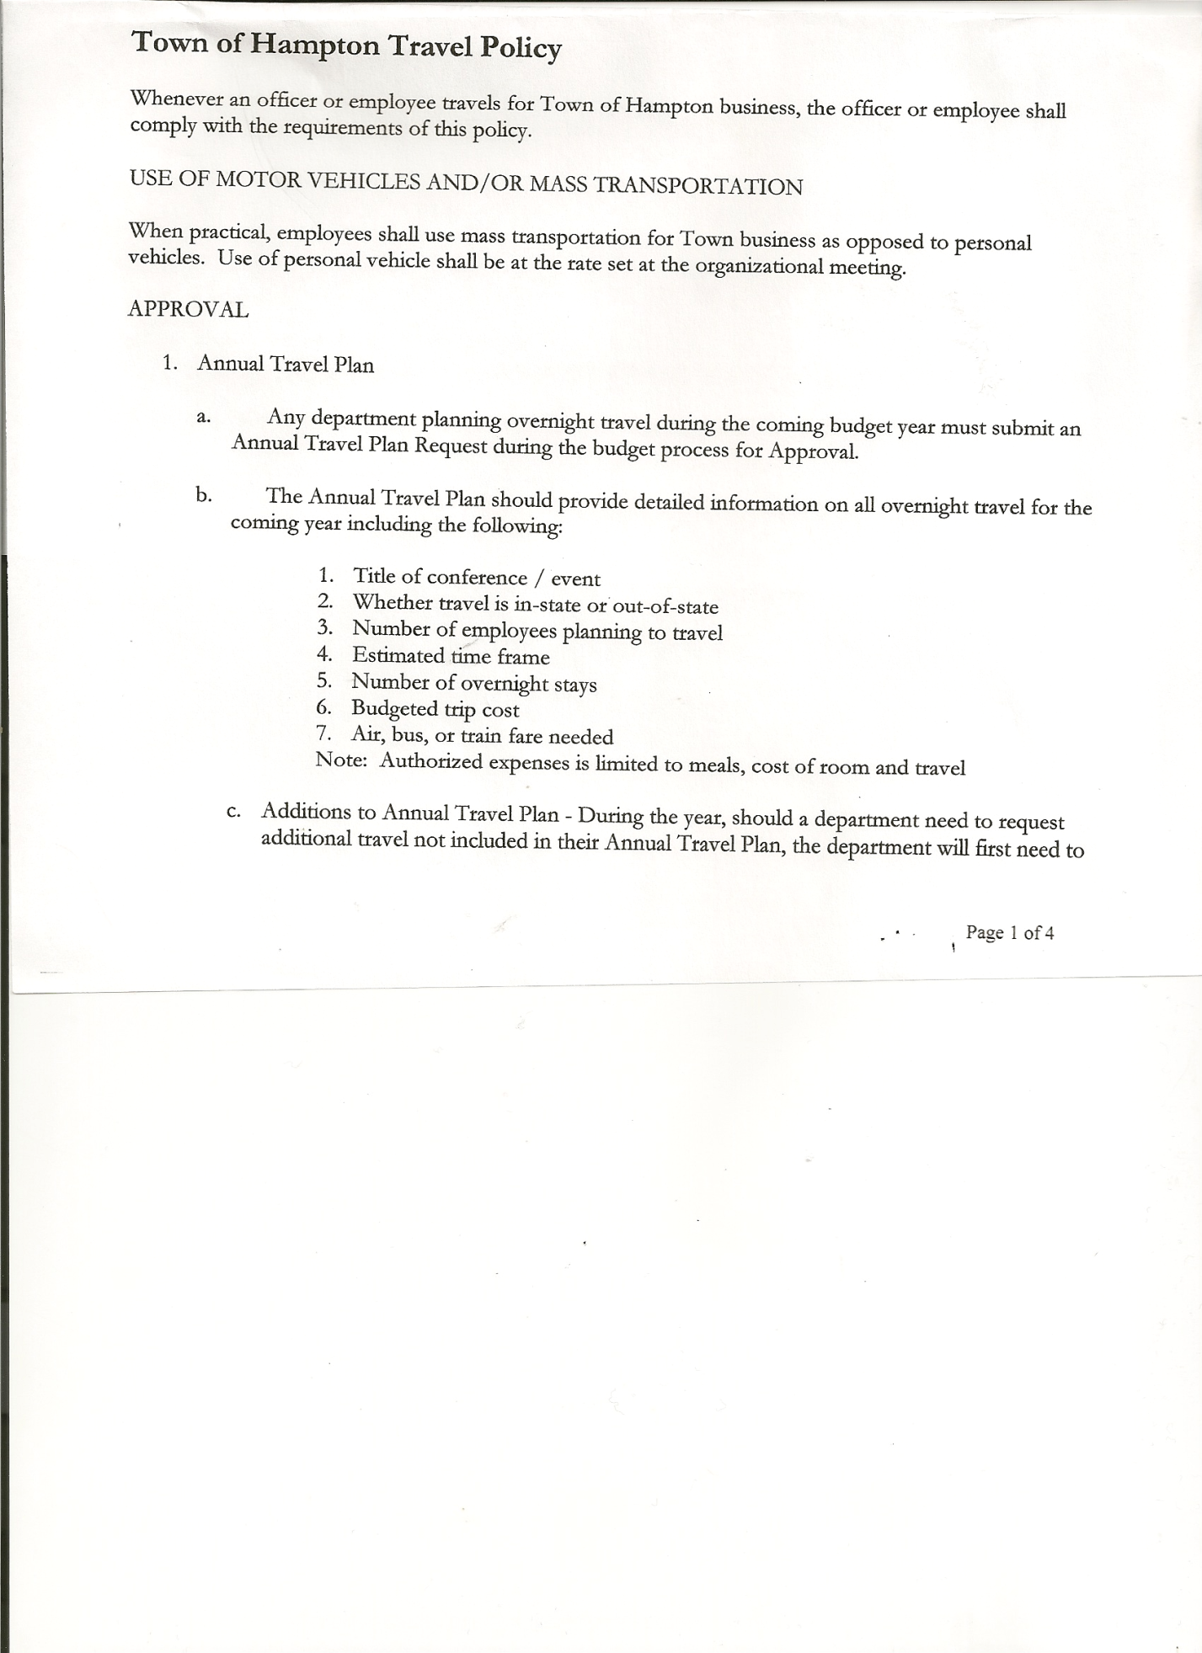 Michael Pietryka------------Councilman

Andrea Kugler---------------Councilwoman

Rebecca Jones---------------Town Clerk

Camilla Shaw----------------Deputy Town Clerk

Tyler McClure---------------Highway Superintendent - absent

Planning Board Member (s):…Matthew Pratt

Others present at the Town Hall: Artie Pratt

The FIRST Public Hearing was called to order by Supervisor O’Brien at 7:15pm.

Town Clerk Rebecca Jones read the Legal Notice of Public Hearing (copy attached), which was published in the *Manchester Newspapers* on 10/31/24 to discuss the proposed contract with Hampton Fire Protection District 1.

Matthew Pratt, member of the Hampton Volunteer Fire Co. shared a picture of the three (3) new Amkus Extraction Tools (Jaws of Life) that was recently purchased. The contract amount for 2025 is $67,718.82. Supervisor O’Brien asked three times for any other comments, hearing none the Public Hearing was closed at 7:20pm

The SECOND Public Hearing was called to order by Supervisor O’Brien at 7:20pm

Town Clerk Rebecca Jones read the Legal Notice of Public Hearing (copy attached), which was published in the *Manchester Newspapers* on 10/31/24 for the Preliminary Budget for 2025.

Supervisor O’Brien asked three times for any comments, hearing none the Public Hearing was closed at 7:22pm

The THIRD Public Hearing was called to order by Supervisor O’Brien at 7:22pm

Town Clerk Rebecca Jones read the Legal Notice of Public Hearing (copy attached), which was published in the *Manchester Newspapers* on 10/31/24 to discuss the proposed local law to override the tax levy limit. Supervisor O’Brien asked three times for any comments, hearing none the Public Hearing was closed at 7:24pm

TOWN BOARD MEETING

NOVEMBER 6, 2024 PAGE 2

**REGULAR MEETING**

The Regular Meeting was called to order by Supervisor O’Brien at 7:24pm, followed by the Pledge of Allegiance. Location of Fire Exits were given. Quorum of board members present.

**RESOLUTION 94-2024**

**APPROVAL OF THE 2025 BUDGET**

On a motion of Councilman Pietryka, seconded by Councilman Sady, the following resolution was ADOPTED:

By Roll Call Vote: Supervisor O’Brien AYE

Councilman Sady AYE

Councilwoman Taran AYE

Councilman Pietryka AYE

Councilwoman Kugler AYE

RESOLVED that, the 2025 Town Budget for the Town of Hampton is adopted.

**RESOLUTION 95-2024**

**HIGHWAY – DODGE 2012**

On a motion of Councilman Sady, seconded by Councilwoman Taran, the following resolution was ADOPTED: AYES 5 O’Brien, Sady, Taran, Pietryka, Kugler

NAYS 0

RESOLVED to authorize Tyler McClure, Highway Superintendent to put the Dodge 2012 out to

Auctions International to sell.

The Tax Cap for 2025 is 2.0305%, the Town of Hampton’s tax levy is 1.99%, therefore the Town did not need to adopt a local law to override the tax levy limit.

**PUBLIC COMMENTS/COUNCIL COMMENTS**

Vermont Fire Departments are not covered by Workers' Compensation when they come over the border for mutual aid. Supervisor O’Brien is going to check to see if New York Fire Departments are covered by Workers’ Compensation if they go over the border for a mutual aid call.

**RESOLUTION NO. 96-2024**

**TOWN HALL USE**

On a motion of Councilman Pietryka, seconded by Councilman Sady, the following resolution was ADOPTED: AYES 5 O’Brien, Kugler, Pietryka, Taran, Kugler

NAYS 0

RESOLVED, to approve the request of Rebecca Jones to use the Town Hall on Saturday, November 16th, 2024 from 4 to 8 pm for Board Game Night.

TOWN BOARD MEETING

NOVEMBER 6, 2024 PAGE 3

**RESOLUTION NO. 97-2024**

**MEETING ADJOURNED**

On a motion of Councilman Sady, seconded by Councilwoman Taran, the following resolution was ADOPTED: AYES 5 O’Brien, Sady, Taran, Pietryka

NAYS 0

RESOLVED that the meeting adjourned at 7:35pm.

Respectfully submitted,

Rebecca S. Jones, RMC

Town Clerk