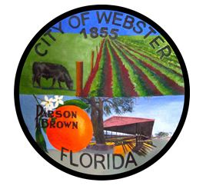
CITY OF WEBSTER
DOLLARS IN
EDUCATION INITATIVE
Completed Application Due to Counselor by 3/31/22

GENERAL STUDENT INFORMATION

Last Name | First Name |  | MI
Home Address | (P.O. Box if applicable)
City | State |  | Zip Code
Home Phone including area code | Email Address (Personal or Home)
School Name

City of Webster Utilities Account #

- Immediately after high school, I plan to enter: (Check the one which best describes your plans)
  - ______ Florida State College (2-year college)
  - ______ Florida Public University
  - ______ Florida Private University
  - ______ Florida Technical School

- My Career Goal is:

- Extra-Curricular Activities, Achievements
ACTIVITY GRADE OFFICES, AWARDS, LETTERS, ETC.

- Essay, typed, double spaced:
Briefly tell us about how you believe municipalities and local government help cities.
The essay must be typed and attached to this application.

School attendance and discipline referrals will be checked at the district office. By turning in this application you are giving consent.

Student Signature Parent Signature

To be completed by District Office Personnel:

Unexcused absences: __________ Unexcused tardies: __________ Discipline: __________

GPA: ___________________

