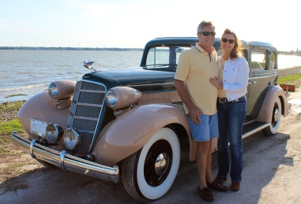
Real Restorations
By Pistorius Collectible Autos

Restorations are a relative thing. Some folks want their car restored back to the original look it had the day it came out of the factory. Others want it to be authentic, but even better than the original build sheet. Some just want it to be a reliable and comfortable ride, so a few modern enhancements are in order. Then there are those who really want to jazz it up, modify, hot rod, get that “cool” factor going.
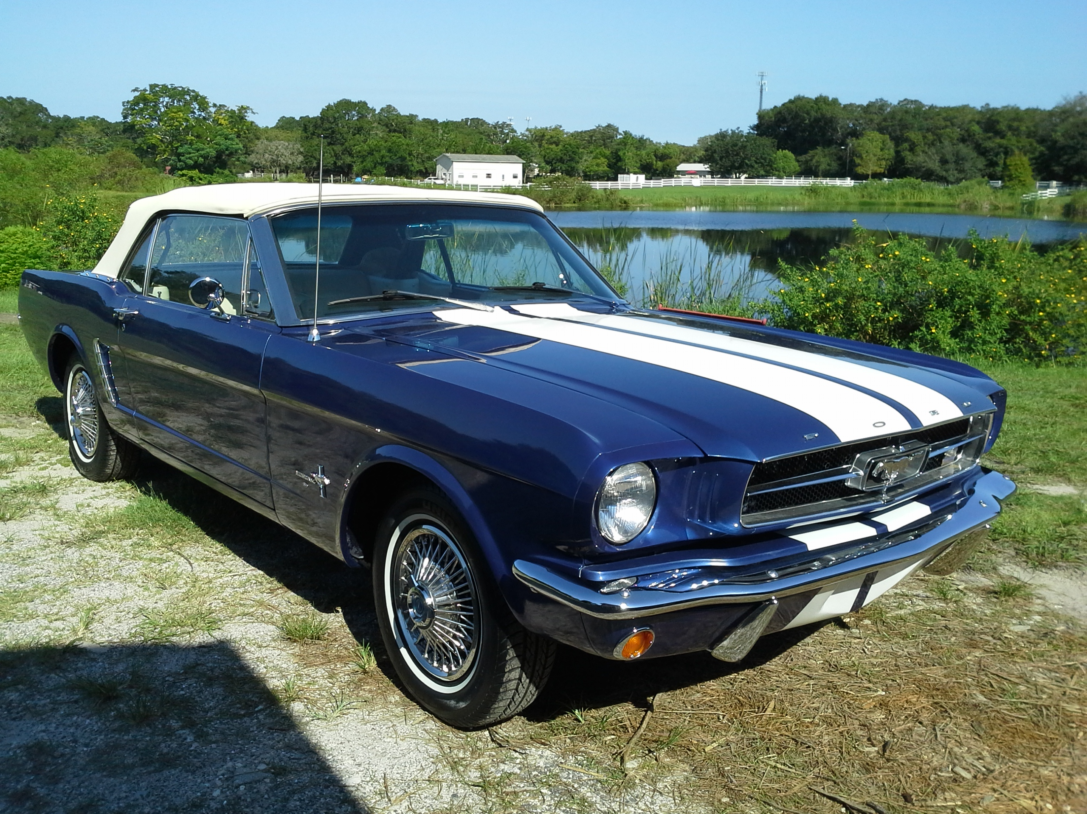
In our shop we cater to all of those folks. We all share the love for great collectible cars. When you decide to restore your car, and if you need a little extra assistance with portions of that restoration, be sure to partner up with an expert who listens to what your vision is. Too often we hear from owners that their car was recently restored, but the accessories are not period correct. If your goal is to restore as original, then make sure parts and accessories you choose were available during that manufacturing year. Don’t worry that your specific car did not have the option installed when it left the showroom floor. If it is period correct and could have come included with your model, then feel free to add the option during your restoration. And remember to choose interior fabric, upholstery, and paint color combinations that were available then as well.
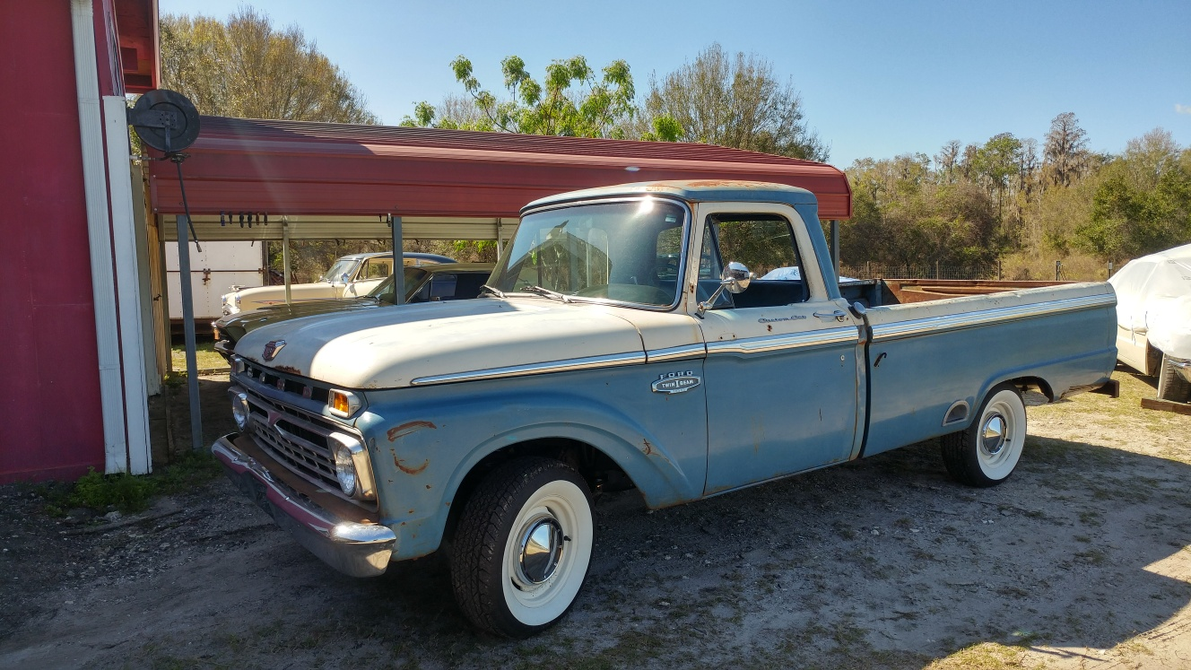When it came to the 1966 Ford F100 that we have been restoring for a Miami couple, the owners wanted it restored as original, even leaving the patina original paint. The truck came with air conditioning, but we had to find a period correct evaporator to fit and get it cooling again. And when it was necessary to replace the transmission, we worked closely with the owner to get the performance he wanted. When the brittle dash cracked, it was a challenge to get another just like it, but luckily it was located and restored as original once again.
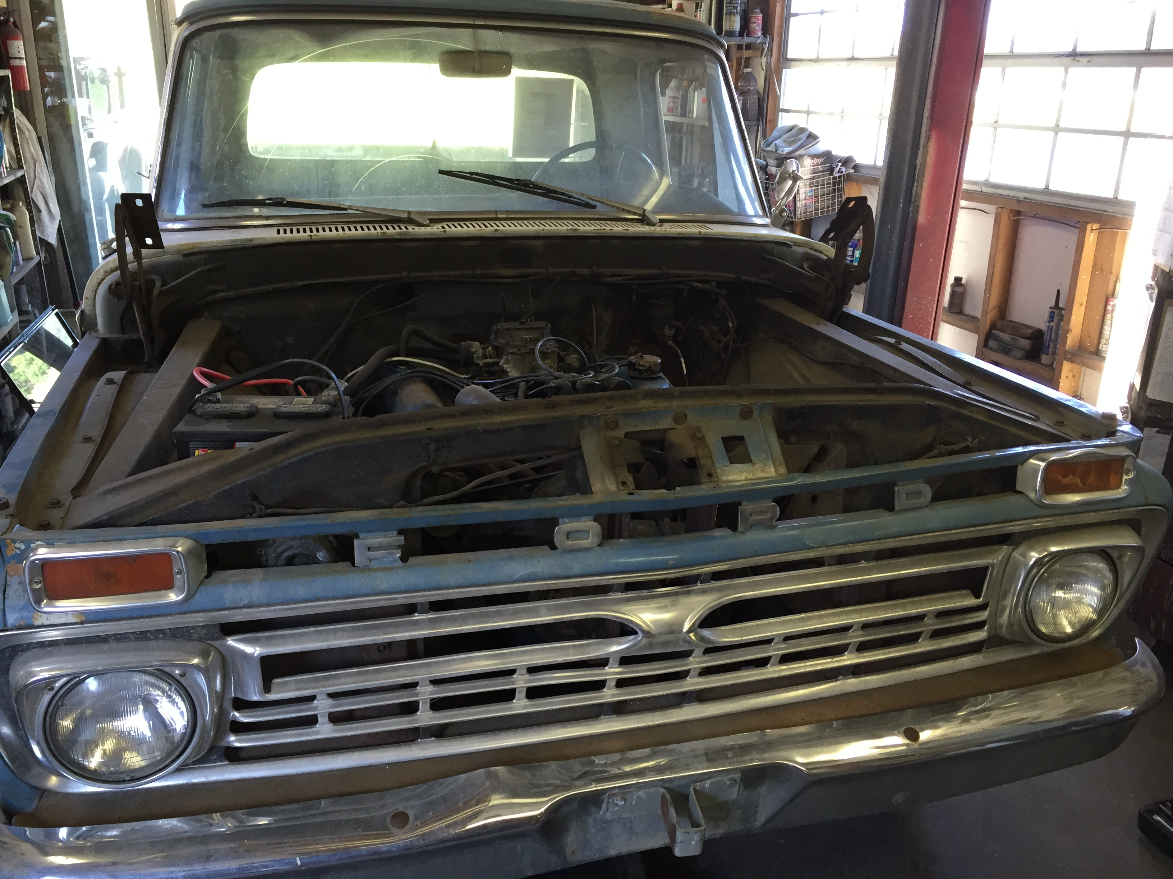
As we mentioned last month, bagging the parts upon disassembly is crucial. During re-assembly, the reverse is just as important. The last item you took off may be the first you put back on. Therefore start with that item, remove, repair, restore and/or replace it, but do this as soon as possible before re-bagging the item, so that you are ready to re-install without delays.
Whether you are restoring your car to tour, show or sell, you want to enjoy the ride while you can. In Florida, the time is now!
Cheers!
Brando & Joanne Pistorius

