**President**

Sue Connors

**Vice-President**

Alicia Johnson

**Past President**

John Romano

**Orator**

Lennie Malvone

**Recording Secretary**

Lynne Martell

**Financial Secretary**

Walter Palino

**Treasurer**

Cheryl Caira

**Trustees**

Janet Engrem

Karen Scalzi

Pia Romano

Judy Agnes

Linda Caruso

**Mistresses of Ceremony**

Michele Caira Nortonen

Mary Kiesinger

**Sentinel**

Cheryl Licciardi

**Deputy**

Betty Sandquist

**April 2022 Newsletter**

April 28 2022 **lodge meeting.** Dinner will begin at 6:30 pm and the meeting will begin at 7:30 pm.

Dinner will be **pizza and salad** from EJ’s for $5.00.

I’ll send out the options in a separate e-mail next week for you to RSVP for dinner.

Please bring a dessert to share.

**Sons & Daughters of Italy Events**

4/19/22 – **Scholarship Auction –** Wakefield Sons & Daughters of Italy

4/29/22 **- Comedy Night –** Wilmington Sons & Daughters of Italy and WHS Band parents

5/01/22 – **MELA AWARDS** – *Grand Lodge of MA*

5/26/22 – **Scholarship dinner –** Wilmington Sons & Daughters of Italy

6/18/22 – **Grand Lodge Convention**

6/30/33 – 7/3/22 – **4th of July Festivities on the Common**

7/6/22 – **Summer bocce** begins – Wilmington Sons & Daughters of Italy

7/16/22– **Encore Casino Trip –** Wilmington Sons & Daughters of Italy

10/28/22 – Italian Heritage **Golf Tournament** – save the date

**Lodge Meetings –**4th **Thursday** of every month at Villanova Hall on Middlesex Ave. in Wilmington at 6:30 pm dinner and 7:30 pm meeting

5/26/22 6/23/22 8/25/22 9/22/22 10/27/22 11/17/22 (3rd week) 12/22/22

**Council Meeting** –2nd **Wednesday** of every month at the 4th of July Building. 5/11/22 6/8/22 8/10/22 9/7/22 10/12/22 11/9/22 12/7/22

The **Grand Lodge** monthly meeting minutes are available to view and download from the “news” tab on the Grand Lodge Website – [www.osiama.org](http://www.osiama.org)

**Donation request should be made using the form on the web site** so that we have all the necessary information. Just click on donation request forms on the first page at [***http://www.wilmingtonsoi.org***](http://www.wilmingtonsoi.org)

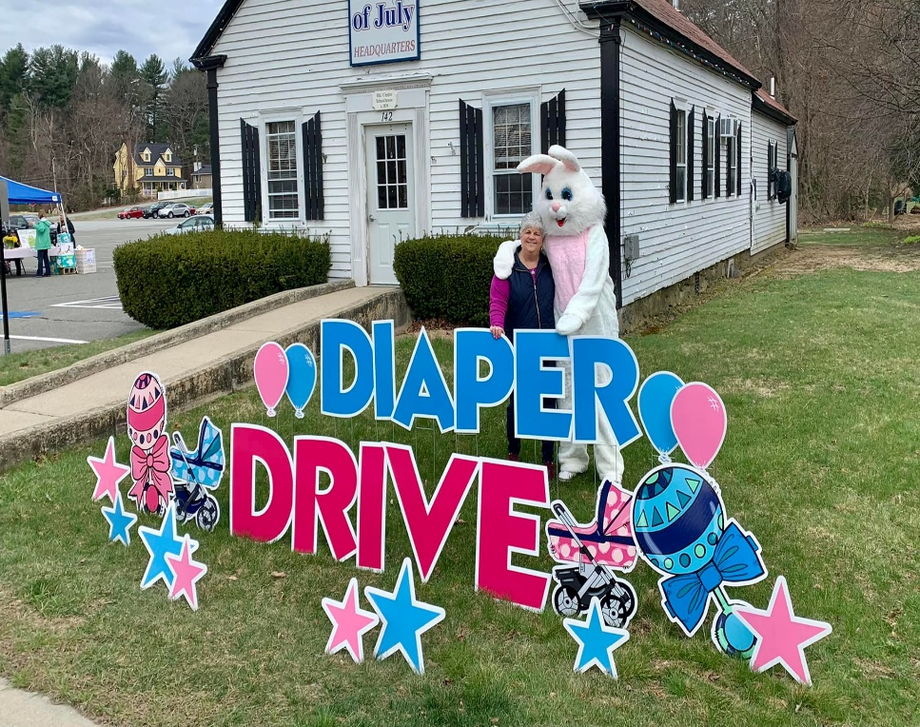

Congratulations on a wonderful and hugely successful Diaper Drive. Great work by the committee!

To date, the Wilmington Sons & Daughters of Italy has collected and donated 1 million diapers!

**Wakefield Sons & Daughters of Italy Charity & Scholarship Auction** – will be held on **Tuesday, April 19, 2022,** at St. Joseph’s Church Hall – 173 Albion St. Wakefield, MA. Dinner 6:30. Tickets $12 with Harrows pie dinner and $6 with no dinner. Contact Paula Sasso – 781-799-6203 [pscrusader78@gmail.com](mailto:pscrusader78@gmail.com) Contact Cheryl Caira if you’d like to attend and she will reserve a table – [cal0701@yahoo.com](mailto:cal0701@yahoo.com). 508-633-2779.

**Comedy Night** – The Wilmington Sons & Daughters of Italy and the WHS Band Parents are hosting a Comedy Night on Friday, April 29th at the Wilmington Tewksbury Elks - 777 South St. Tewksbury, MA, starting at 9:00 pm. Doors open at 7:30pm. BYO snacks/food. Great raffles and Silent Auction items! Tickets are $20 pp. Please contact Kevin at (508) 633-2681 for tickets. See flyer attached!

**May**

**Congratulations to the following Grand Lodge Scholarship Recipients!** They will receive their scholarships at the Massachusetts Education and Law Awards on May 1, 2022.

Grace Ciaccio, Lennie and Josie Ciaccio’s granddaughter; Brady Martin, Vincent Ruocco’s grandson; and

Kevin Stevens, Janice Steven’s son.

**Wilmington Sons & Daughters of Italy Scholarship Dinner –** will take place on Thursday, May 26, 2022, at our regular monthly meeting where we will award our lodge scholarships

**Congratulations to the following Wilmington Sons & Daughters of Italy Scholarship Recipients!** Kevin Stevens, Janice Steven’s son; Matthew Pupa, Brian Pupa’s son and Jerry and Ginny Pupa’s grandson; William O’Shea, Gail O’Shea’s son.

**Congratulations to the following Wilmington Sons & Daughters of Italy Graduate Scholarship Recipients!** Julia Rankin, Kylie McGilvray, Leann Otis.

**JULY**

**MC900287390[1]Wilmington SOI 4th of July Festivities on the Common** – Thursday, 6/30 – Friday, 7/1, Saturday 7/2, Sunday 7/3. Family Day is Saturday, 7/2 with fireworks at 9pm and the big fireworks are Sunday, 7/3. Our booth will serve ice cream and meatball subs. Help is needed to work in the booth. An hour or two would be great! Sign up at the meeting to help or contact Sue Connors [smc19thhole@comcast.net](mailto:smc19thhole@comcast.net) 508-527-0785.

**MC900054991[1]Encore Casino Trip** – We are planning a trip to the Encore Casino in Everett on **Saturday, July 16, 2022.** The cost is $35 pp and you will receive a $20 voucher for the Casino. We will meet at the 4th of July parking lot and the bus will leave at 9:00 am. We will return to Wilmington by 4:00pm. If you would like to attend this trip, please contact Lynne Martell 978-694-1632 [Lynne_martell@comcast.net](mailto:Lynne_martell@comcast.net). or Lucille Clark 339-927-1447. There will also be a sign-up sheet at the meeting.

**Bocce** – Summer bocce will begin on July 6,2022. Bocce is played at Jack Cushing’s bocce courts on Middlesex Ave on Wednesday evenings at 6:15 and 7:15 running for eight weeks. If you would like to play sign up at the meeting.

**October**

**Italian Heritage Month –** Michele and Lennie are working on events for Italian Heritage Month this October. They are planning a photo display with old pictures of Boston’s North End and are hoping to do a comparison of then and now. They are asking members to provide **photos of the North End** for their project.  If you have any you can send them to  Lennie at  [MALRN1031@aol.com](mailto:MALRN1031@aol.com). You can also bring hard copies to one of the upcoming Sons & Daughters of Italy meetings. Any questions please contact Lennie [MALRN1031@aol.com](mailto:MALRN1031@aol.com)  617-835-2184 orMichele [mnortonen@gmail.com](mailto:mnortonen@gmail.com)  978-604-6437. More info to follow!



to our members with April Birthdays – Ron Aprile, Marie Ardito, Frank Asimakopoulos, Brianne Caira, Jane Caira, Susan Cataldo, Joseph Corriveau, Andrea Gillis, Marie Graffeo, John Harding, Tony Hogan, Lisa Lyons, Anthony Martiniello, Wendy Martiniello, Ginamarie Mastrorilli, Julianna Mastrorilli, Raymond Mercuri, Walter Palino, Evelyn Olivari.

It’s time to celebrate all April birthdays! With the daisy as this month’s flower, we are always reminded of the beauty of springtime and the blooming of flowers across the country. The daisy is also a symbol of innocence.

**Here are some more fun facts about this month!**

* The zodiac signs of this month are Aries (March 21-April 19), which is characterized as being adventurous and lively, and Taurus (April 20-May 20), which is characterized by generosity and dependability

# It is thought that the name April comes from the Latin word “to open”, and is believed to have been used to describe the opening of the trees that happens during springtime

* The professional baseball season begins in the United States
* National monthly observances this month include National Humor Month, Mathematics Awareness Month, National Poetry Month, and National Jazz Appreciation Month
* Famous birthdays this month: Pharrell Williams (4/5), David Letterman (4/12), Emma Watson (4/15), James Franco (4/19), Kelly Clarkson (4/24), Channing Tatum (4/26), Jet Li (4/26), Jerry Seinfeld (4/29), and Penelope Cruz (4/28)!

**We hope you have a wonderful birthday and a beautiful spring!**



Please report any sunshine to Linda Tobin. Please **let Linda know if someone** is sick, has surgery, or has a death in the family. Linda’s contact information is phone 978-604-4706 or e-mail [beatlefanlinda@aol.com](mailto:beatlefanlinda@aol.com)



We send our condolences to Sue Connors and her family on the death of her uncle, Thomas Pascarella.

We send our prayers and get well wishes to Lorraine Eddy, Terri Zucchi, John Saladino



Please let me know if you have any **GOOD NEWS** that I can share with the lodge such as a promotion, birth, new house, graduation, engagement – **anything that we can celebrate**!

Congratulations to Doug and Lucille Clark on the birth of their new granddaughter,

Isabella Theresa Clark!

Congratulations to Patricia Romano - The North End Athletic Association has announced that it will dedicate its 2022 Baseball Opening Day to Patricia Tanso-Romano for all her years of service to the youth and families of the North End Community.  "For over 50 years Patricia has been working to provide programs and services to the youth and families in our neighborhood and continues to do so as part of the Nazzaro Center's Non-profit Board of Directors and we are honored to recognize her at this event " stated N.E.A.A.'s Baseball Coordinator Ralph Martignetti.

The N.E.A.A. will have a daylong event on Saturday April 30th starting at 9am at Langone Park on Commercial Street with 5 baseball games throughout the day.  There will be a BBQ, Face Painting, a Balloon Artist and much more.  1st Pitch Ceremonies to honor Patricia will be at 1:15pm, we hope everyone can join in with the N.E.A.A. and help us thank and celebrate all that Patricia has done for the North End Community!

Please send any address or e-mail changes to [Lynne_martell@comcast.net](mailto:Lynne_martell@comcast.net) or 978-694-1632.