In This Issue
ISSUE
Apr
2022

CCUMC NEWSLETTER
Pg. 1 Pastor’s Page
Pg. 2 Coming Up Next
Pg. 3 Bible Studies & Small Groups
Pg. 4, 5, 6 Keeping You in the Loop
Pg. 7 Vacation Bible School for 2022
Pg. 8 Calendar for April 2022
Pg. 9 Church Information
This pastor’s corner I would like to discuss Luke 11:34 “Your eye is the lamp of your body. When your eyes are healthy, your whole body also is full of light. But when they are unhealthy, your body also is full of darkness. 35 See to it, then, that the light within you is not darkness.” The Greek word for healthy in verse 34 means generous and in verse 34 the Greek word for unhealthy means stingy. So, allow me to re-write Luke 11:34-35 Your eye is the lamp of your body. When your eyes are generous, your whole body also is full of light. But when they are stingy, your body also is full of darkness. 35 See to it, then, that the light within you is not darkness.”
What do you think Jesus meant by telling us to have generous eyesight? I believe Jesus is telling us to look at things from God’s perspective. Let me explain, The world divides us by our race our gender and just about anything else that someone somewhere can make an issue out of. But God see’s all of us as being of sacred worth, Christ died on the cross to pay the atonement for all our sins not just some of us. How do you look at people on the street at Walmart’s or Meijer’s? Have we partially fallen victim to looking at the wrong source for deciding who’s in and who’s out of the Kingdom? It’s an easy trap to fall into even when desperately try not to if we are stingy in are eyesight. Let me explain, if all Bishop or Pastor look at is what’s wrong with the world and the church then how generous are they being with their eyesight if all they look at is their perception of darkness and injustice and oppression? I’m not saying there isn’t injustice and oppression in the world, I’m saying if that’s all you focus on then you’re being rather stingy with your eyesight.
Brandon Heath wrote a song Give Me Your Eyes the chorus of the song says this, ”Give me your eyes for just one second. Give me Your eyes so I can see. Everything that I keep missing. Give me Your love for humanity. Give me Your arms for the broken-hearted. The ones who are far beyond my reach. Give me your heart for the ones forgotten. Give me your eyes so I can see. That would be a good prayer wouldn’t it asking God to give us his eyes to see the world as he sees it. And anytime we want to refresh our memories on how God see’s the world all we have to do is go back to our Bibles and read the words of Christ found in the Gospels.

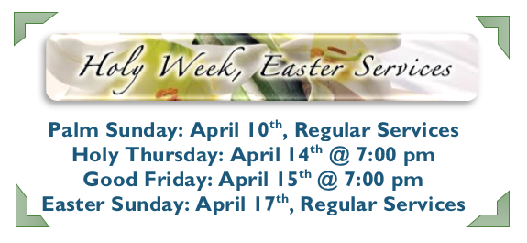
Save
The
Date

UMW Soup Luncheon
on 4/29/22 @11:00 am to 1:00 pm
in the CCUMC Fellowship Hall

Commission On Aging Meals
Every Tuesday & Thursday @ Noon
In the CCUMC Fellowship Hall
Contact COA @ 989-831-7476
For reservations & cost
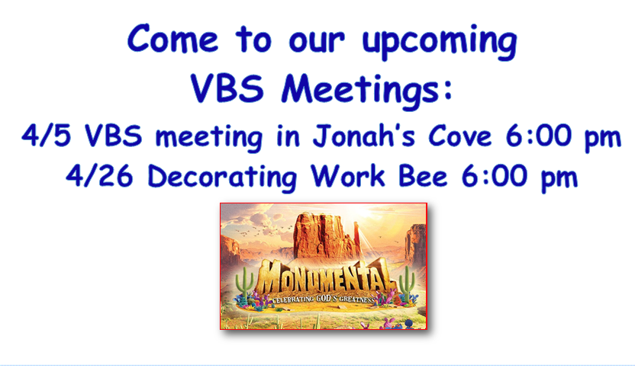
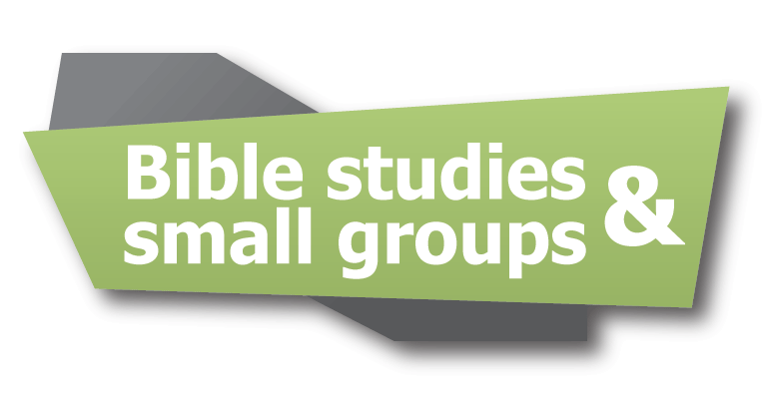

P.T. is a group that meets to hold ourselves up and others in prayer. We also learn God’s Word through studies, movies, discussions, laughter, and tears. P.T. meets every Monday from 6:30-8:00 pm. For more information, call Walthagaye Leavitt at 989-640-0238.

Women's Group meets every Sunday night 6:30-8:30 pm. All women who would like to be refreshed and energized in this world of ever-increasing fear, bad news and disappointment, are invited to come check us out! We laugh, learn, and intentionally connect with God and each other. New faces are always welcomed and cared for. Contact Nancy Wilson for more info. 989.763.5975.

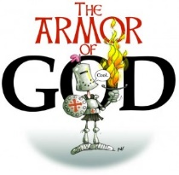

A.R.K. meets every Wednesday @ 6:30-8:30 pm in Daniels Den. We will be learning about the Names of God in the Old Testament.

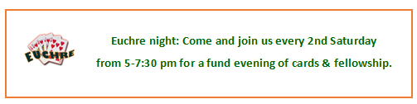
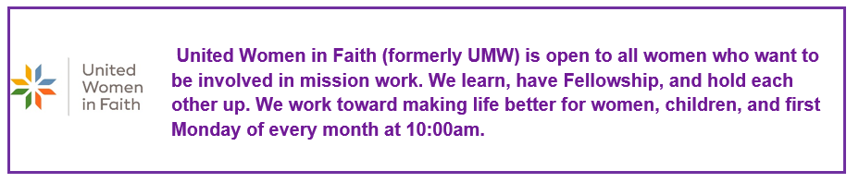

United Methodist Women Name Change – submitted by Walthagaye Leavitt

The organization of UMW had its roots over 150 years ago when eight imperfect women got together to do something about the plight of women, children, and youth in India. This was during a time in history that women were not able to vote and didn’t have much say in their own households. But as a group- they had power!
Now, we are in 2022, and things have changed. UMW has changed.
The name has been changed to United Women in Faith. We reflect what we are and who we are. Women in Faith is felt to be more inclusive- to not limit our membership to just Methodists. Anyone can be part of this missional organization. Nothing else has changed about the organization. UMW has undergone about 25 name changes as women have joined and renamed it to show more accurately what they do.
Please check out the Outhouse bulletin board that shows where our money goes. That will not change. It travels to New York City and then across the US and the world to pay for institutions and programs to benefit women, children, and youth. The Legacy Fund is still collecting money to ensure those institutions and programs continue long after we are gone.

Growing a World Wonder – submitted by WalthaGaye Leavitt
The Great Green Wall is one of the most inspirational and urgent movements of our times. The African-led initiative aims to grow an 8,000 km or 5,000-mile new world wonder across the entire width of the Continent to transform the lives of millions living on the frontline of climate change. The Sahara Desert has been slowly increasing in size at the world heats up. A wall of trees and plants are being planted by people from eleven countries along the desert. This is the poorest part of Africa, and its people face persistent droughts, lack of food, conflicts over dwindling natural resources and mass migration to Europe.
A decade in and roughly 15% underway, the initiative is already bringing life back to Africa’s degraded landscapes at an unprecedented scale, providing food security, jobs, and a reason to stay for the millions who live along its path. Once complete, the Great Green Wall will be the largest living structure on the planet, three times the size of the Great Barrier Reef, growing hope, growing food security, growing health, and well-being. Find out more at the GreatGreenWall.org

Keeping You in the Loop cont’d
The Easter Lily – submitted by Walthagaye Leavitt
The magnificent Easter lily, with its sheer white petals, signifies life, purity, innocence, joy, and peace. The beautiful white flowers of the lily related to these traits well before Jesus Christ. Many ancient allegories connect the flower with motherhood.
It is said that beautiful white lilies sprang up in the Garden of Gethsemane, where Jesus wept in the last hours before he was betrayed by Judas. The lilies sprang up where drops of Christ’s sweat fell to the ground in his final hours of sorrow.
The lilies from Christ’s time were not the Easter lily that we know today (Lilium longiflorum), which is native to the southern islands of Japan and now cultivated in areas such as California and Oregon. The lilies in Jesus’ area were wild lilies of the valleys and fields. Still, our Easter lily serves as a reminder of the lilies mentioned frequently throughout the Bible. Easter lilies grace homes and churches each spring as a symbol of new life.

Beautiful Reflection- submitted by Doug & Francie Soper

In the late 1930s-1940s, Michael Bond, author of Paddington Bear, saw Jewish refugee children (Kindertransport children) walking through London’s Reading Station, arriving in Britain escaping from the Nazi horrors of Europe. Mr. Bond, touched by what he saw, recalled those memories 20 years later when he began his story of Paddington Bear. One morning in 1958, he was searching for writing inspiration and simply wrote the words: “Mr. and Mrs. Brown first met Paddington on a railway platform…”
“They all had a label round their neck with their name and address on and a little case or package containing all their treasured possessions,” Bond said in an interview with The Telegraph before his death in 2017. “So, Paddington, in a sense, was a refugee, and I do think that there’s no sadder sight than refugees.”
Paddington Bear – known for his blue overcoat, bright red hat, and wearing a simple hand-written tag that says “Please look after this bear. Thank you,” Paddington embodies the appearance of many refugee children. His suitcase is an emblem of his own refugee status.
“We took in some Jewish children who often sat in front of the fire every evening, quietly crying because they had no idea what had happened to their parents, and neither did we at the time. It’s the reason Paddington arrived with the label around his neck.” – Michael Bond
Michael Bond died at 91 in 2021. The epitaph on his gravestone reads “Please look after this bear. Thank you.”
Please look after all the young Bears in Ukraine.

Keeping You in the Loop cont’d

Cool Hour Update – submitted by Roberta Kile
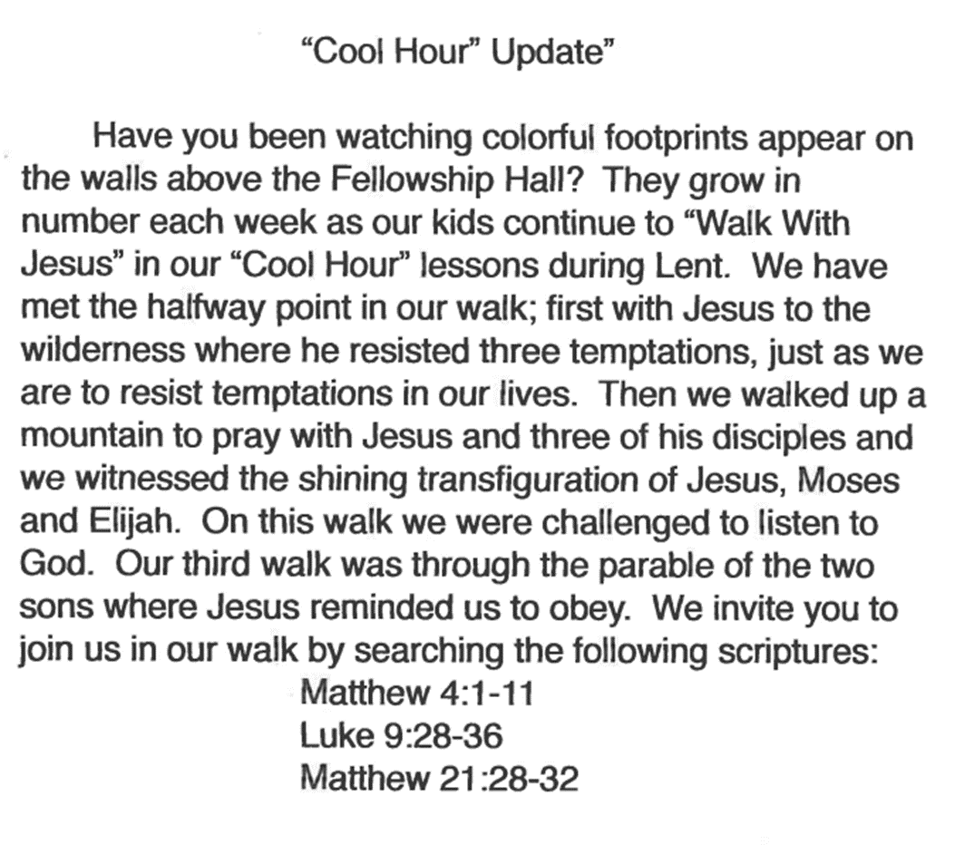

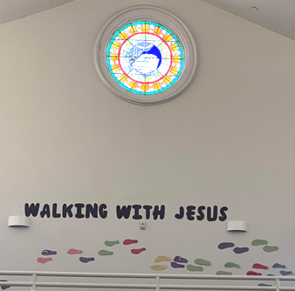

Vacation Bible School - 2022
Monumental
Celebrating GOD’s GREATNESS

“Celebrating God’s Greatness,” the theme for this summer’s VBS is scheduled for Sunday through Thursday evenings, July 17 – 21, 2022, from 6:00-8:30 p.m. Those who attended the March 8th meeting chose Psalm 8:1 as the umbrella scripture for the week’s activities.
“O Lord, our Lord, how majestic is your name in all earth.”
All kids, from 3 years through those entering 6th grade, whether your kids, grandkids, friends, and neighbors, are encouraged to attend this amazing week of experiencing God’s greatness through scripture, Bible Adventures, games, Imagination Station, Kid-Vid- Cinema and snacks. In serving others, we will be providing money to purchase school supplies for Native American children in North America.
You can help through prayer as we spread God’s love throughout this area. If you have any of the following supplies to donate, any will be very much appreciated. Possibilities include; small pup tents, cylindrical oatmeal boxes, poop noodles, and colorful tissue paper.
Next meeting is Tuesday, April 5th at 6 p.m.

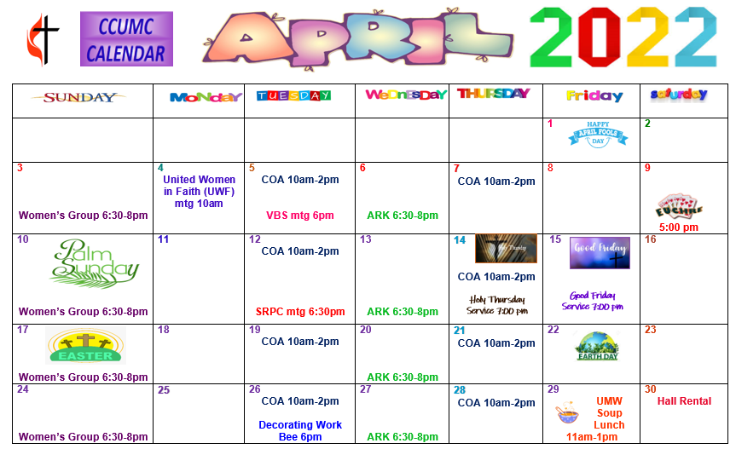

“Schedule’s subject to change – contact office for more information”

Stay connected! Follow us on:

Join Us Each Sunday

Worship Services 10:30 am

(masks are optional)

Carson City United Methodist Church
Phone: 989-584-3797
Email: carsoncityumc@gmail.com
Website: carsoncityumc.com
Office Hours: Monday to Thursday, 9:00 am-Noon
After hours by appointment
Pastor: Ian McDonald (906) 322-5318
Secretary: Bonnie Seaman (989) 763-1674

Weekly Sunday Bulletin now available on our website
at www.carsoncityumc.com

Online giving available: Website: http://www.carsoncityumc.com/donate.html

