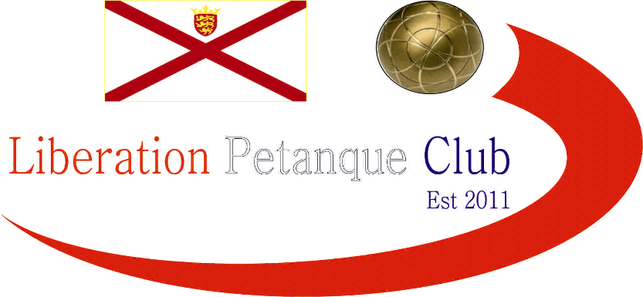

# 2014

# Liberation Petanque Club

# Elements Media (Jersey)

# Singles Cup

# 

# 34 players took part in this year’s competition which is more members than the club had when it started just 3 years ago which shows how much the club has grown recently.

# As is now the standard format for all Liberation competitions, the Swiss system, using the same Computer software as used in the European Championships, due to time constraints though just four rounds.

# This meant each round would get harder as winners would play each other with the top eight ranked players after the four rounds going through to the quarter finals.

# Some interesting results in round one with Lorna Limbrick handing out a 13 – 0 defeat to Stefan Riccio, David Ibitson lost to rising star Matt Buesnel and David Spencer beat Alice Ibitson who is two divisions above him in the singles league.

# Round two saw new member James Gennoe beat Lorna for his second win. There were also three big ties with all Premier League players with Keith overcoming Toby, David Siouville beating Ross and Matt Ryan beating Andrew Bellamy.

# Alan Oliveira beat his second Premier league opponent, this time Brian Harris, David Siouville beat Keith. Gary Coburn impressed beating John McGaw and Brigitte won her second match, this time against Lorna, but very close 13 – 11.

# Round four saw Alan Oliveira top the rankings beating David Siouville his third Premier League scalp of the evening.

# Brigitte Ibitson beat Callum to make the top eight and qualify for the quarter finals. Matt Ryan looking to retain his trophy thrashed Steve Simpkin 13 – 2 to finish second.

# Ross could not have got any closer to the top eight losing out to Keith Pinel on points scored, Keith 50, and Ross 49 after been tied on everything else.

# The quarter finals saw time run out in Alan v Keith as Alan won 11 – 7, Brigitte Ibitson gave Matt Ryan a scare losing 13 – 8. Matt Buesnel will be rueing missed chances after losing 13 – 12 to David Siouville and Steve Simpkins superb placing out did Brian’s firing.

# The semi-finals saw the holder bow out as David Siouville beat Matt Ryan in a fantastic match at one point trading carreaux’s.

# Steve was comfortable against Alan all the way as his placing was spot on throughout the match.

# So David Siouville who played in the first ever Singles Cup final in 2012, losing out to Andrew Bellamy, returned to face Steve Simpkin, who took the early advantage, however as the light suddenly began to fade so did Steve’s accuracy with David consistently out placing Steve to seal a 13 – 6 win.

# Matt Ryan took 3rd place beating Alan Oliveira 13 – 4.

# Champion

# David Siouville

# IMG_9070

# Thank you to Colin, Steve, Matt and Me, Callum and Alan for helping prepare for this competition and the running of it on the day which takes a great deal of time and effort. If you like to help out at future competitions please let me know.

# The clubs last big competition of the year is the Liberation Charity Triples on the 27th September 2014.

# NOTE: If you like to play for Jersey in this year’s INTER INSULAR to be played in Guernsey over the weekend of the 11th & 12th of October please contact Elaine Paisnel at [fredelaine@paisnel.co.uk](mailto:fredelaine@paisnel.co.uk). Could you also let me know as I like to keep a record of club members who do, or do not get selected.

# Kind Regards, Toby