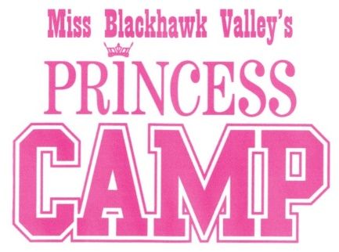
Script Information
This information will be used in the production of the Miss Blackhawk Valley Competition. Please write or print legibly. This is a worksheet and will be seen only by the producer and director of the pageant. We may not use all the information you provide.

Princess Name

How do you want the emcee to introduce you? Full name?

How do you want your parents to be introduced? Usual is “Daughter of Dad’s first name and Mom’s first name, then the last name”

Where do you go to school? What grade are you in? What is your favorite subject?

Do you have a talent? If so, what is it? Do you take lessons to improve your talent?

We would like to know one interesting fact about you that is not related to the pageant.

Do you belong to any club or organization? Is so, give us some information about it.

Revised 7/27/22

