USING OPENWATER TO SUBMIT ONE ACTS, THESPYS, TECH EVENTS, SCHOLARSHIPS:

If a student is not yet a Thespian, they may not have an account in Community Hub. When they go to create an application in OpenWater, they should be redirected to the Community Hub page. On this page they can click "Don't have an account?" to create one (using the same email address as they did in OpenWater). Once they have done that, they can use SSO to access OpenWater. This is true for directors of non-Thespians troupes.

If a student is a Thespian, when they are directed to Community Hub they should enter the email address currently connected to EdTA's database, click "forgot your password?" and update their password for Community Hub, then proceed to Open Water.

Go to: https://edta-chapter-events.secure-platform.com/a/organizations/main/home

You will see:

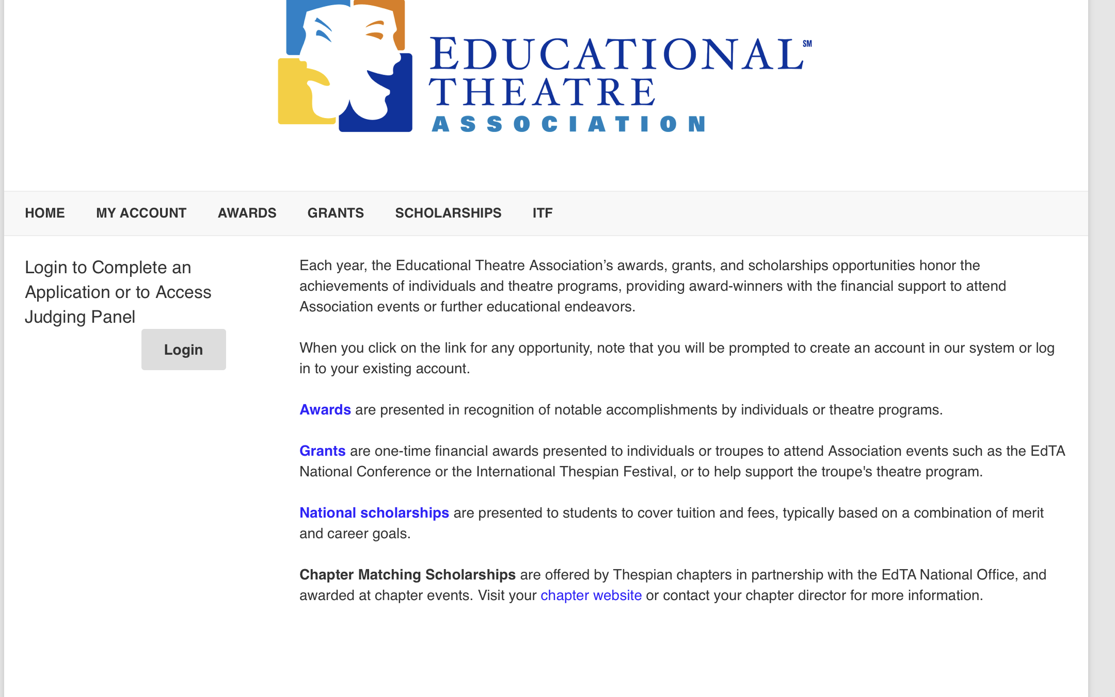

After creating a log-in and logging in, you will see:

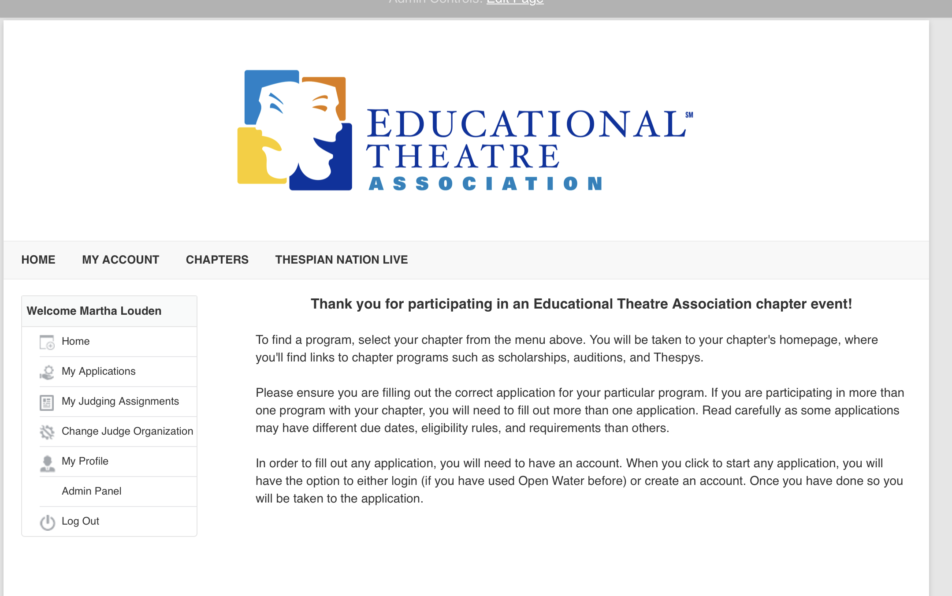

Hover over the CHAPTERS and scroll to find West Virginia – click on that. Then you will see:

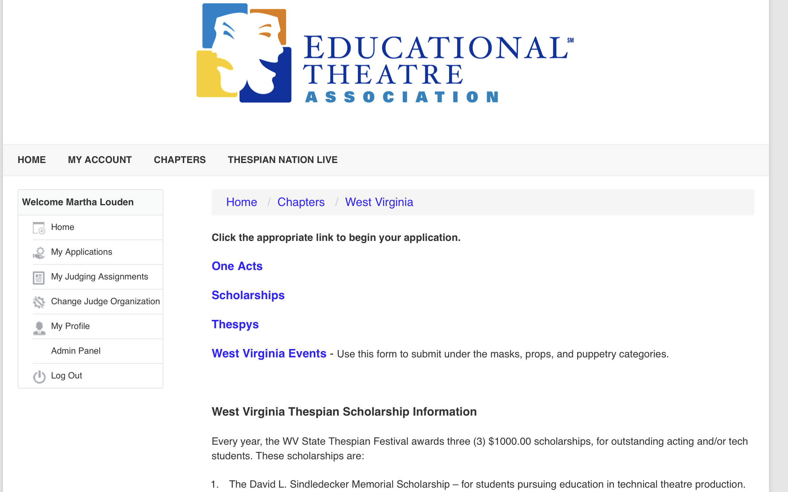

From here, click on the appropriate link and just fill in the form that follows.
NOTICE: West Virginia Events link is for masks, props, and puppetry categories. ALL other performance events and tech projects should use the Thespys link.

