Using both the concepts of “intrinsic and extrinsic motivation” along with Maslow’s hierarchy of needs, write down three things that you did over the weekend. Identify if they intrinsically motivated or extrinsically motivated? Where on the hierarchy of needs did the activity fall?
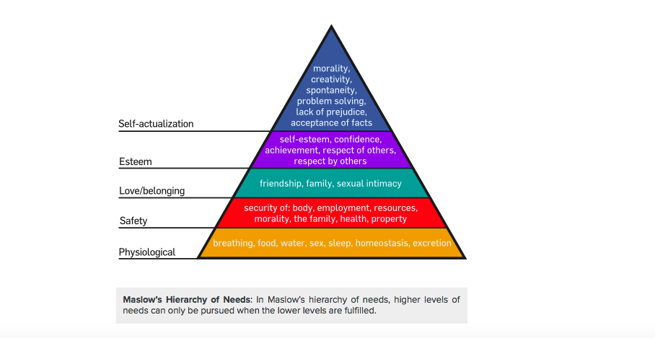

- What I did? ________________________________________________________
- Type of Motivation? Intrinsic _______ Extrinsic _______
  - Why? _______________________________________________________
- Where on the Hierarchy of Needs did this fall? ____________________________

- What I did? ________________________________________________________
- Type of Motivation? Intrinsic _______ Extrinsic _______
  - Why? _______________________________________________________
- Where on the Hierarchy of Needs did this fall? ____________________________

- What I did? ________________________________________________________
- Type of Motivation? Intrinsic _______ Extrinsic _______
  - Why? _______________________________________________________
- Where on the Hierarchy of Needs did this fall? ____________________________

HOMEWORK:
Using what we learned about the concepts of “intrinsic and extrinsic motivation” along with Maslow’s hierarchy of needs, ask your parents for three things that they have done this week. Write them down. Identify if they intrinsically motivated or extrinsically motivated? Where on the hierarchy of needs did the activity fall?
- What my parent did? ________________________________________________________
- Type of Motivation? Intrinsic _______ Extrinsic _______
  - Why? _______________________________________________________
- Where on the Hierarchy of Needs did this fall? ____________________________

- What my parent did? ________________________________________________________
- Type of Motivation? Intrinsic _______ Extrinsic _______
  - Why? _______________________________________________________
- Where on the Hierarchy of Needs did this fall? ____________________________

- What my parent did? ________________________________________________________
- Type of Motivation? Intrinsic _______ Extrinsic _______
  - Why? _______________________________________________________
- Where on the Hierarchy of Needs did this fall? ____________________________

