TracPipe / OmegaFlex / Counterstrike Bonding Requirements per 2014 Manual

When additional bonding of the CounterStrike®or TracPipe PS-II®system is required by local codes, a bonding clamp must be attached to either the brass AutoFlare®fitting adapter (See Figure: 4-25), or to a black pipe component (pipe or fitting) within the gas piping system. The corrugated stainless steel portion of the gas piping system SHALL NOT be used as the bonding attachment point. The bonding should be in accordance with the National Electrical Code NFPA 70. Bonding electrode conductor sizing shall be in accordance with NFPA 70 Article 250.66 and Table: 250-66.

1.CounterStrike®bonding clamps have been tested and approved by CSA in accordance with UL 467 / CSA C22.2 No. 41-07 when installed on black iron/galvanized steel pipe and CounterStrike® brass hex fittings (report #3000657, 5/2/08).

2.If possible, avoid running the bonding conductor a long distance through the building. The connection should be as short as possible. Gas meter should be near the electrical service if possible. If not, the bond can be connected at a point on the piping system near the electrical service.

3.Lightning induced voltages seeking ground are subject to impedance; consider utilizing a multi-stranded bonding jumper for greater surface area, rather than solid wire.

All references to model building codes are to the version of those codes adopted by the local authority having jurisdiction. If there are no such local codes, refer to the current edition of the National Fuel Gas Code NFPA 54 and National Electrical Code NFPA 70.
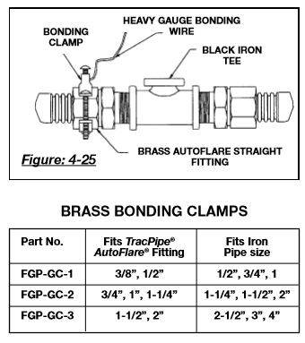

IMPORTANT SAFETY PRECAUTIONS
Failure to properly bond the TracPipe CounterStrike®flexible gas piping system in accordance with NEC/NFPA 70 may lead to damage to the CSST system in the event of a lightning strike. •A lightning induced fire in the building could lead to serious personal injury or significant property damage. •Lightning is a powerful and unpredictable natural force, and it has the capacity of damaging gas piping systems due to arcing between the gas piping system and other metallic systems in the building. •If the building to be piped is in a high lightning flash density area or a region with a high number of thunderstorm days per year, consideration should be given to utilizing the Lightning Risk Assessment method given in Annex L of NFPA 780 for a determination of the need for a lightning protection system.

