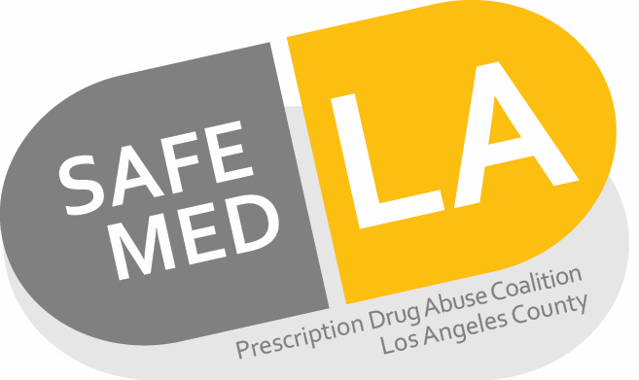

Commercially Available Naloxone Products
Brand | Generic | Packaging | Manufacturer
Brand product is not available | Naloxone 0.4 mg/mL solution for injection | 0.4 mg/mL as 1 mL vials and cartridges and 10 mL vial | Various
Brand product is not available | Naloxone 1 mg/mL solution for injection | 2 mL pre-filled syringe | International Medication Systems, Ltd
Narcan 4 mg/0.1 mL nasal spray | Naloxone 4 mg/0.4 mL nasal spray | 2 bottles per box | Various
Narcan 2 mg/ spray nasal spray* | Naloxone 2 mg/spray nasal spray | 4 bottles or 24 bottles per carton | Adapt Pharma Inc.
Evzio | Naloxone solution auto-injector | 0.4 mg/0.4 mL and 2 mg/0.4 mL injector | Kaleo
*Currently FDA approved, pending commercial availability. Per manufacturer, an estimated release date is not available.
References:
- Clinical Pharmacology. Available at: http://www.clinicalpharmacology-ip.com/Default.aspx. Accessed January, 2018.
- Narcan Nasal Spray [Prescribing Information]. Radnor, PA: Adapt Pharma, Inc. February 2017.

Disclaimer: availability verified as of January 2018, check individual product status with respective manufactures for up to date availability.

