**FUN FEBRUARY**

**During the month of February, we pick a fun spirit event**

**to do each week.**

February 6th-9th is **Crazy Sock Week**

February 13th-16th is **Pajama Week**

February 20th-23rd is **Hilarious Hair Week**

February 27th-March 2nd is **Red, Black, & White Week**

GET READY TO BRING F* U* N

TO FEBRUARY!



C:\Users\Stephanie\Pictures\Microsoft Clip Organizer\j0416014.wmfC:\Users\Stephanie\Pictures\Microsoft Clip Organizer\j0416014.wmfC:\Users\Stephanie\Pictures\Microsoft Clip Organizer\j0416014.wmf

**INSPIRATION** C:\Users\Stephanie\Pictures\Microsoft Clip Organizer\j0416014.wmf

“Things are Impossible Until Somebody Does it.” #motivation 

**#nsdsummersizzle**

Strike a pose!

**#class of the month** C:\Users\Stephanie\Pictures\Microsoft Clip Organizer\j0416014.wmf

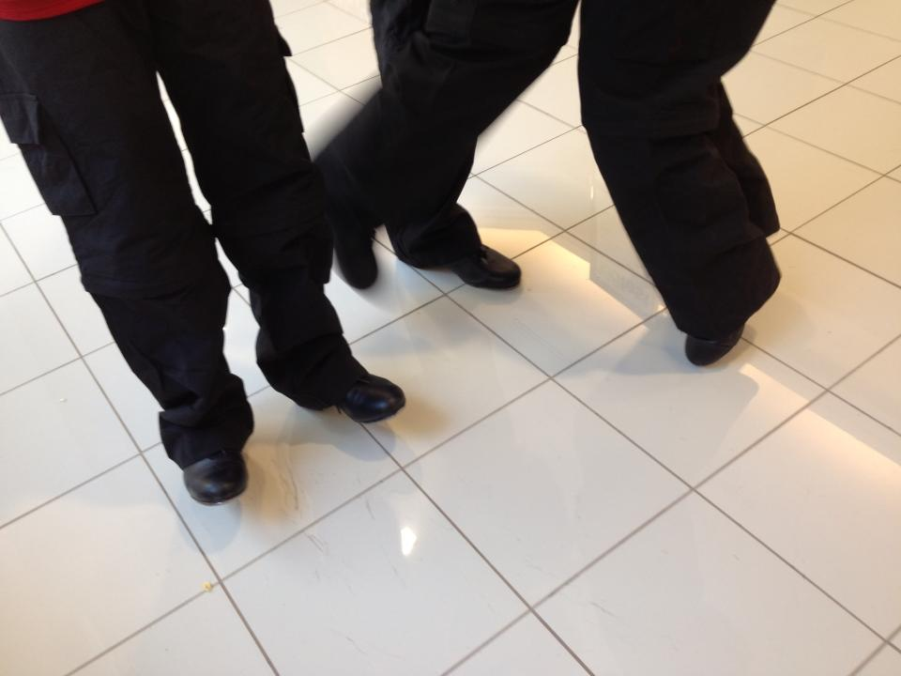

***TAP CLASSES***

One of the most exciting sounds to hear coming from the studios are the rhythmic sounds of students tapping. Whether it is warm-up or a combination, with music or acappella those shoes are singing a song!

**2017 SUMMER CLASSES**

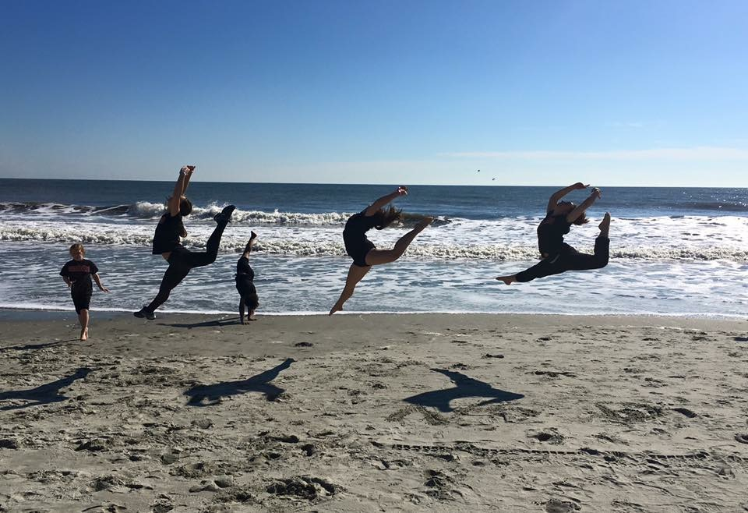 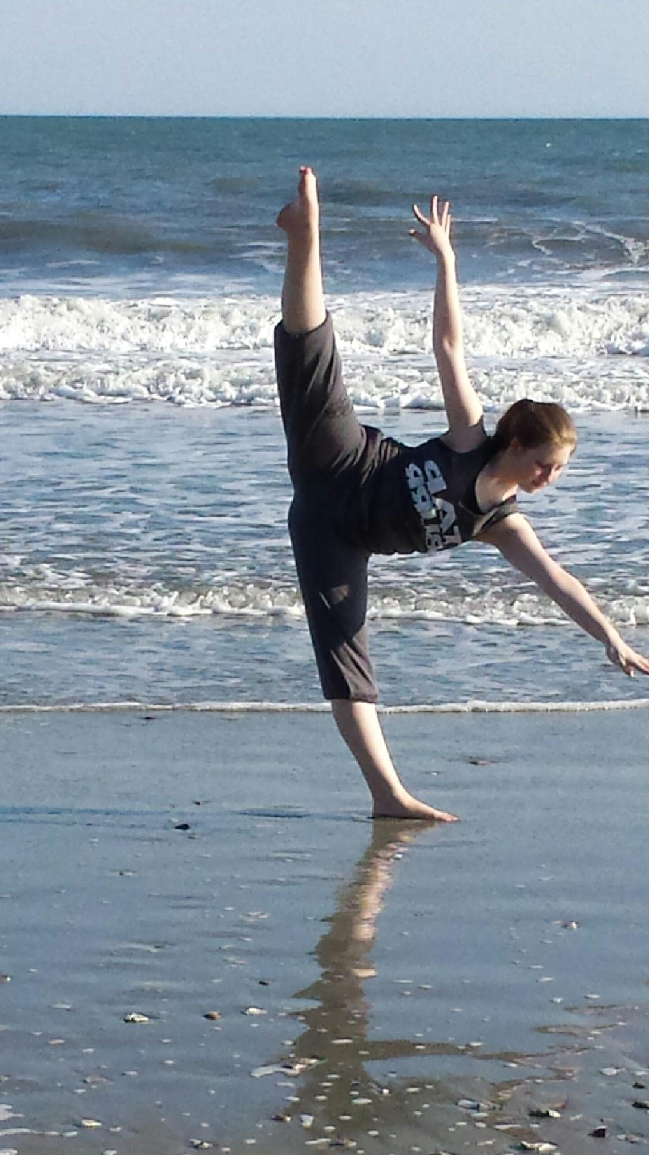

Our 2017 summer classes are online now! Check out what is happening for summer during our 4-week session.

We have a wide variety of dance styles and our Tiny Stepper Program is back along with our all guys’ classes. If you are age 2-adult, there is something for you at Next Step Dance. Refer family and friends and share in their excitement of dance when you receive a credit to your dance account! See something missing from our schedule? Let us know and we can see if it is possible to add it on for you.

C:\Users\Stephanie\Pictures\Microsoft Clip Organizer\j0416014.wmf C:\Users\Stephanie\Pictures\Microsoft Clip Organizer\j0416014.wmf

Steppin’ into FEBRUARY 2017 with Next Step Dance

[**www.thenextstepnc.com**](http://www.thenextstepnc.com)

**7712 Sossamon Lane, NW Concord, NC 28027 (704) 786-7837 nsdcalendar@gmail.com**

**OPEN HOUSE**

Thinking ahead to summer activities or even Fall 2017? Have a friend or relative interested in dance? Have a younger sibling that will be old enough for our Tiny Steppers program? Find out schedules and all the important stuff at our Open House on Saturday, June 3, 2017 from 10:00am-1:00pm. There will be classes to tryout and informational sessions to learn more about Next Step Dance and what is happening with us for the rest of 2017.

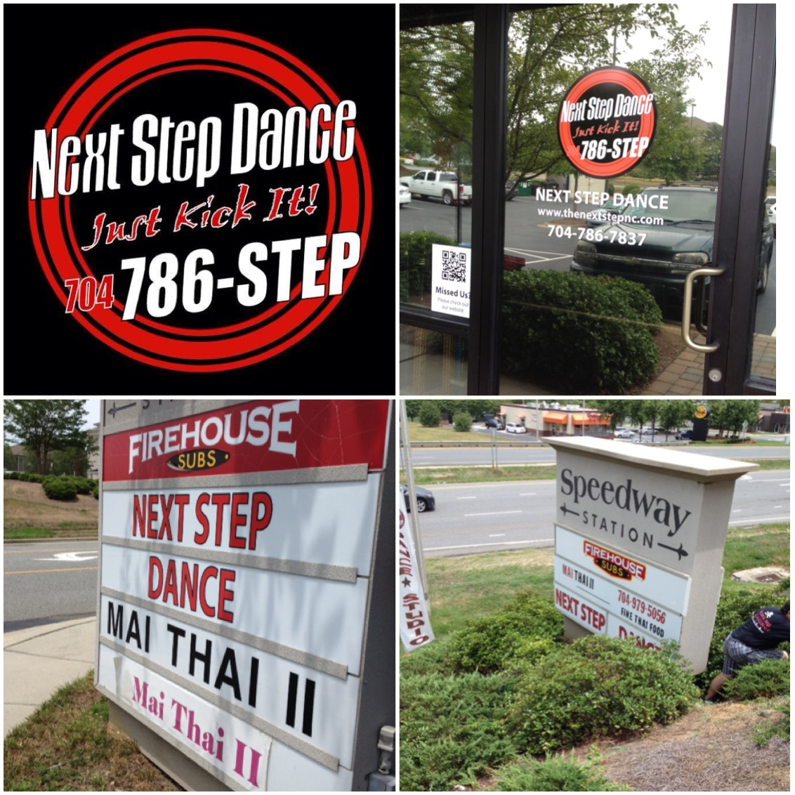

**SAVE THE DATE** C:\Users\Stephanie\Pictures\Microsoft Clip Organizer\j0416014.wmf

February 14, 2017

Don’t forget your Valentine!



Shoe orders take approximately 1-week for delivery and some we have in stock!

REMEMBER TO JOIN US ON

Facebook, Twitter, & Instagram!