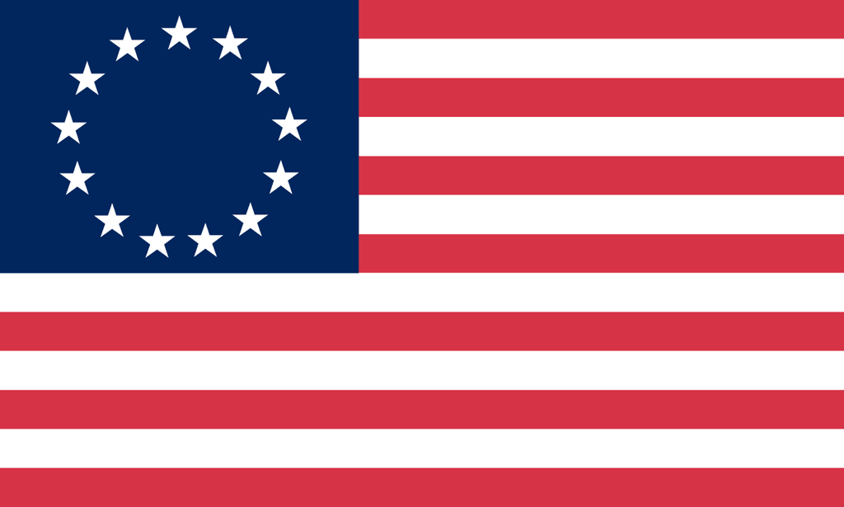U.S. History with Mr. Brown Name _______________________________ Period _____
Binder Quiz EE & EEC
Directions: Find the answers to the following questions in your binder. Don’t forget to use your learning goals as well as your vocab and notes.

1) What three reasons drove European Countries to explore and settle in the new world?

2) Which country sent fur trappers and traders to the new world that settled west of the Appalachian Mountains, toward the Mississippi River, and in the Great Lakes region?

3) The Major Era we are studying now is:  A Exploration and Colonization  B The Antebellum Era  C The Revolutionary Era
  4) Which of the following was the MAIN reason groups like the Pilgrims, Puritans, and Quakers left Europe?
  A | to develop new crops
  B | to establish a new monarchy in America
  C | to seek religious freedom
  D | to spread Catholic beliefs to American Indians

For each of the following write either God, Gold, Or Glory on the line beside each idea.

5) Spread Christianity - _______________

6) Gold and silver nuggets - _____________

7) Adventure - _____________

8) Land - _____________

9) Tobacco - _____________

10) Religious Freedom - _____________

11) Who was the Native American girl who helped John Smith and the Jamestown Settlement survive?

12) The Virginia House of Burgesses was the first _____________________ government in the New World.

13) Factors that led to the development of _______________________ government were; Familiarity with Parliamentary System; Distance from England; isolation of communities

14) _____________________ Groups like Pilgrims, Puritans, and Quakers were the first to establish self-governing communities as a role of religion and virtue.

15) Adventure, __________________ Freedom, Political Freedom, and Free or Cheap Land were reasons for English colonization in the new world.

